|  |  |  |  |  |
| --- | --- | --- | --- | --- |
| **Module** | **Company Name** | **Company Code** | **Student** | **Trainer** |
| **Sap FICO** | **Tata Consultancy** | **2323** | **A P Durai Selvan** | **Prabhakar** |

**FINANCIAL AND CONTROLLING OVERVIEW**

**Finance:**

1. **ENTERPRISES STRUCTURE**
2. **GENERAL LEDGER**
3. **ACCOUNTS PAYABLE (VENDORS, SUNDRY CREDITORS, SUPPLIER)**
4. **ACCOUNTS RECEIVABLE (CUSTOMERS,SUNDRY DEBTORS)**
5. **BANK – AUTOMATIC PAYMENT**
6. **ASSET ACCOUNTING**

**Controlling:**

1. **CONTROLLING AREA**
2. **COST ELEMENT**
3. **COST CENETR ACCOUNTING**

**10. PROFIT CENETR ACCOUNT**

1. **Enterprise Structure**

* **Creation of Company – OX15**
* **Creation of Company Code – OX02**
* **Assign Company Code to Company – OX16**
* **Creation of Credit Control Area – OB45**
* **Assign Credit Control Area to Company Code – OB38**
* **Creation of Fiscal Year Variant – OB29**
* **Assign Fiscal Year Variant to Company Code – OB37**
* **Creation of Posting Period Variant – OBBO**
* **Assign Posting Period Variant to Company Code – OBBP**
* **Opening & Closing Posting Period Variant – OB52**
* **Creation of Field Status Variant – OBC4**
* **Assign Field Status Variant to Company Code – OBC5**
* **Creation of Chart of Account – OB13**
* **Assign of Chart of Account to Company Code – OB62**
* **Retained Earnings - OB53**
* **Document Types & Number Ranges – OBA7 & FBN1**
* **Posting Keys – OB41**
* **Tolerance for Group**

1. **G/L – OBAO**
2. **User – OBA4**

* **Global Parameter – OBY6**
* **Creation of A/C Groups – OBD4**
* **Deactivation of Document Splitting**

# Sap Project

## Enterprise Structure

### Company creation(ox15)

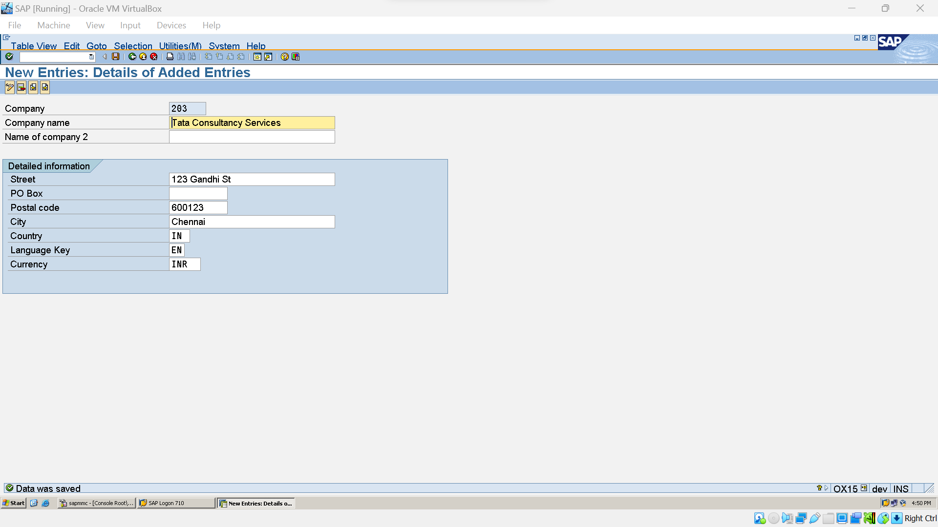

### Company Code creation (ox12)

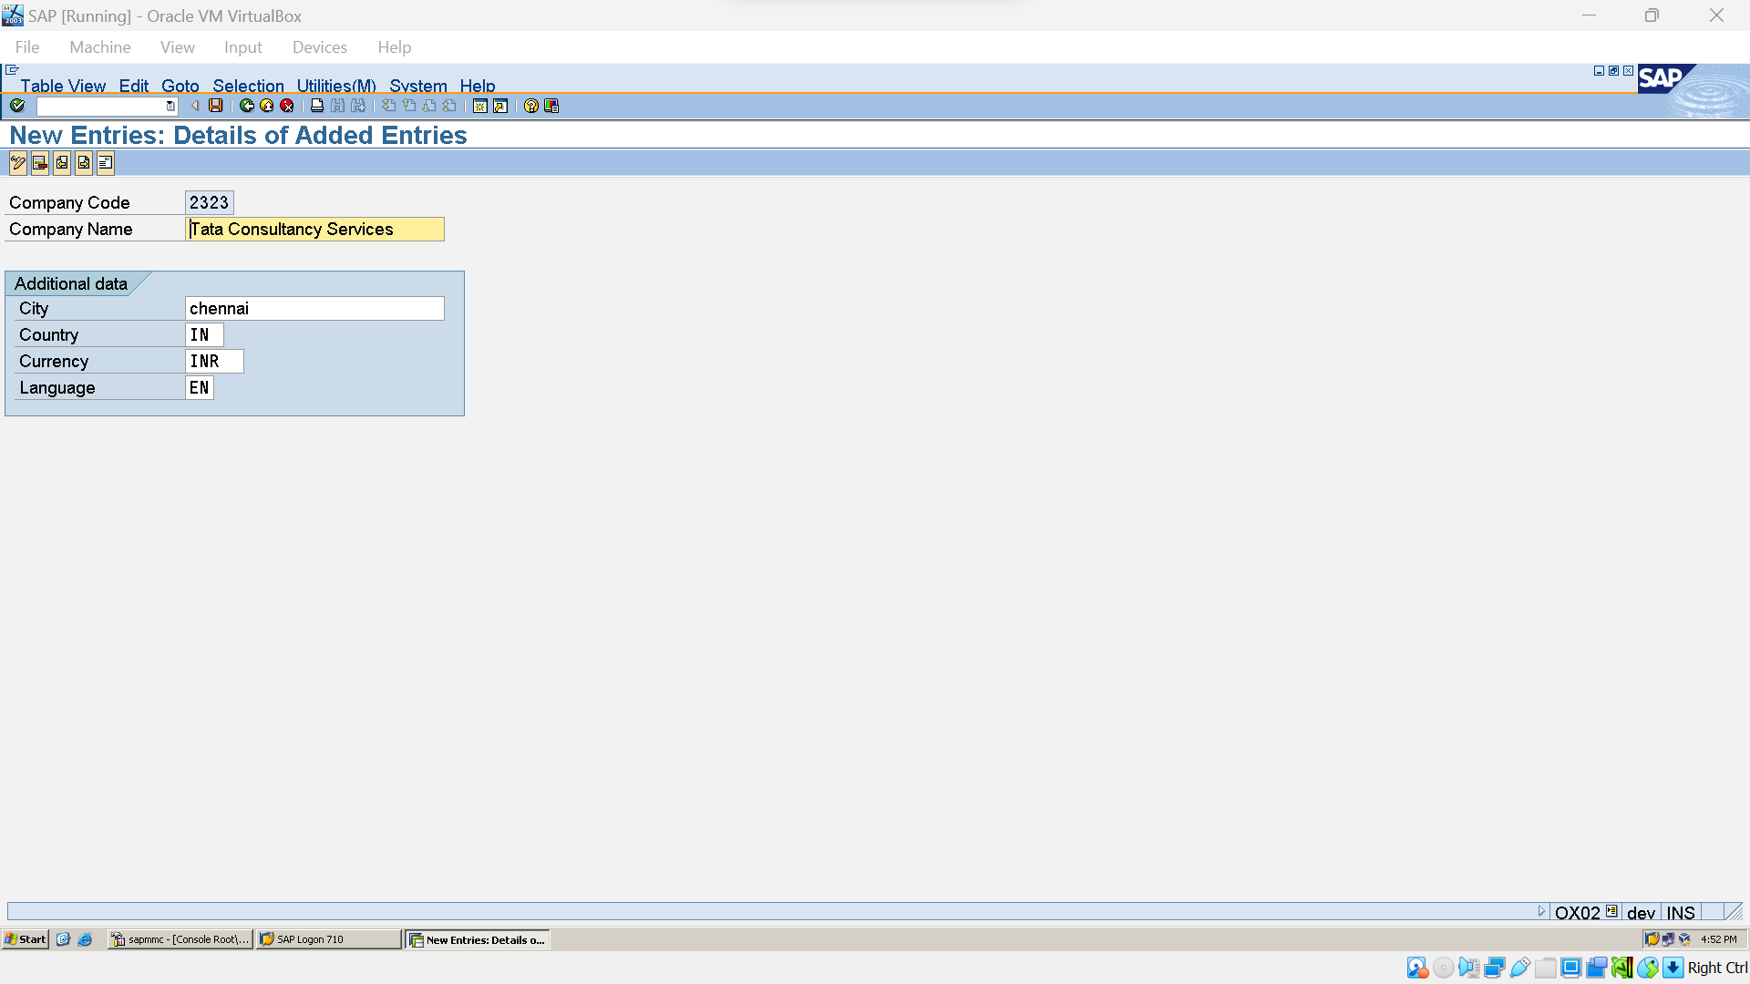

### Business Area creation(OX03)

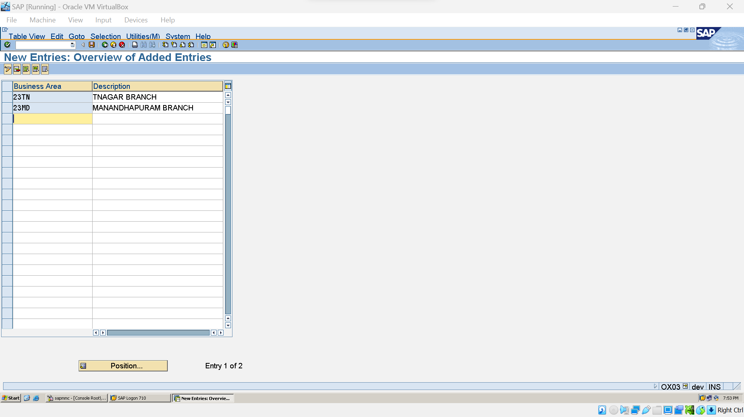

### Assign Company code & company(ox16)

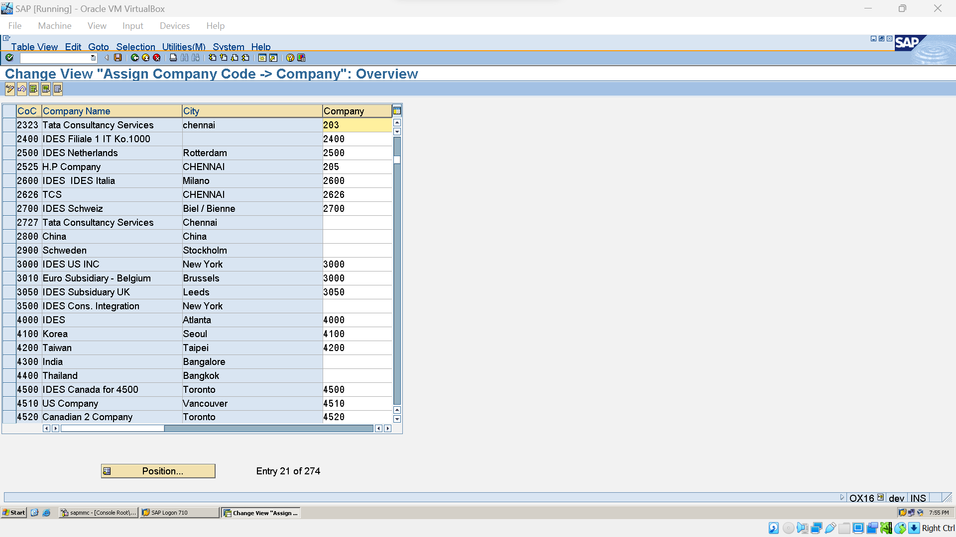

### Fiscial year define (ob29)

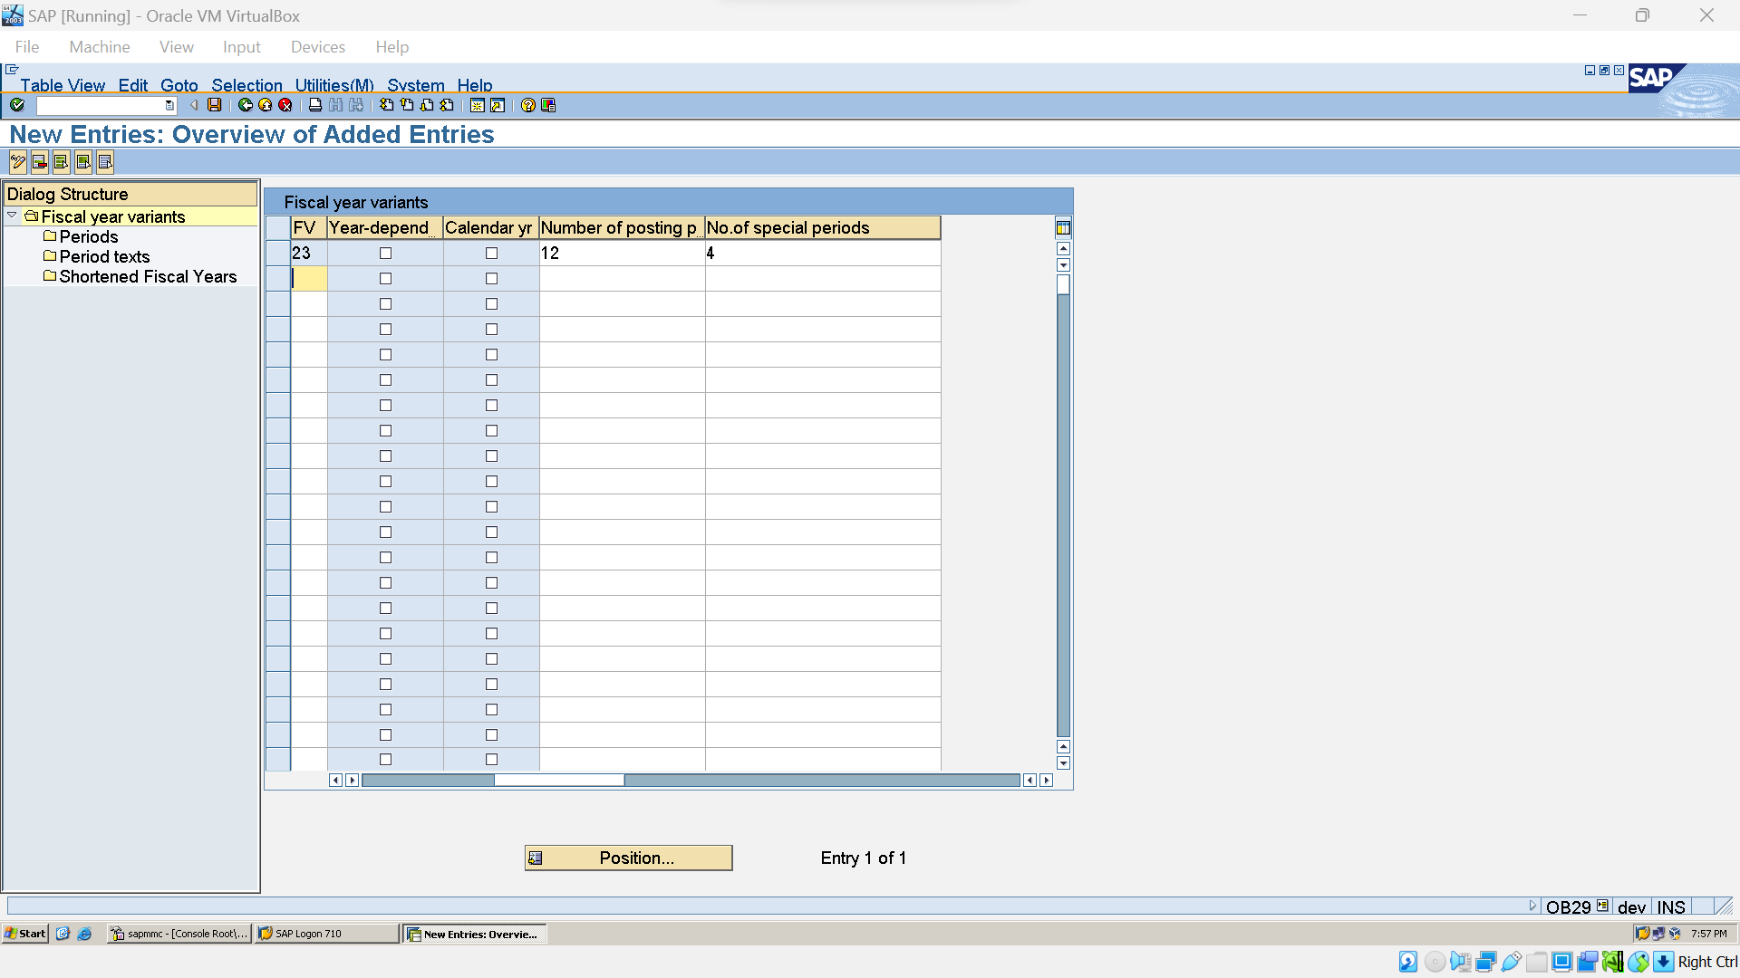

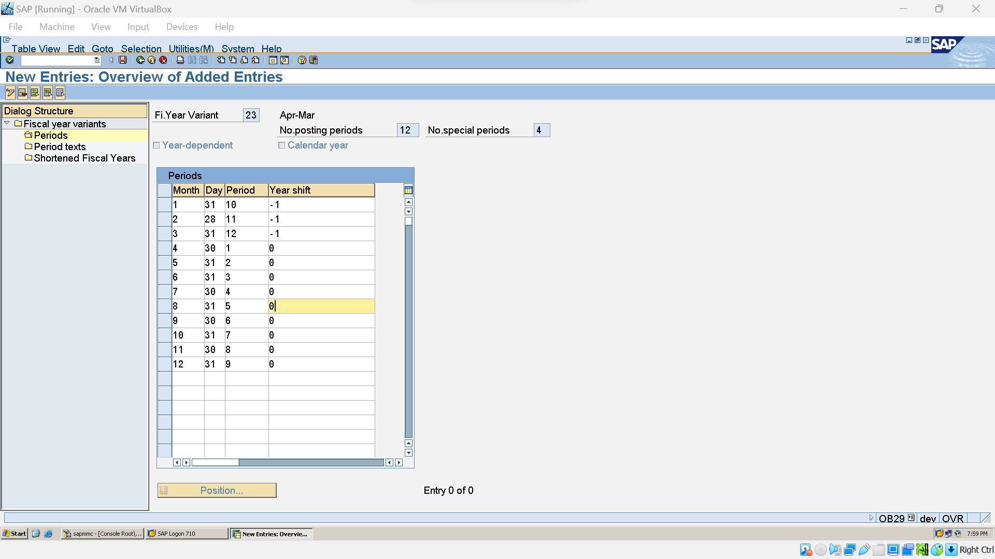

### Assign Company Code to Fiscal year

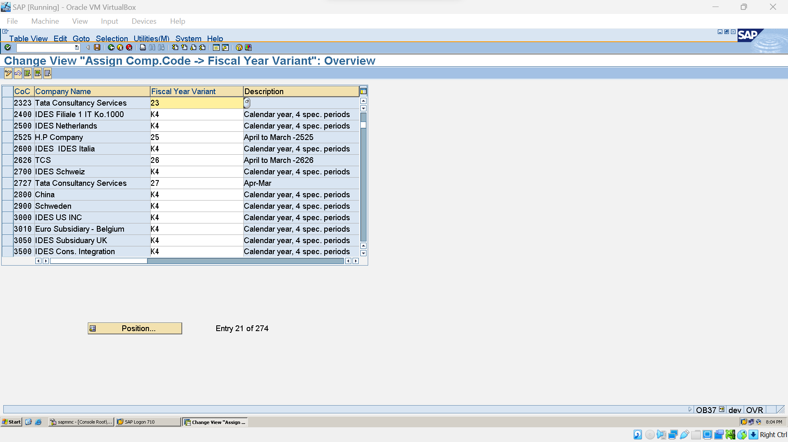

### Variant Open Posting Periods (OBBO)

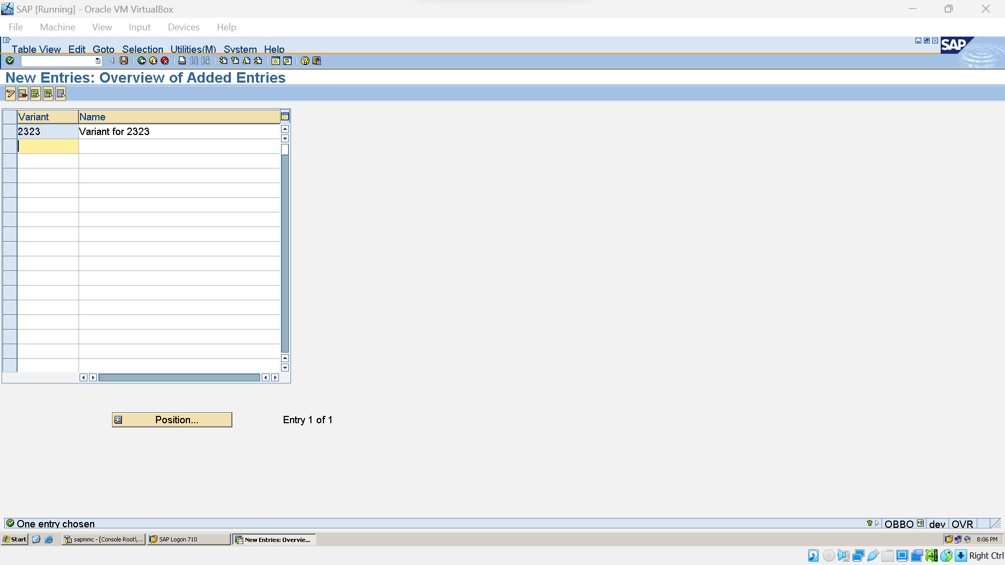

### Assign Company Code to Posting Periods (obbp)

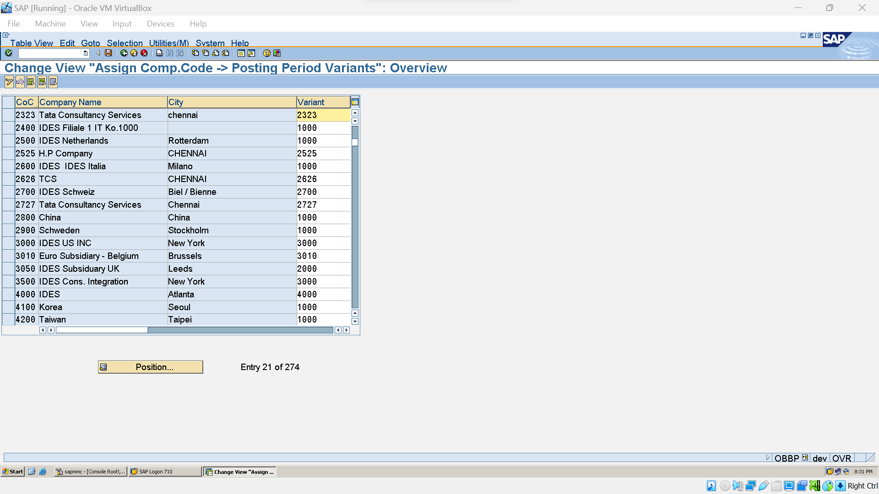

### Opening & Closing Posting Periods (Ob52)

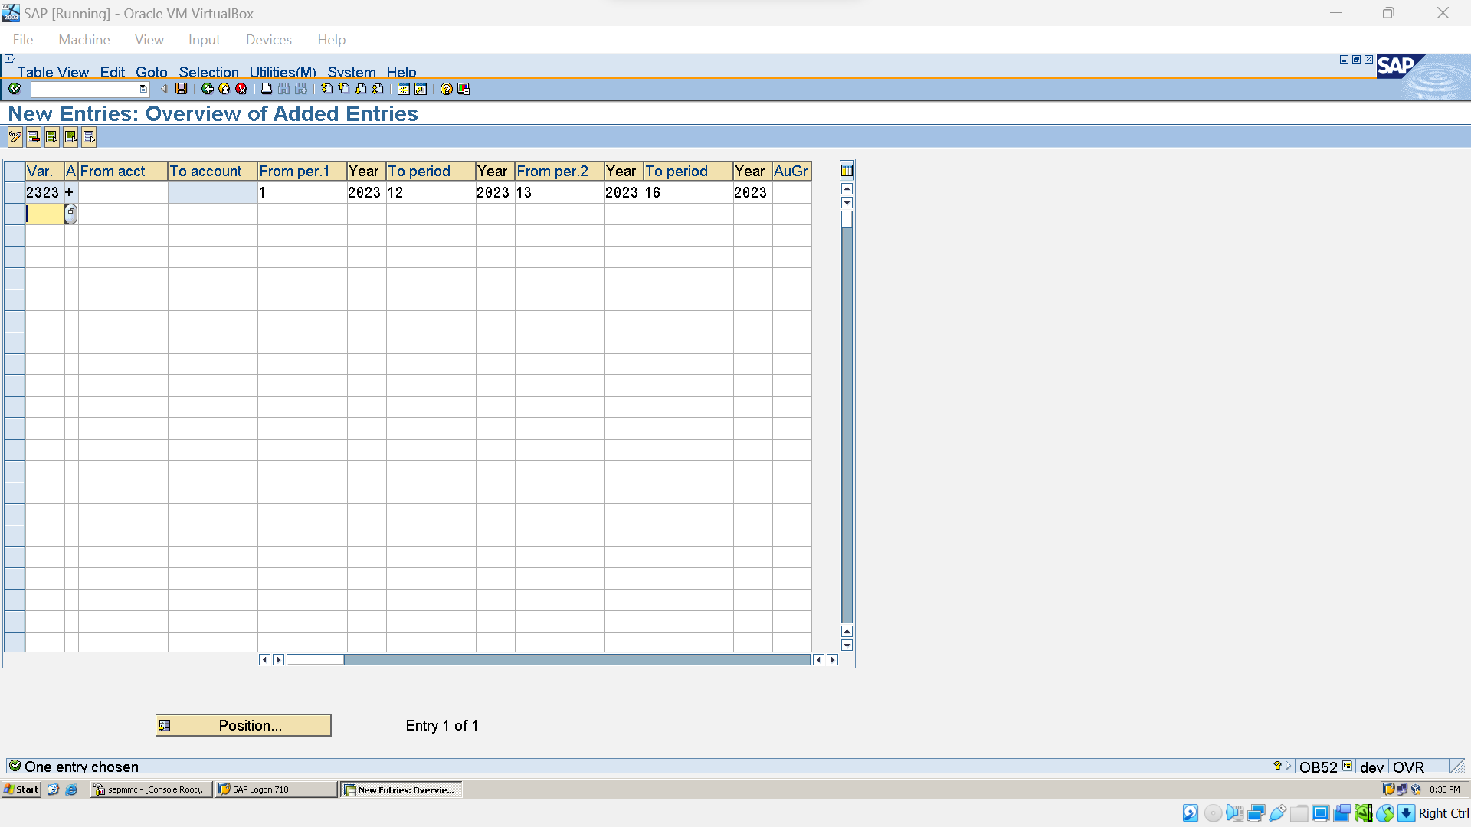

### Document type and No. of Ranges (OBA7)

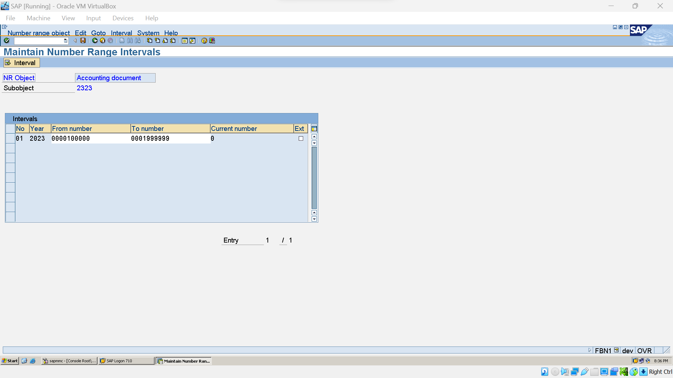

### Field Status Variant (obc4)

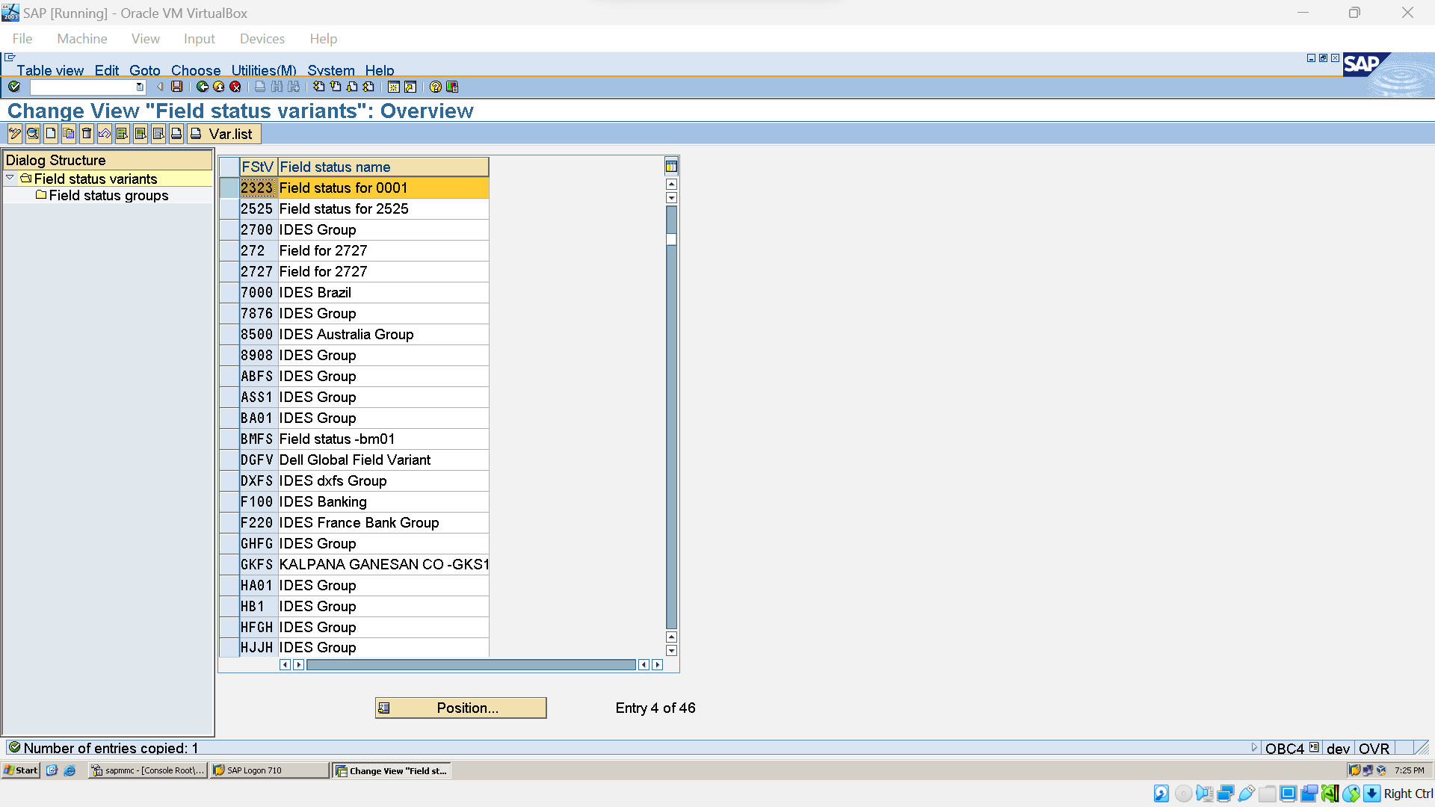

### Assign Field Status Variant (obc5)

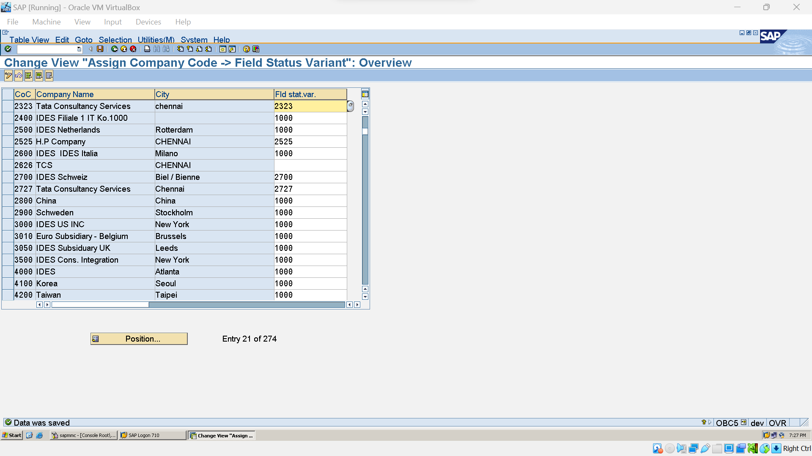

### Tolerance group for G/L A/C: (OBA0)

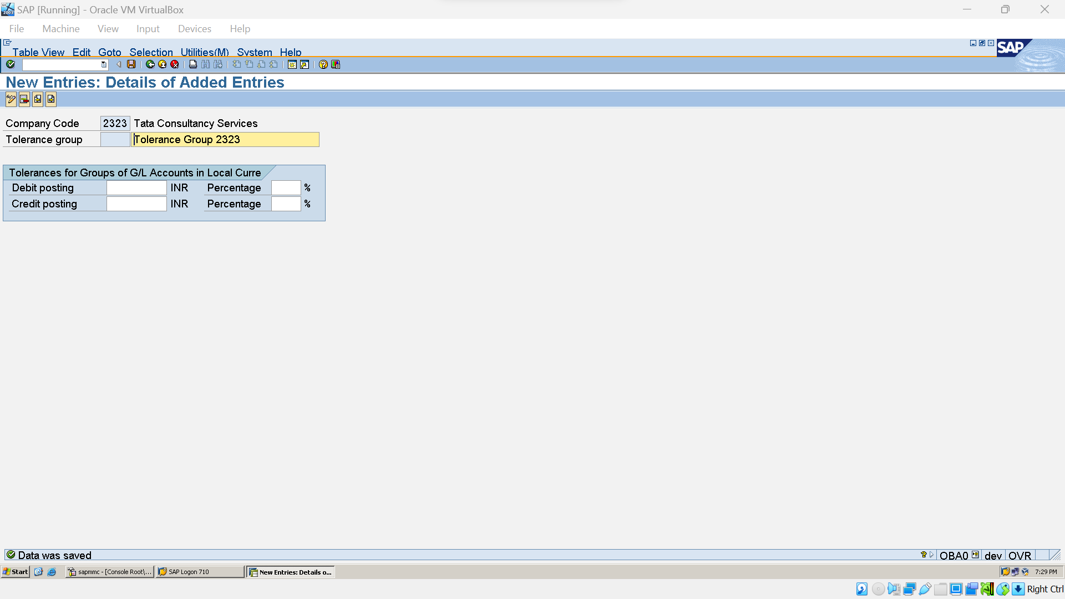

### Tolerance Group for Employess (OBA4)

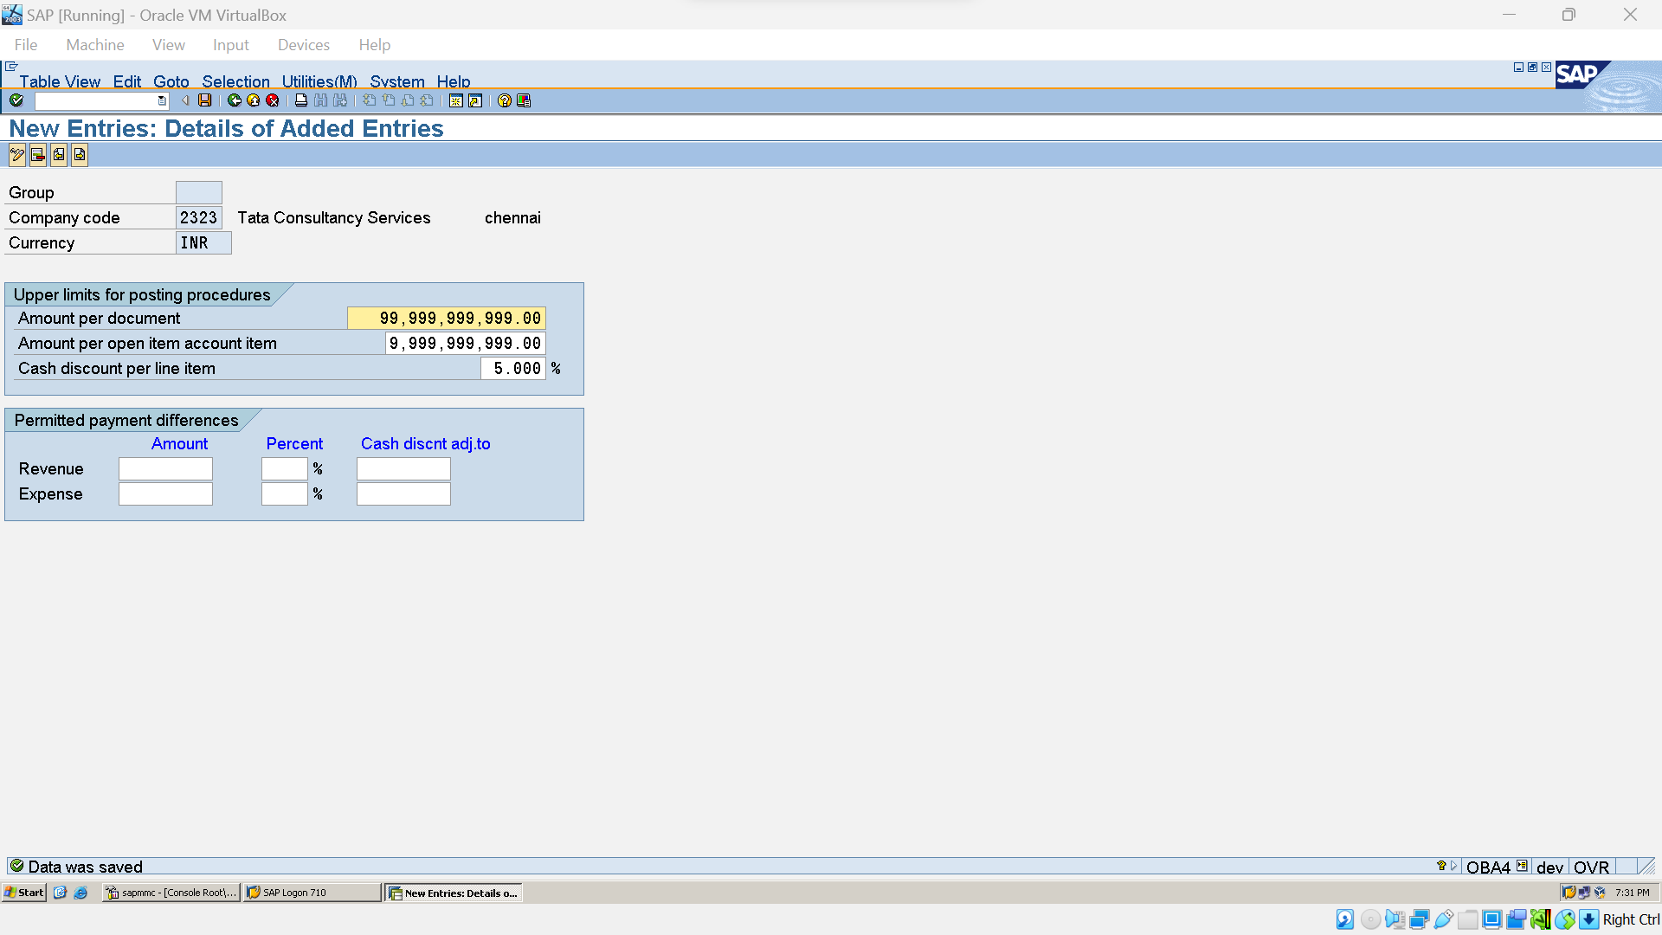

### Creation of chart of A/c List (ob13)

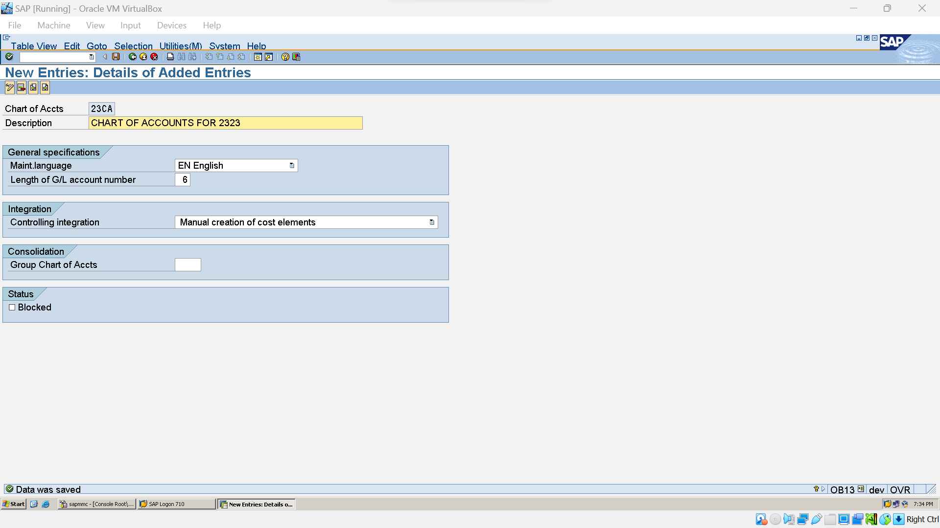

### Assign chart of a/c to company code (ob62)

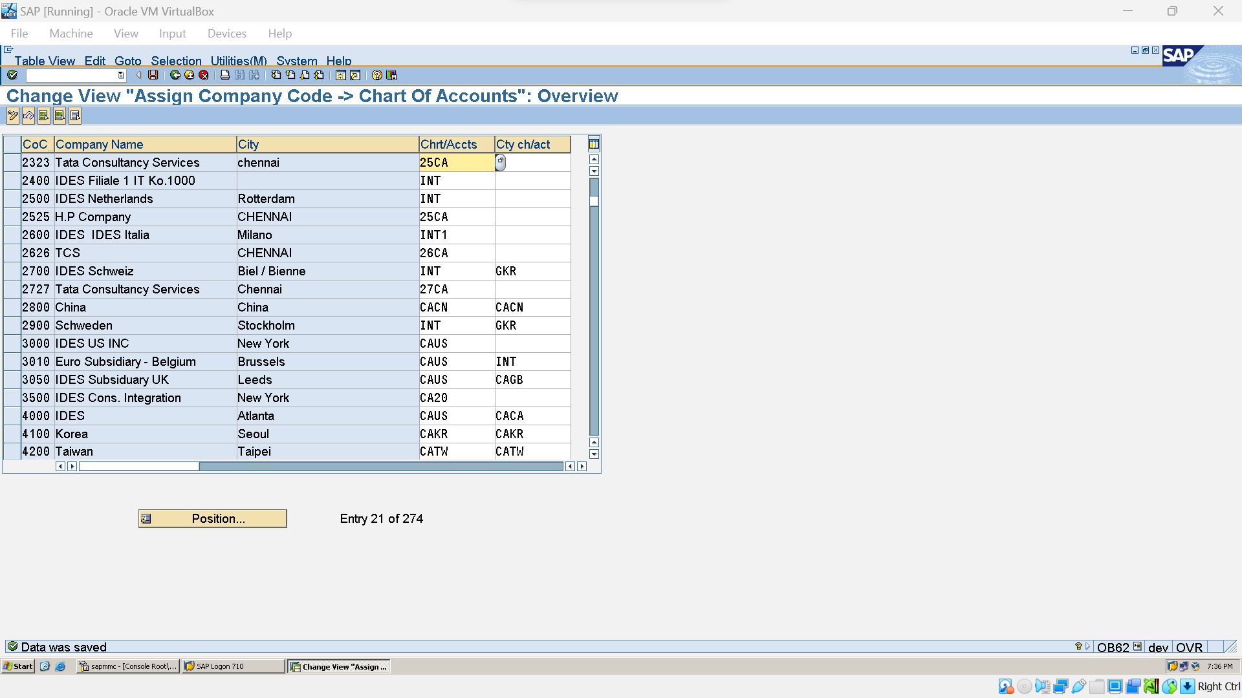

### Account Groups (OBD4)

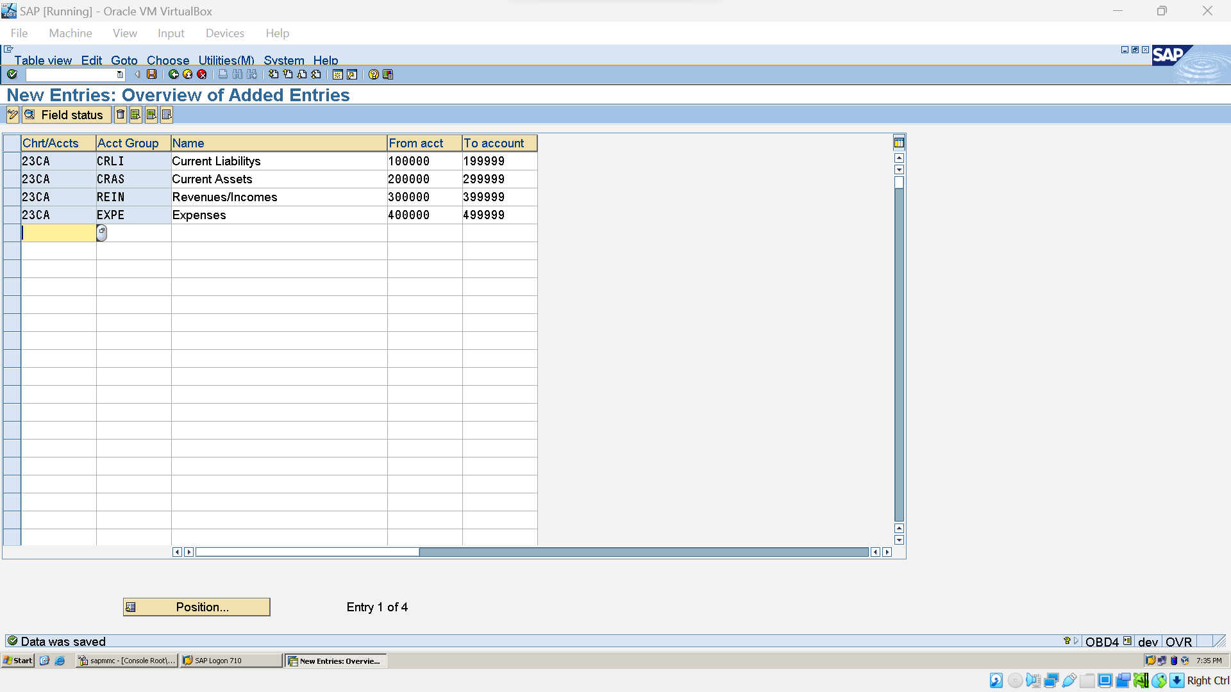

### Retained Earnings A/C(OB53)

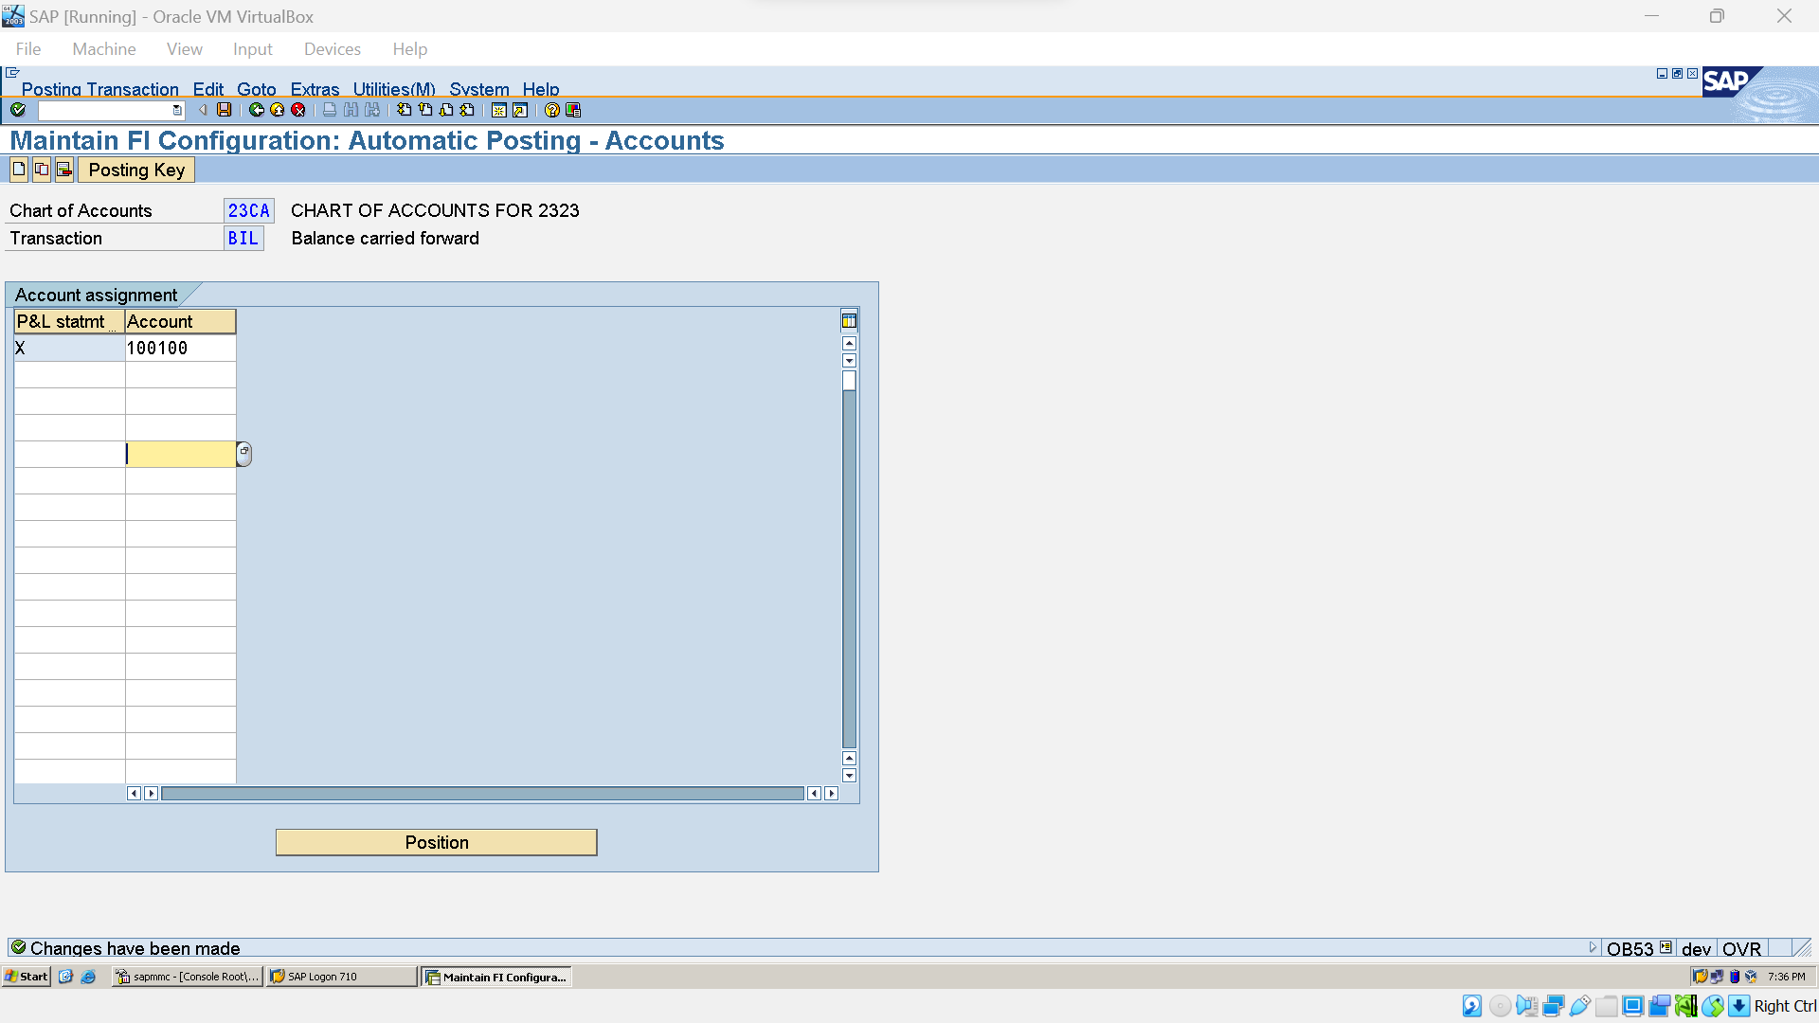

### Deactivate Document Spliting

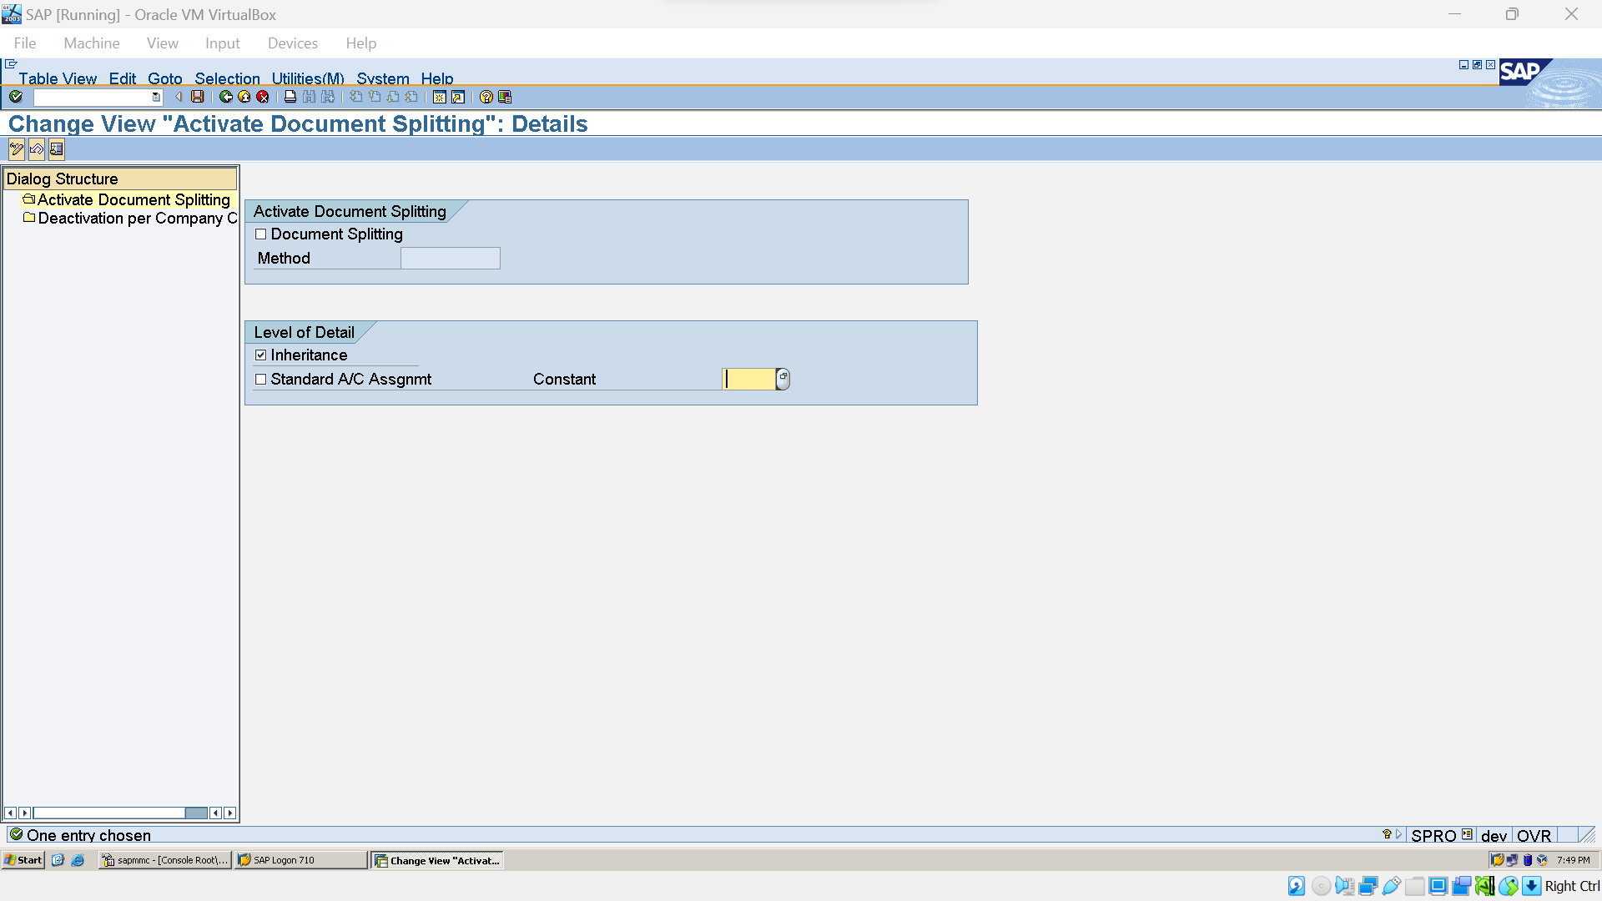

Rermoved Document Spliting Checkbox.

### Define Credit Control area(OB45)

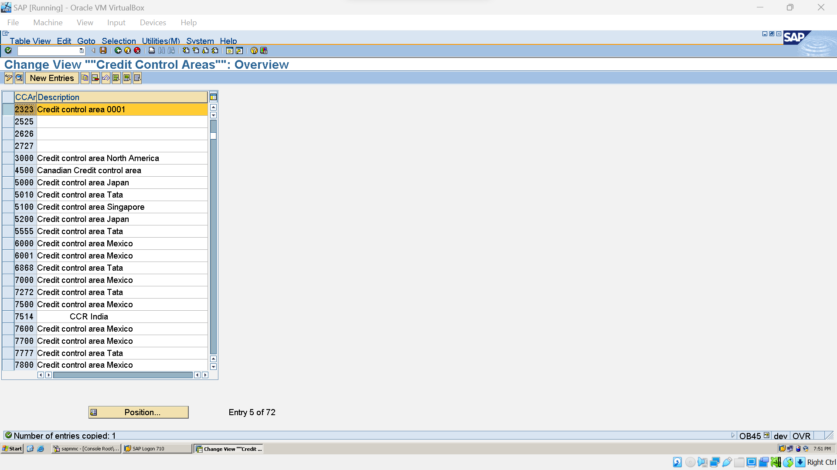

### Assign Credit Control Area to Company Code (OB38):

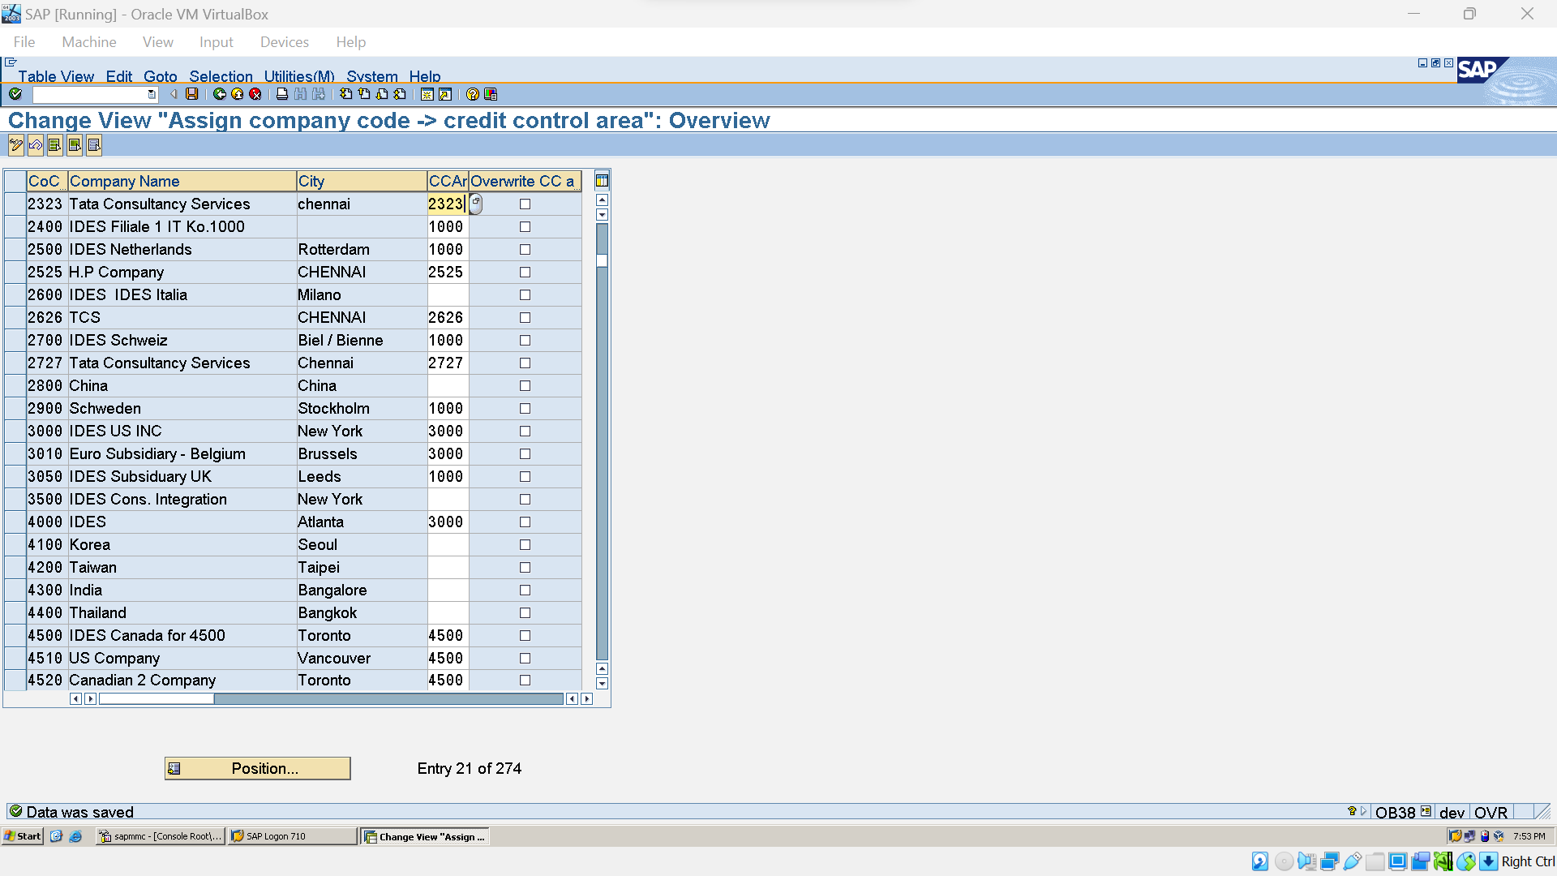

## G/L Master:

### Edit Chart of A/C(FSP0)

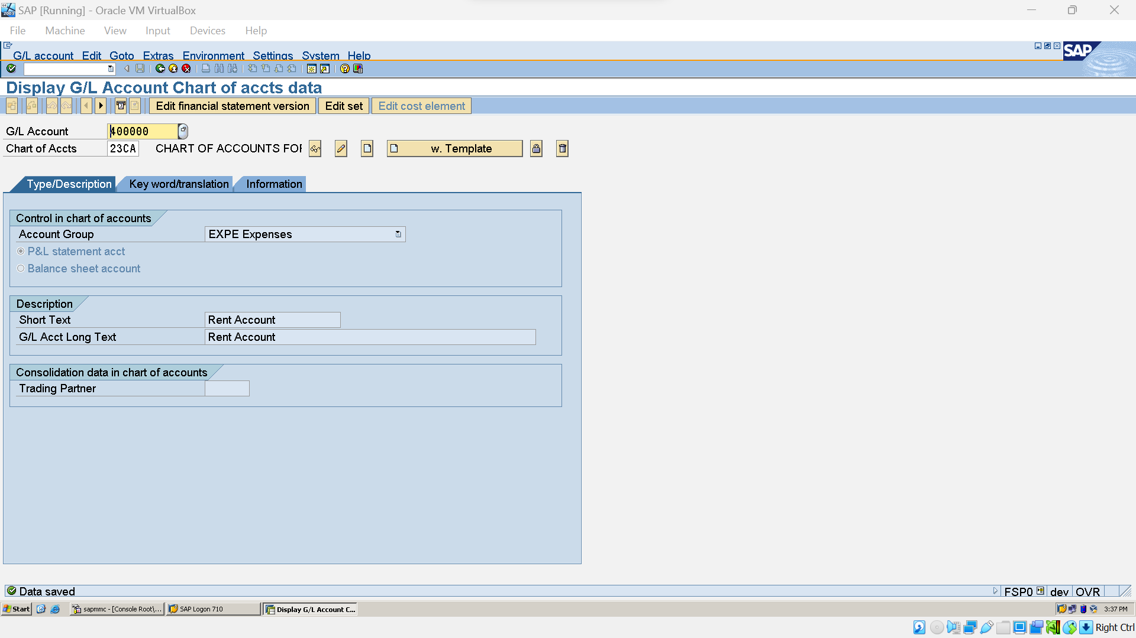

### Create G/L Company Code level (FSS0)

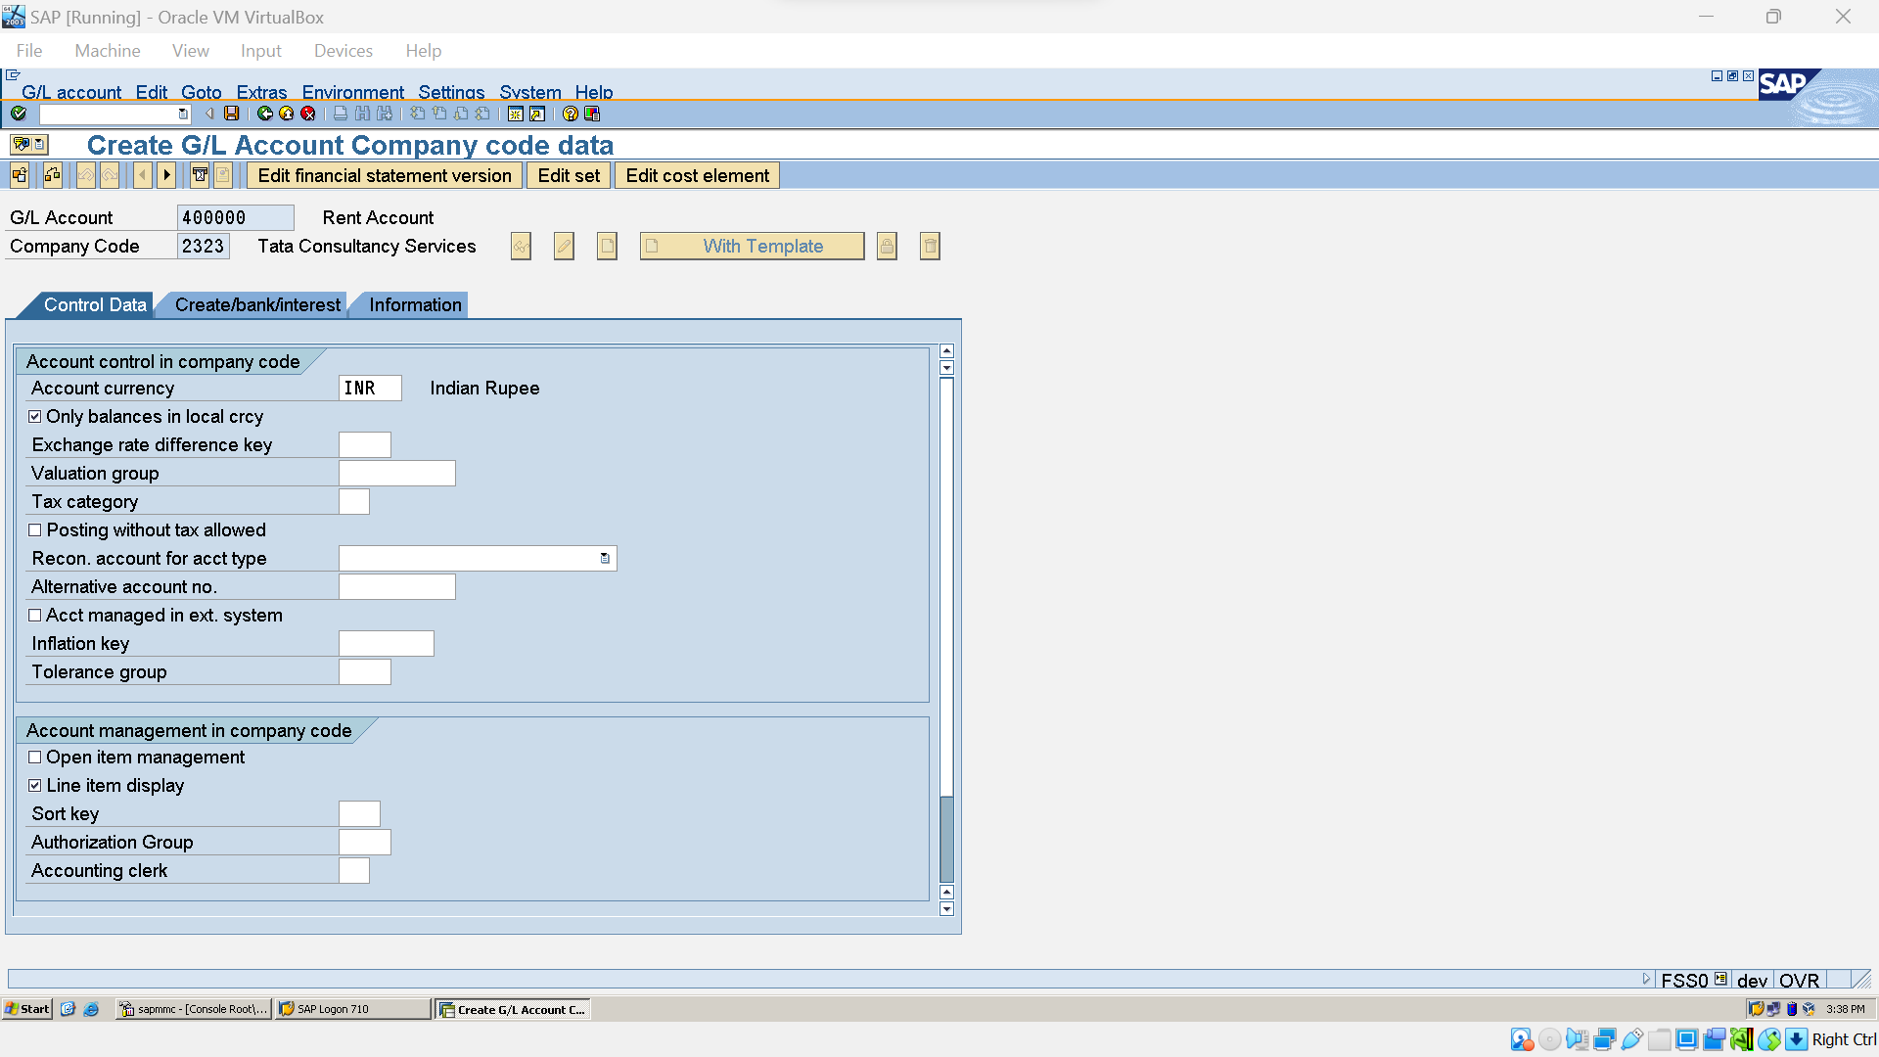

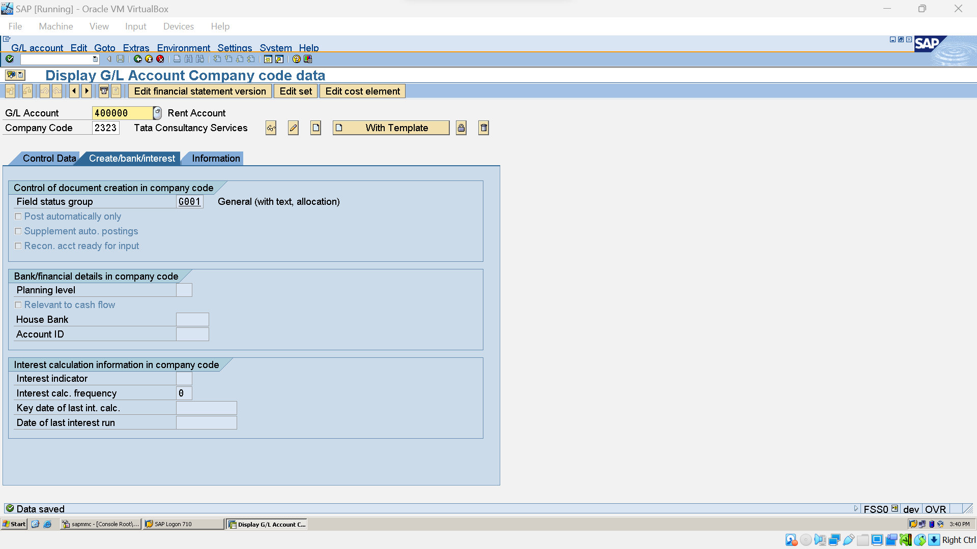

### G/L A/C creation (Centrally-FS00)

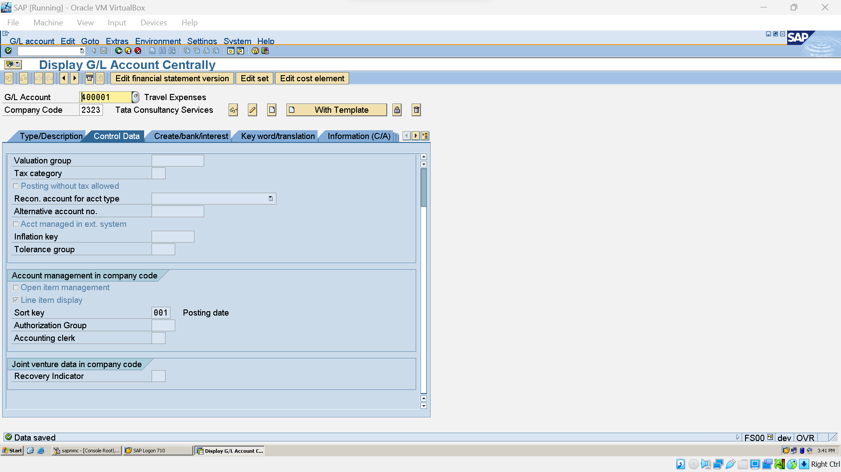

### Create Insurance G/L A/C (FS00)

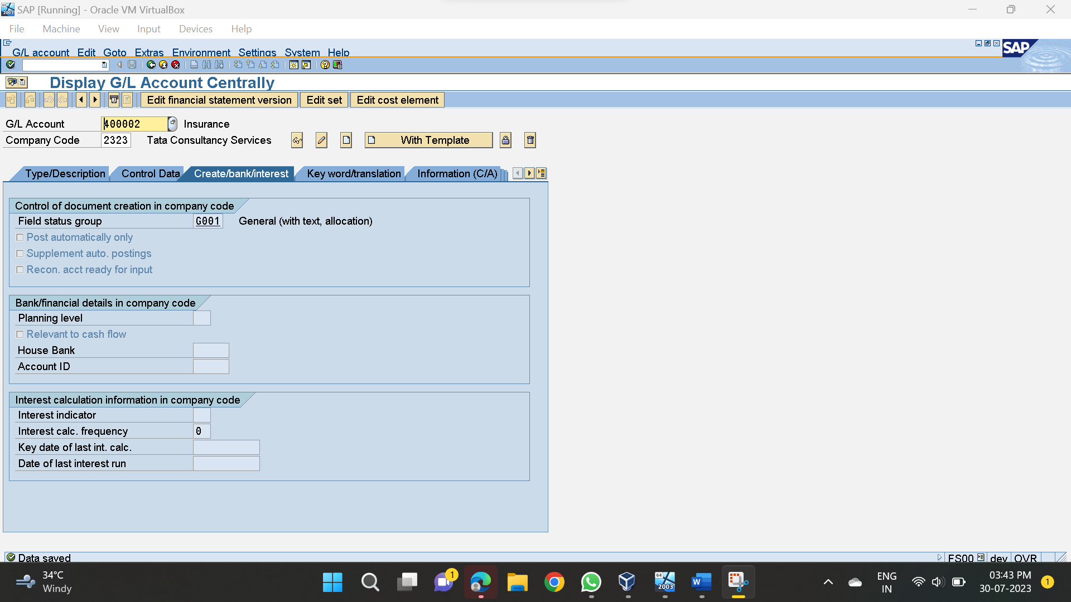

### Bank G/L Creation (FS00):

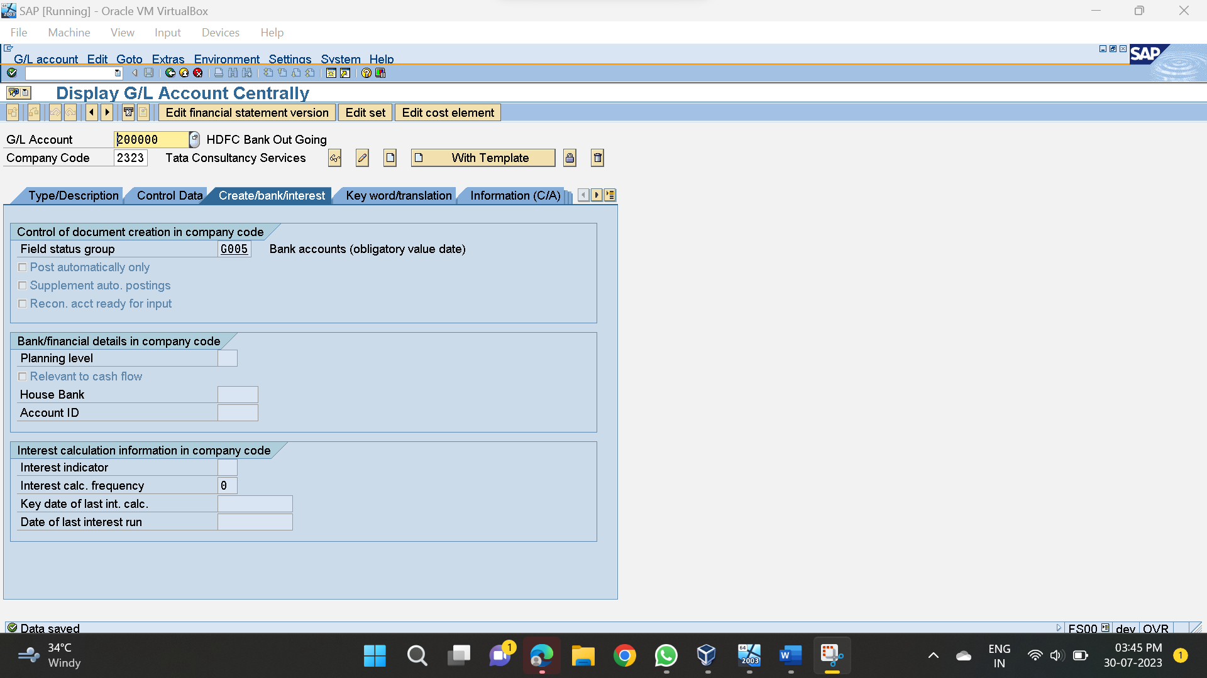

### Create Purchases G/L A/C :

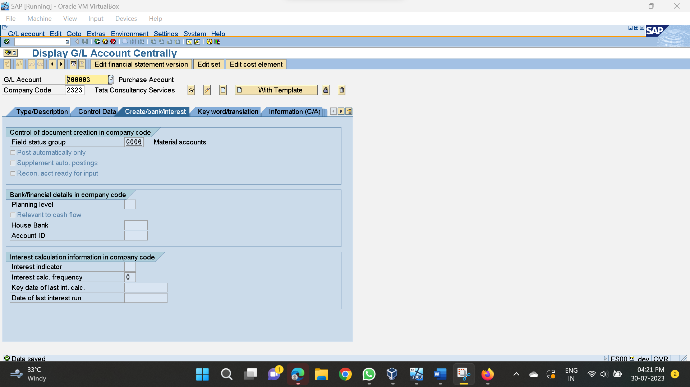

### Create Sale G/L A/C:

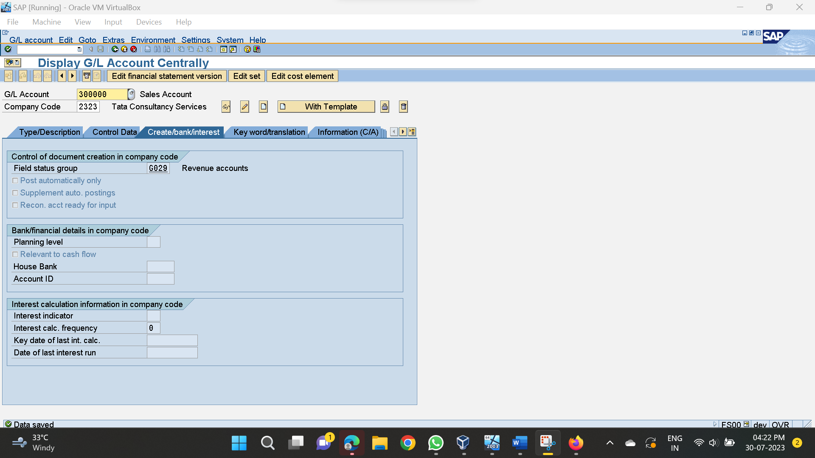

### G/l Postings: (FB50)

### Rent posting:

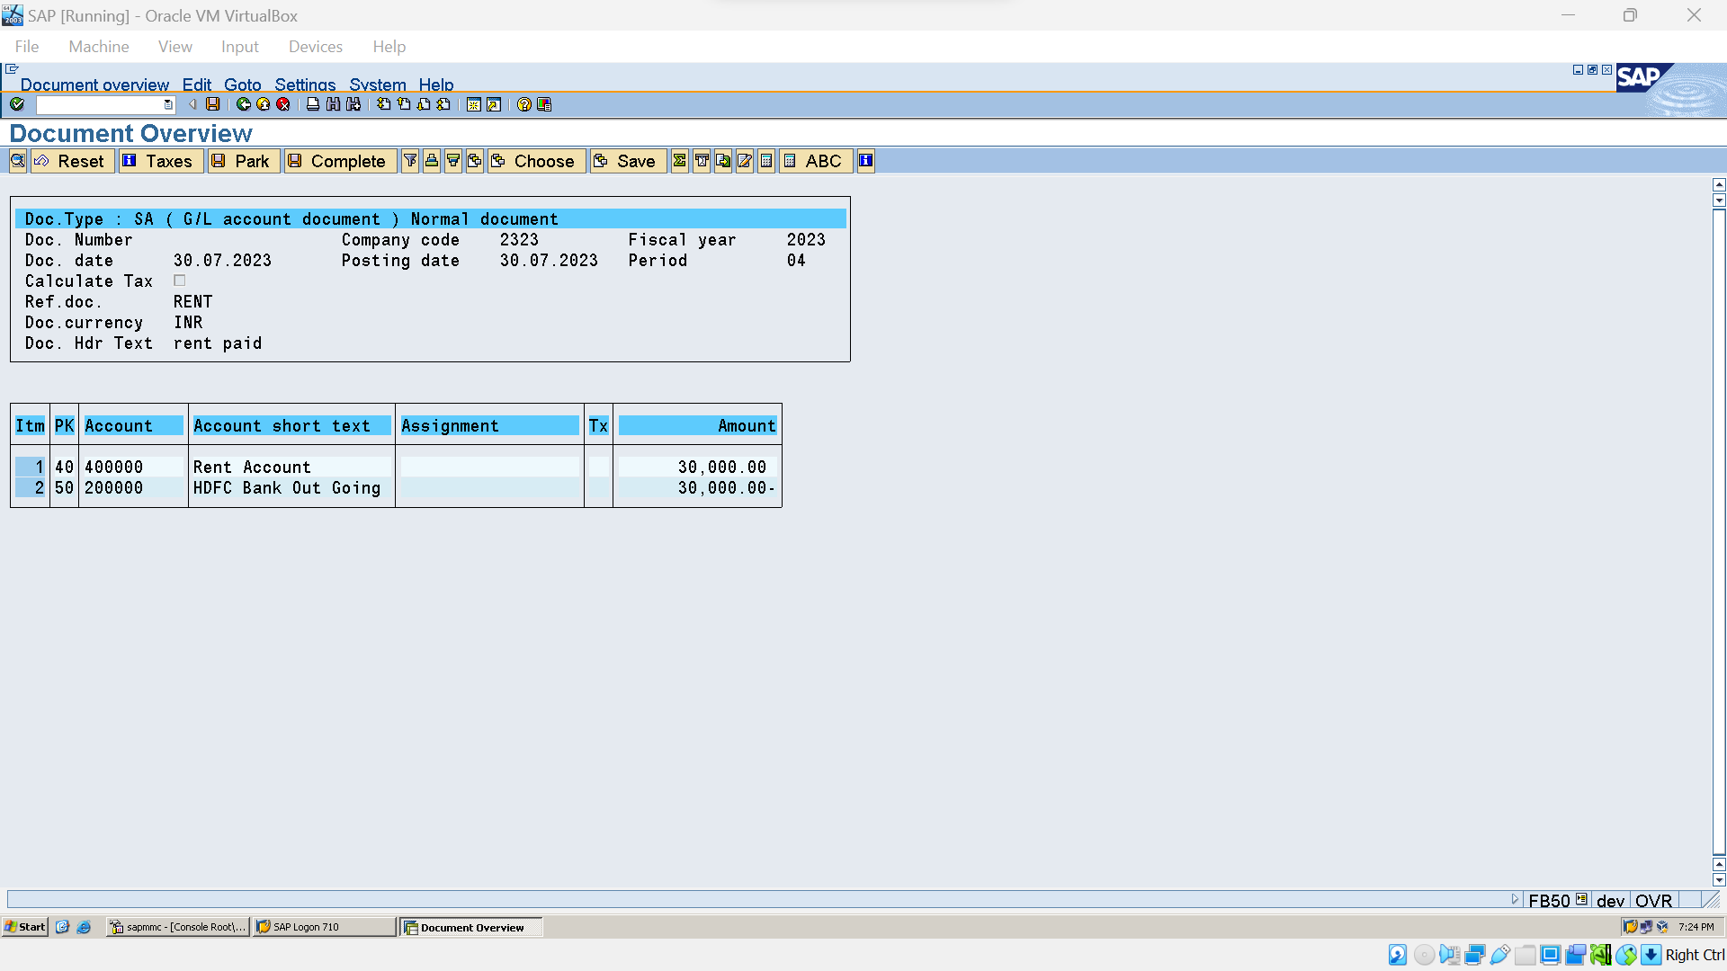



### G/L Line Item Display (FBL3N)

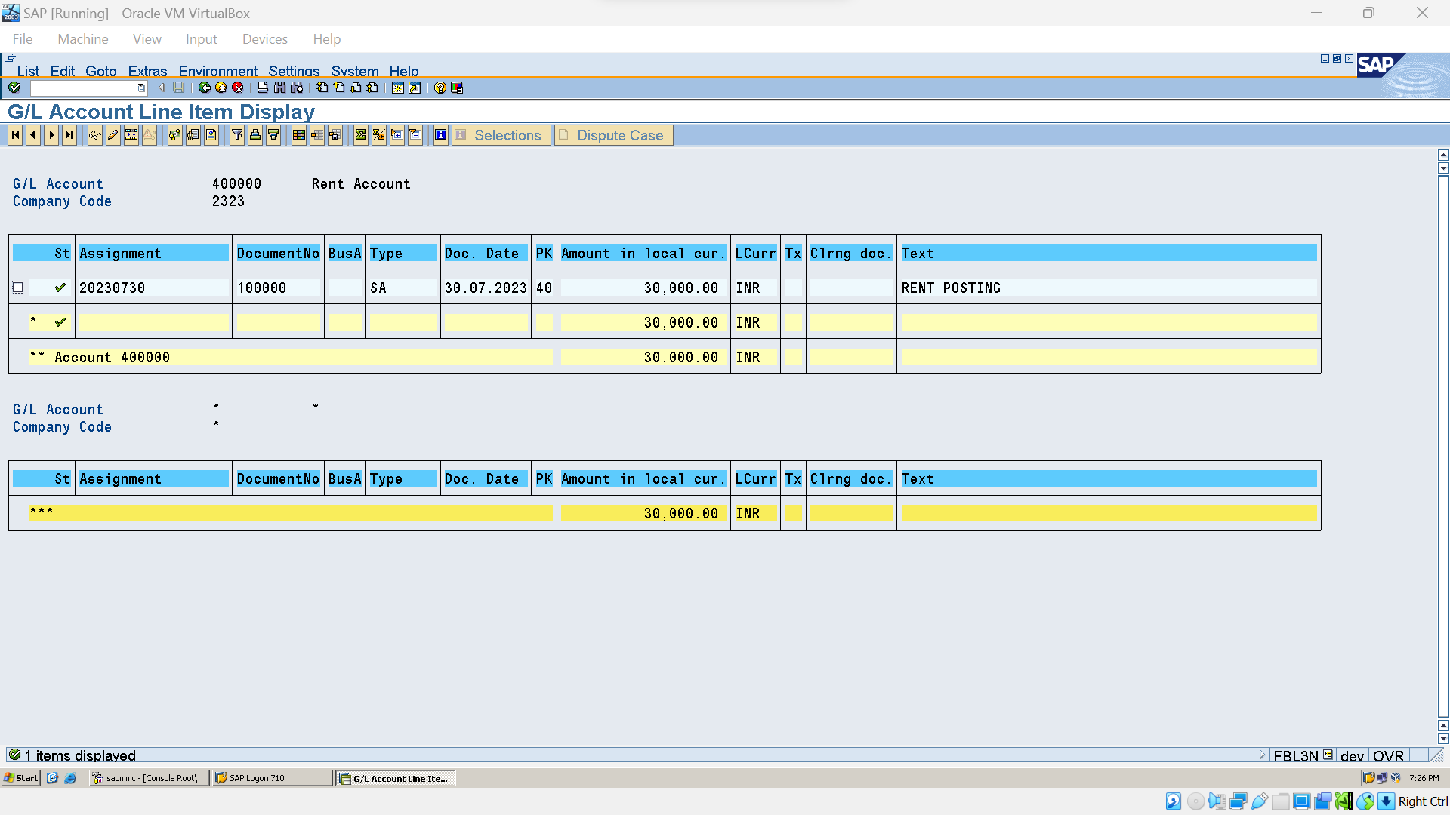

### Park Document :

### Create(FV50)

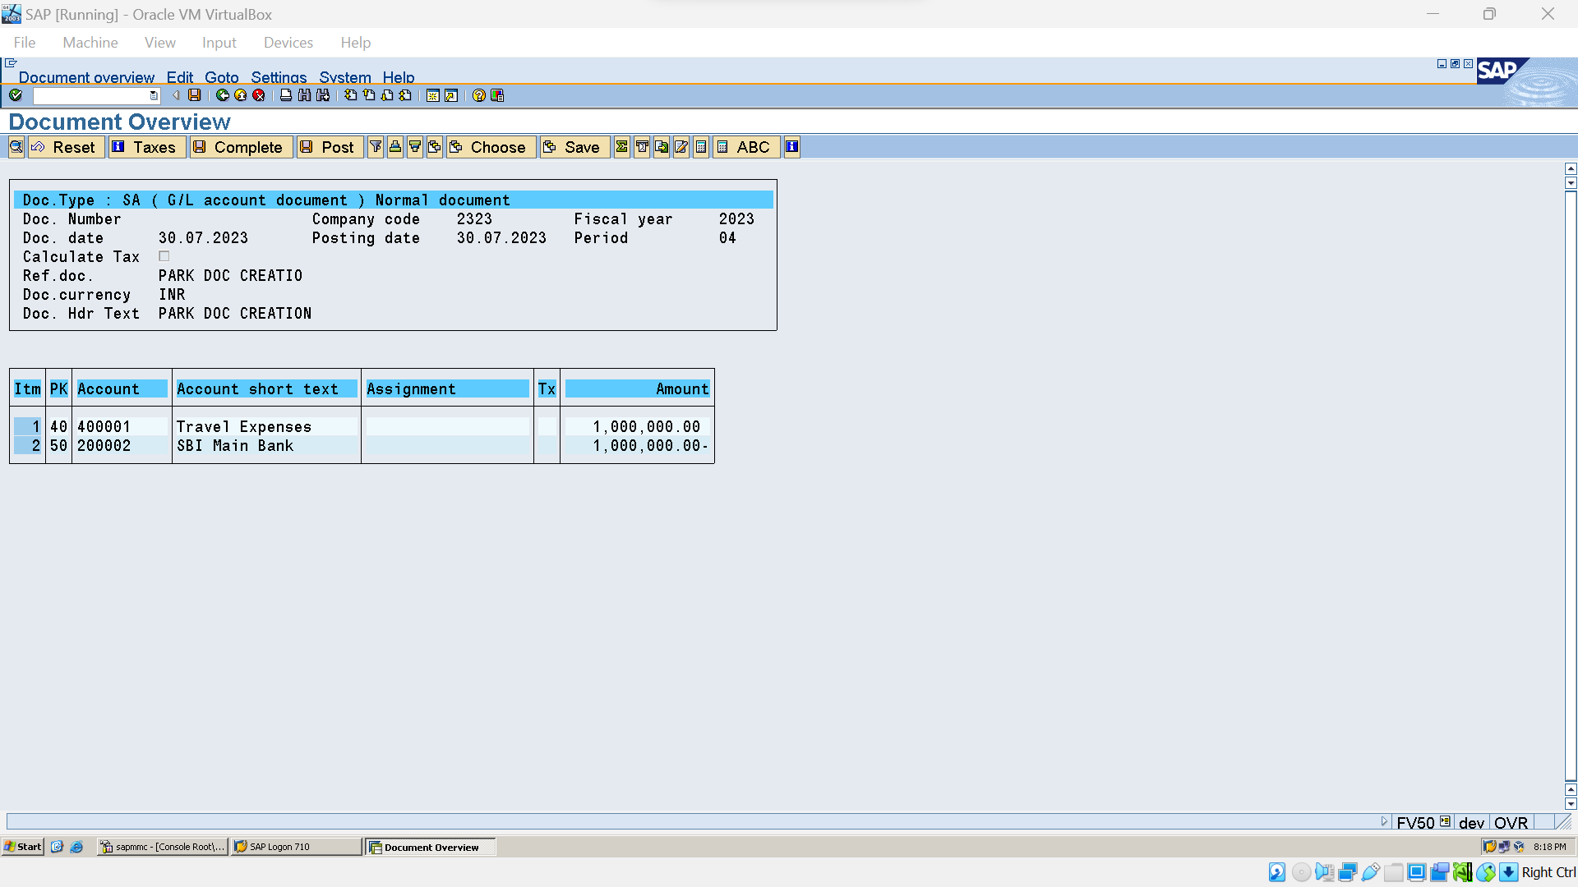



### Post Parked Doc (FBV0):

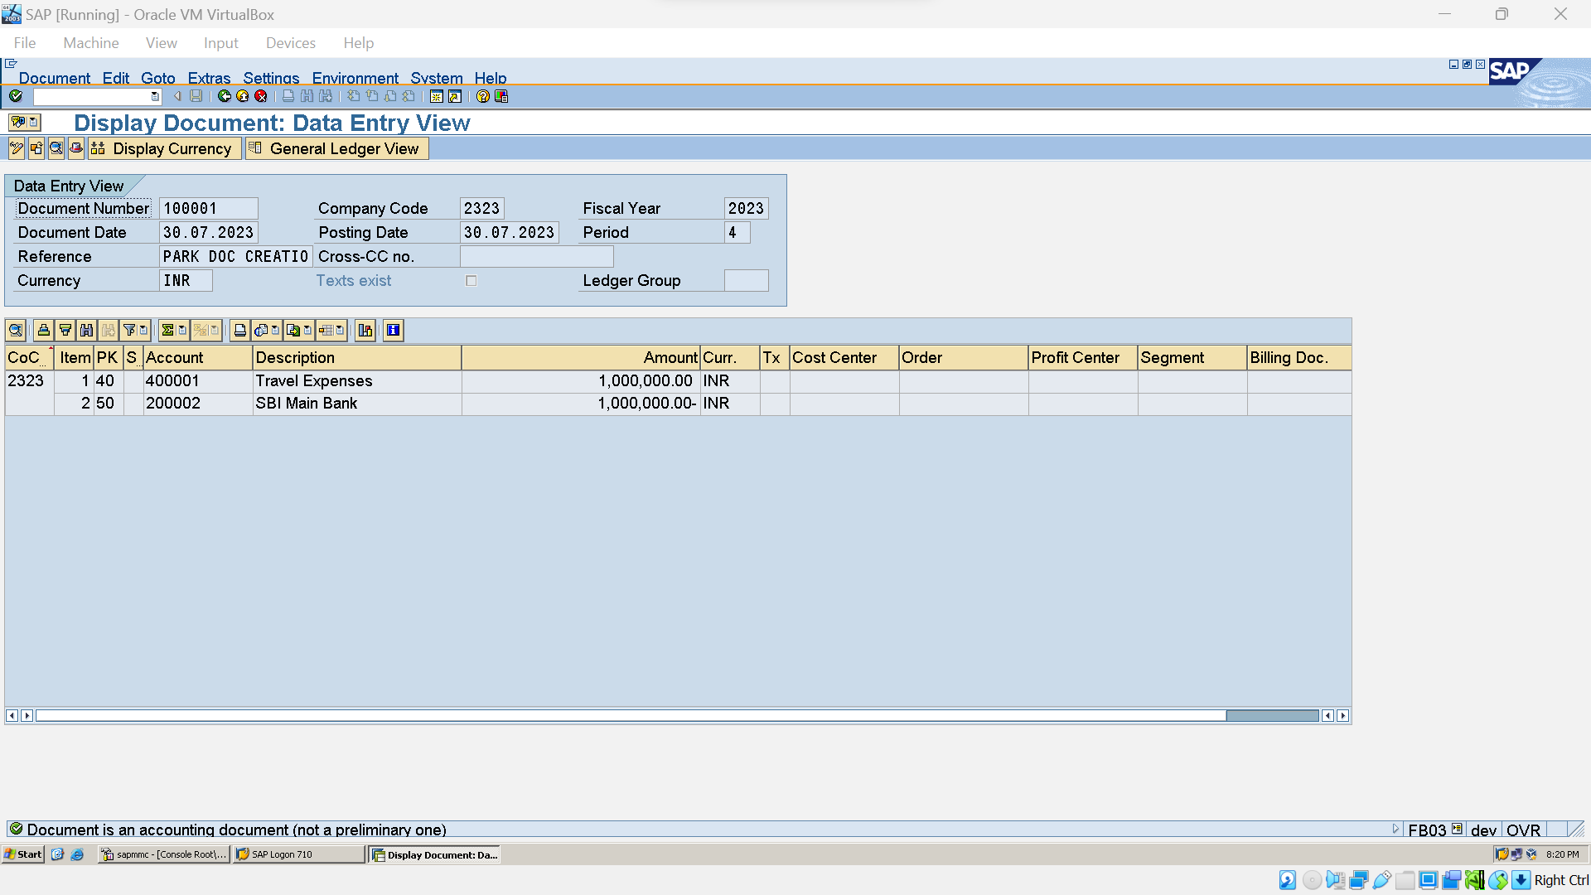

## Accounts Payable:

### Create Vendor A/C grp (OBD3)

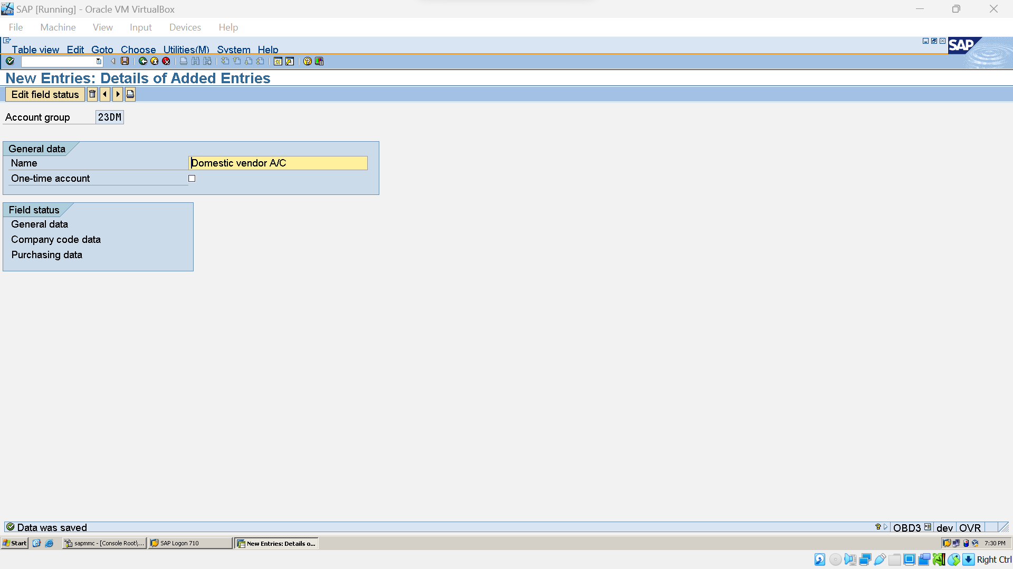

### Create No. Ranges for vendors (XKN1):

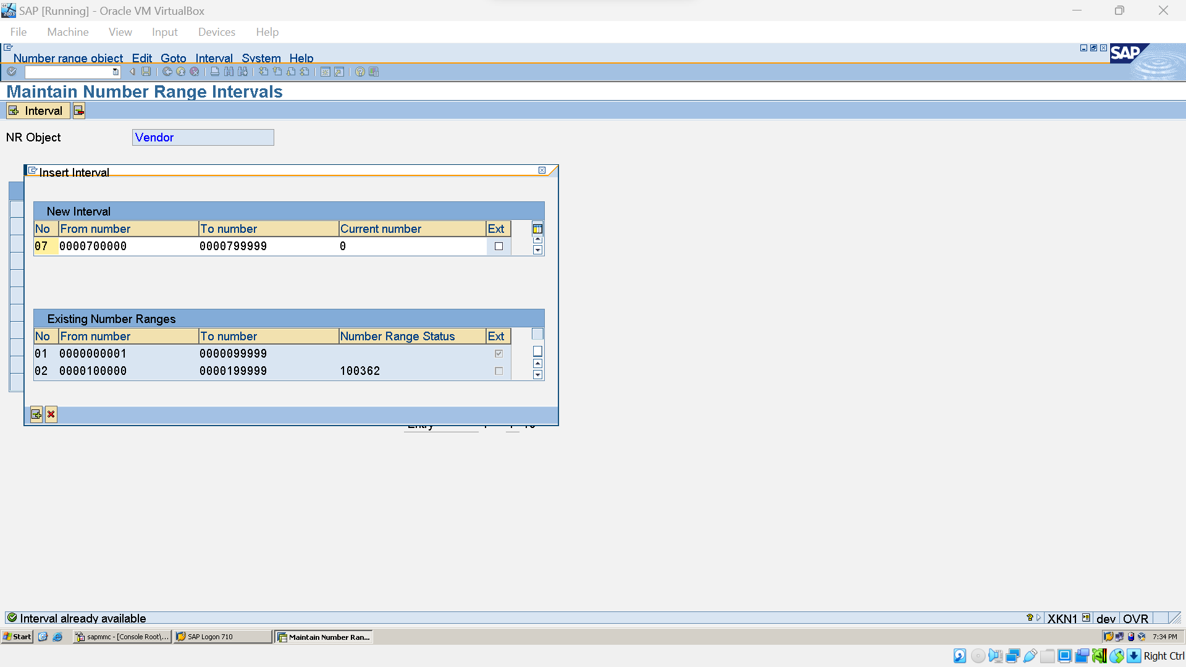

### Assign Vendor A/C groups to No. Ranges(OBAS):

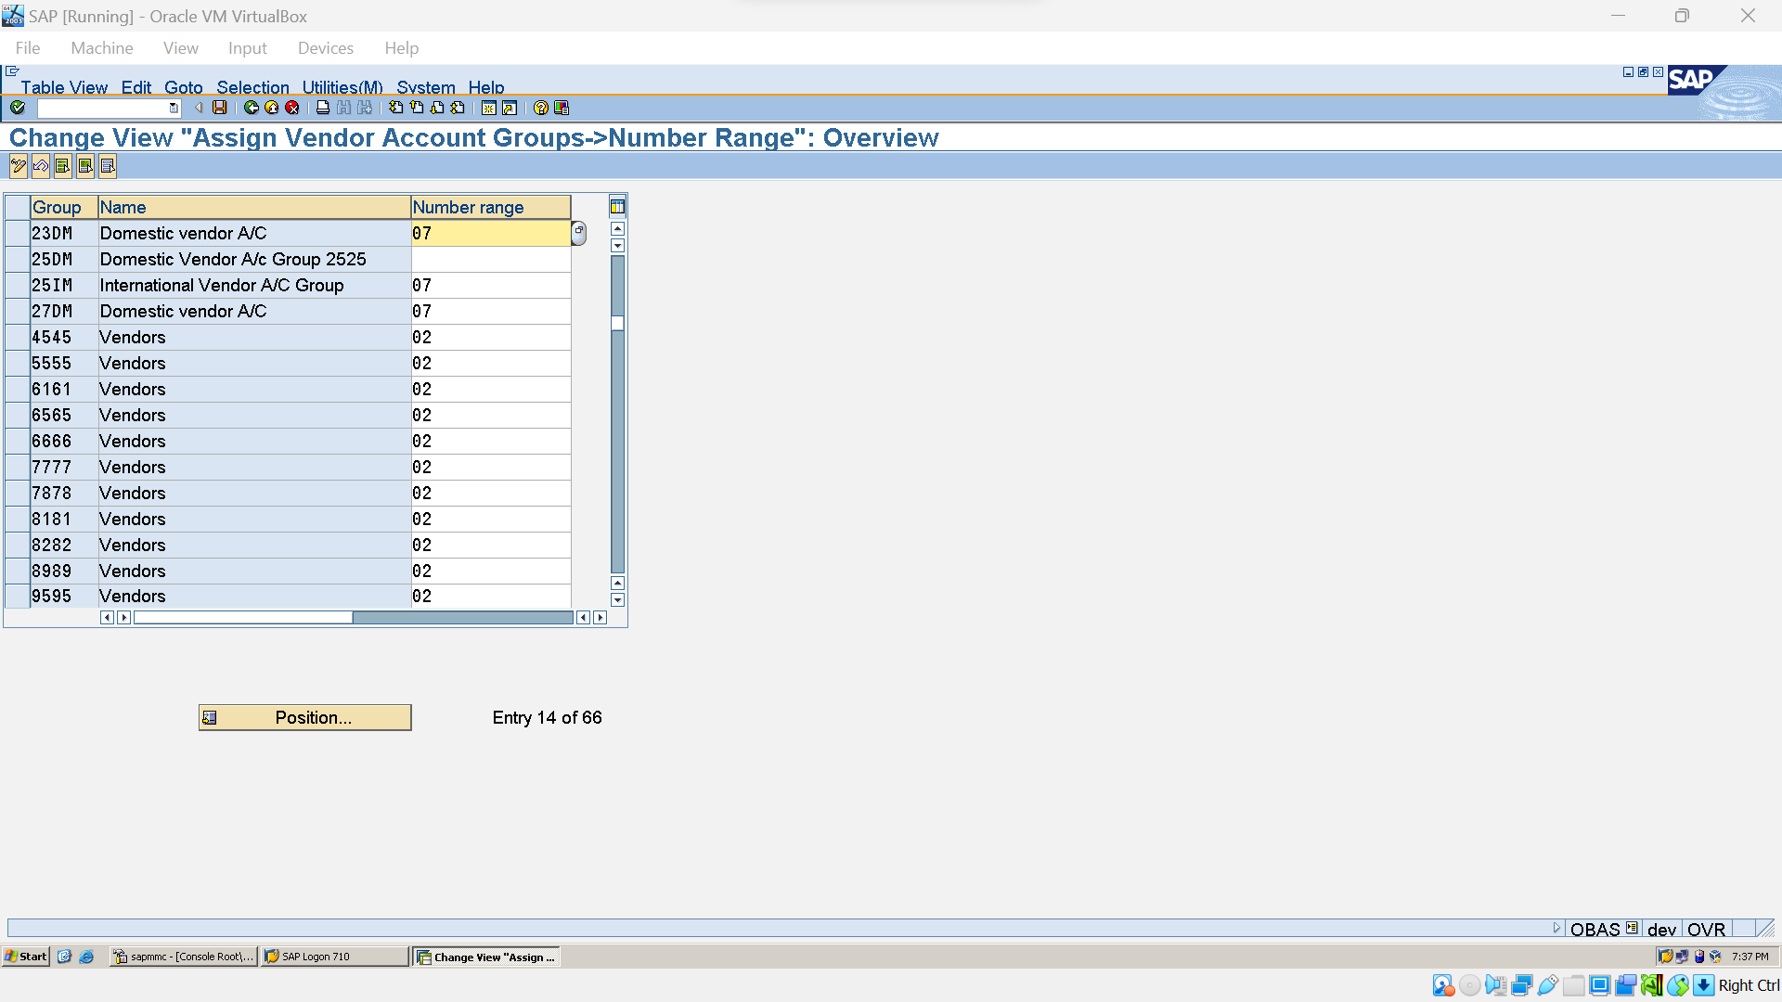

### Create Recoslation G/L For Vendor (FS00)

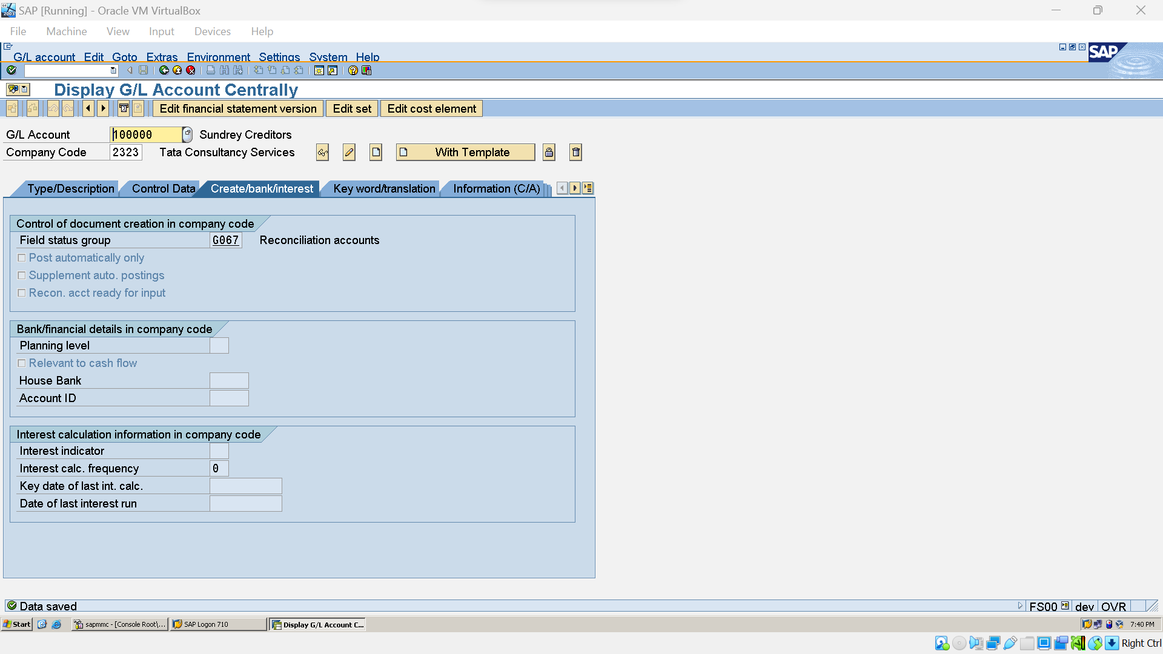

### Create No. Ranges for Vendor Posting (FBN1)

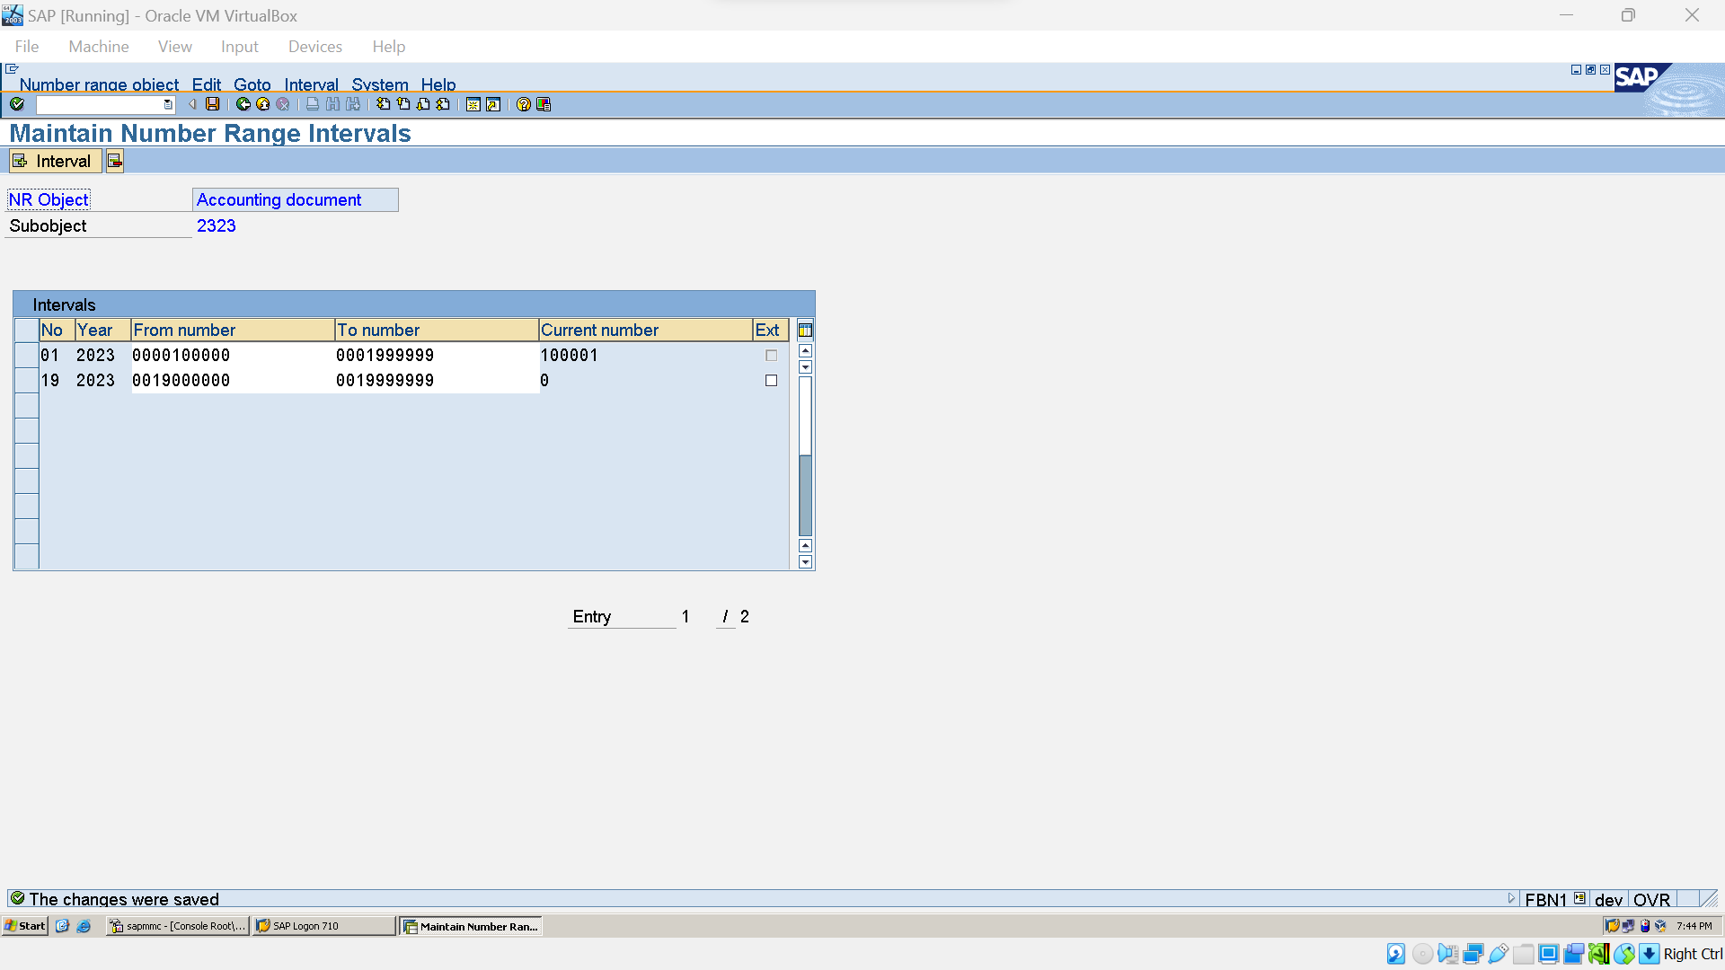

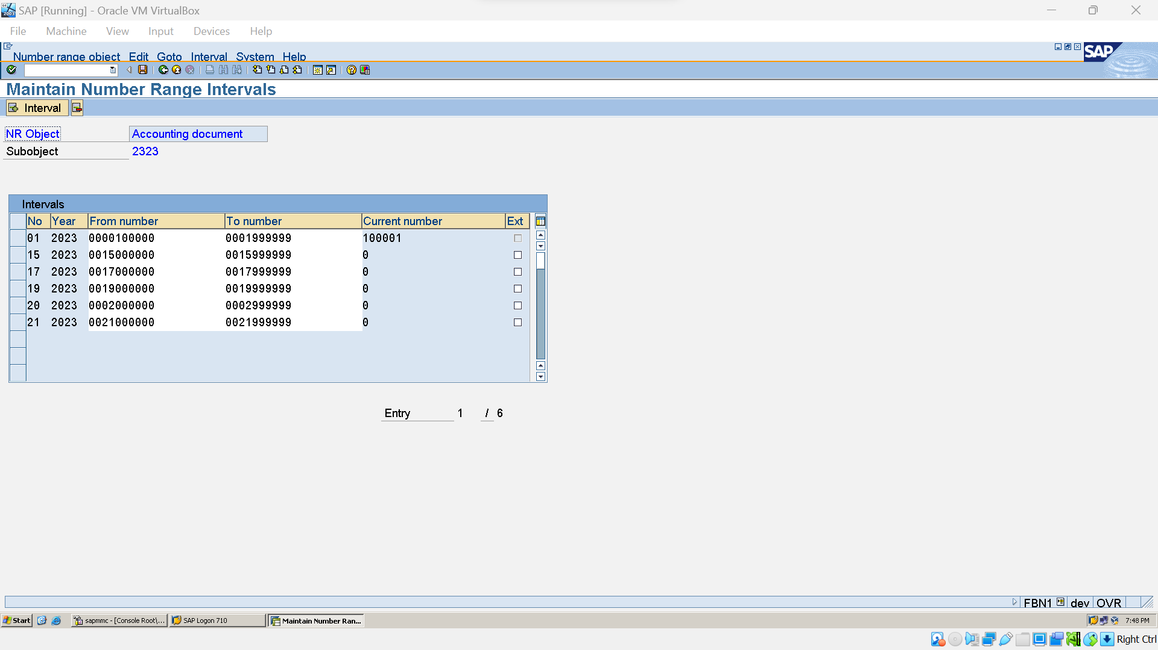

### Create Vendor Master (FK01):

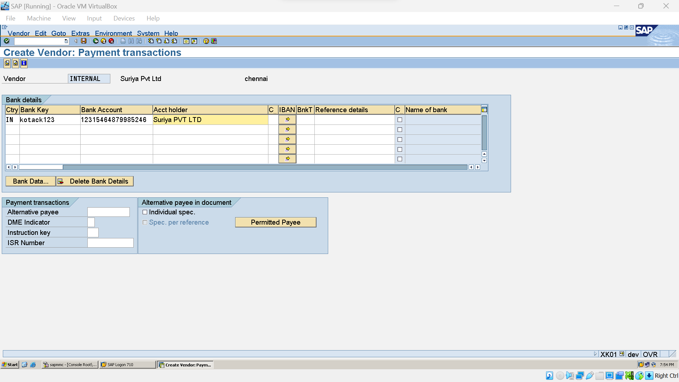



### Posting:

#### Vendor Invoice Posting(FB60):

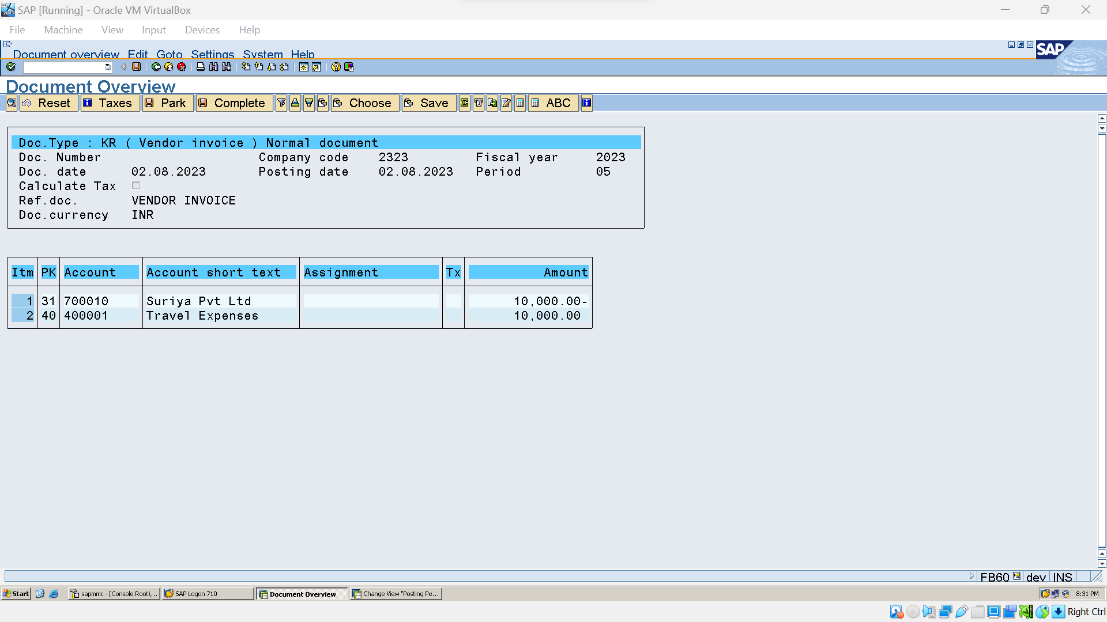



#### Vendor Outgoing Payment (F-53):

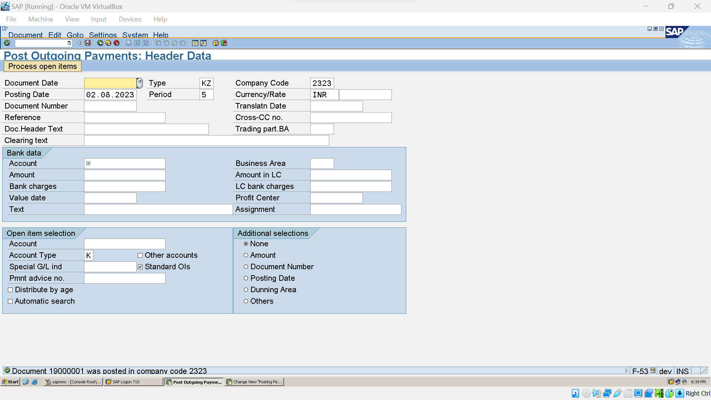

#### Vendor Down Payment Process(F-47):

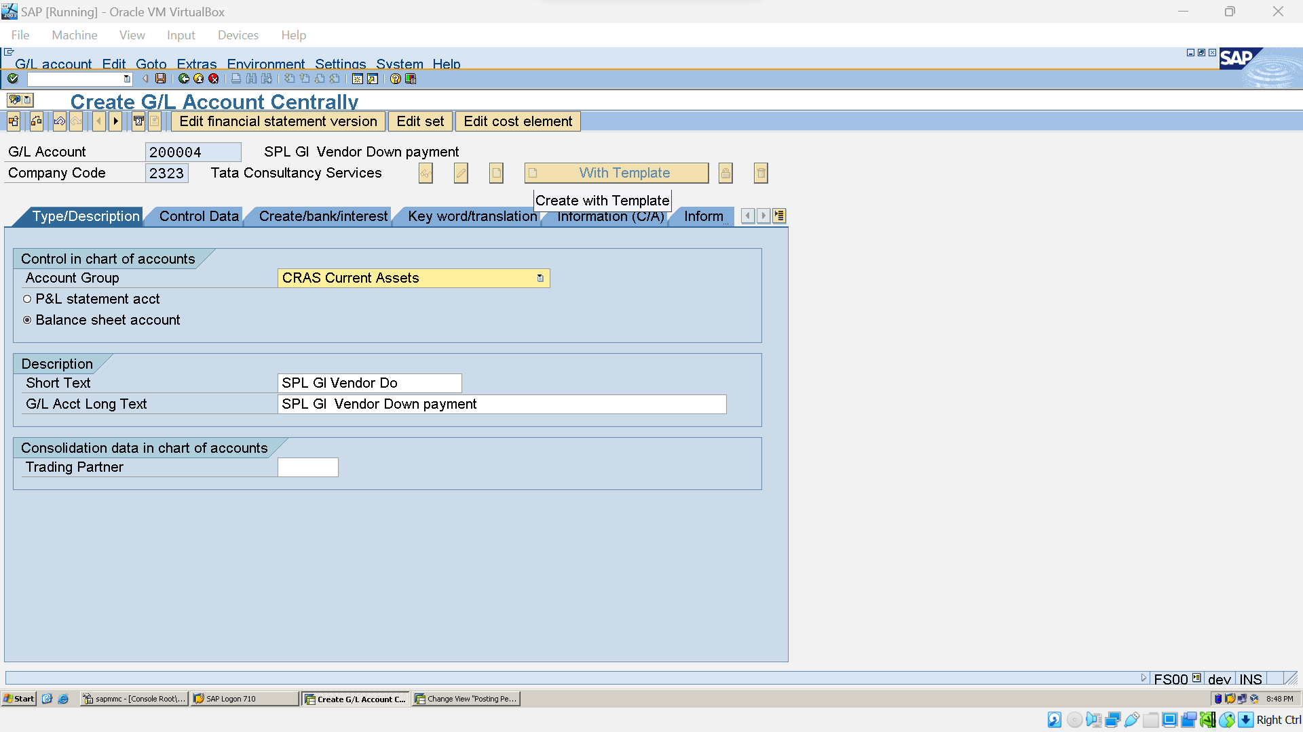

#### Assign Special G/L to reconciliation G/L A/C (OBYR):

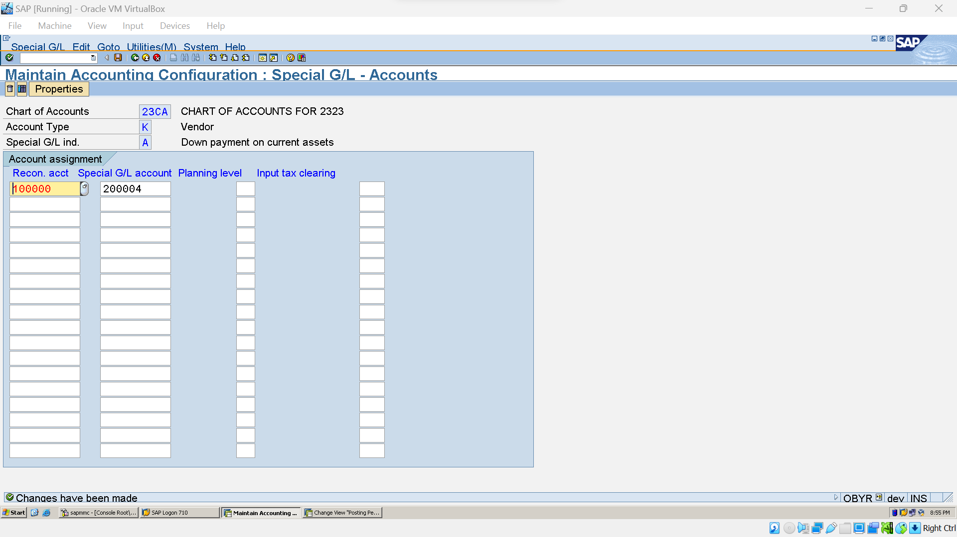

#### Vendor Downpayment Request (f-47):

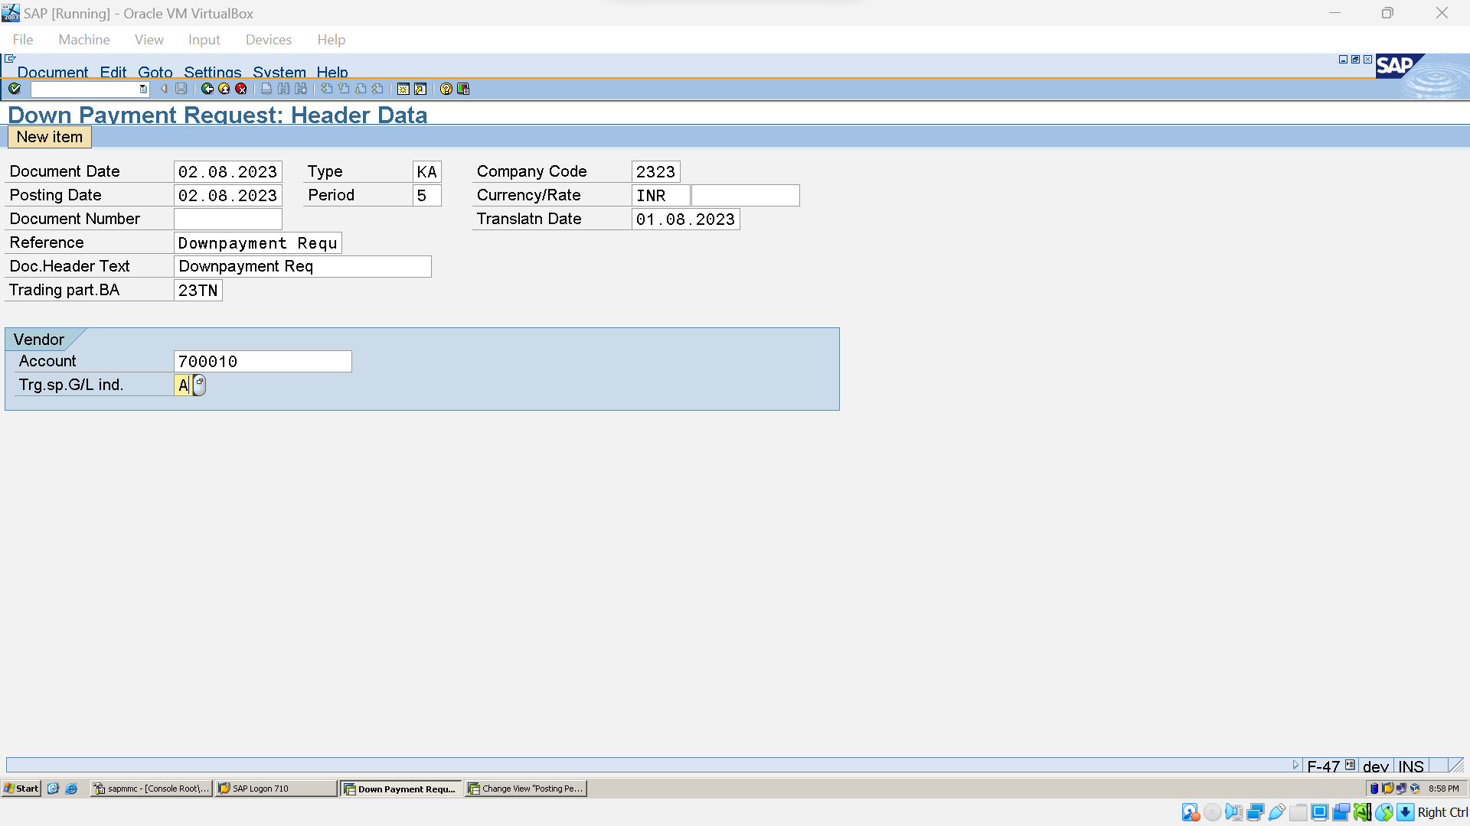

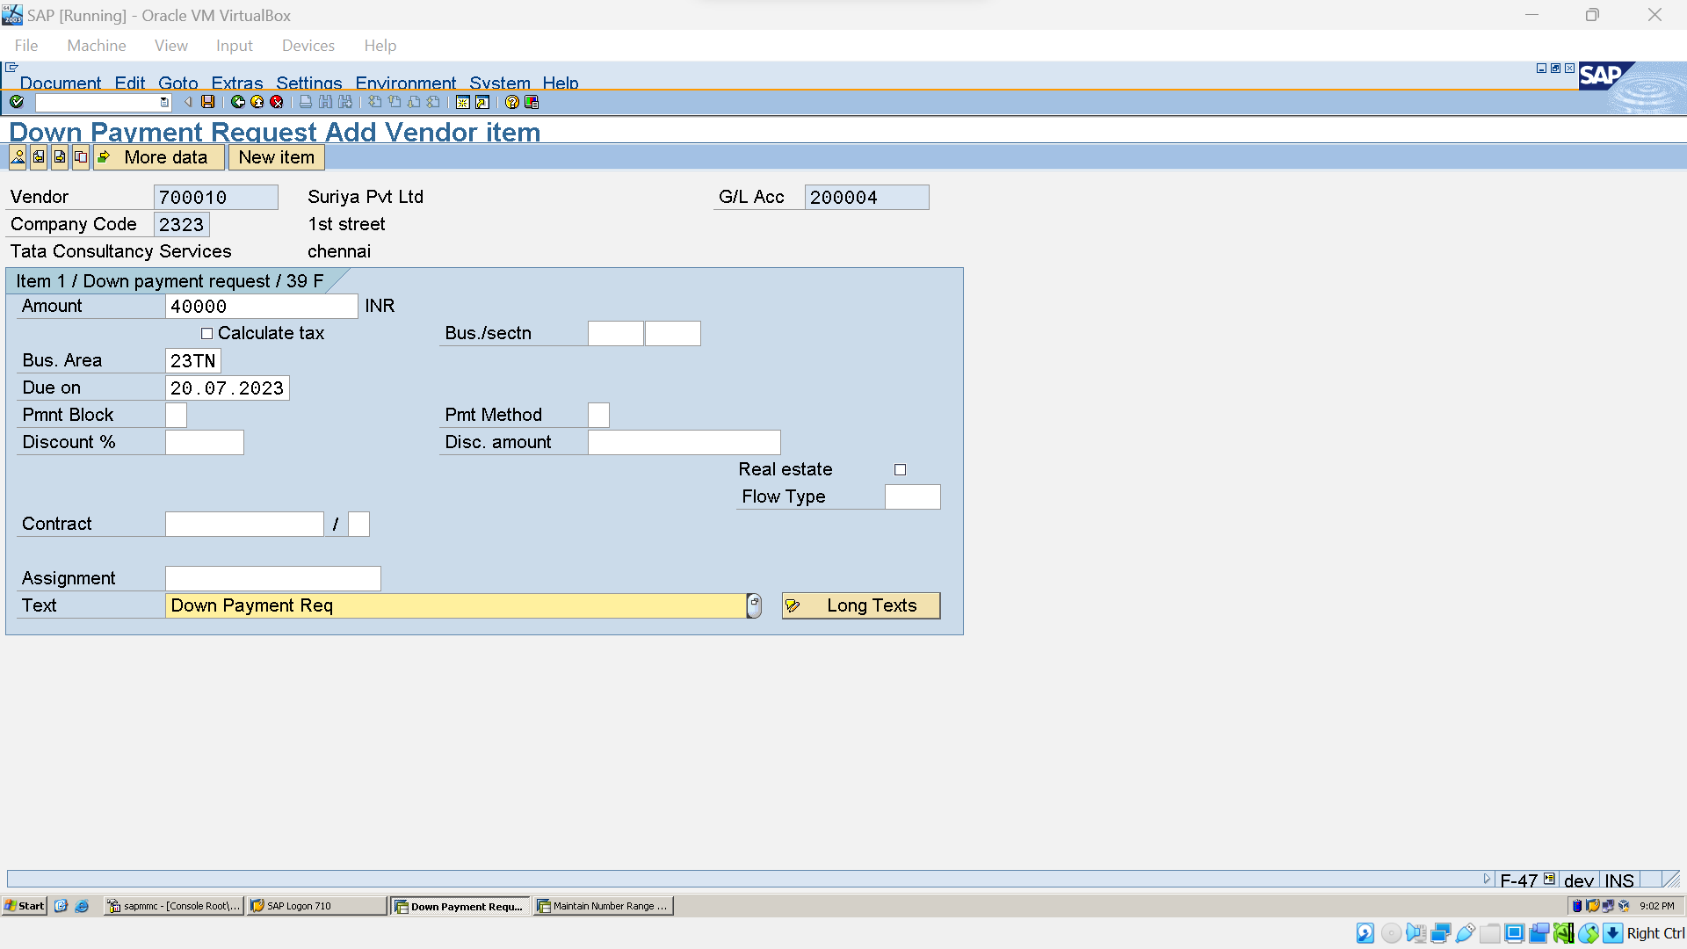



#### Vendor Downpayment post (F-48)

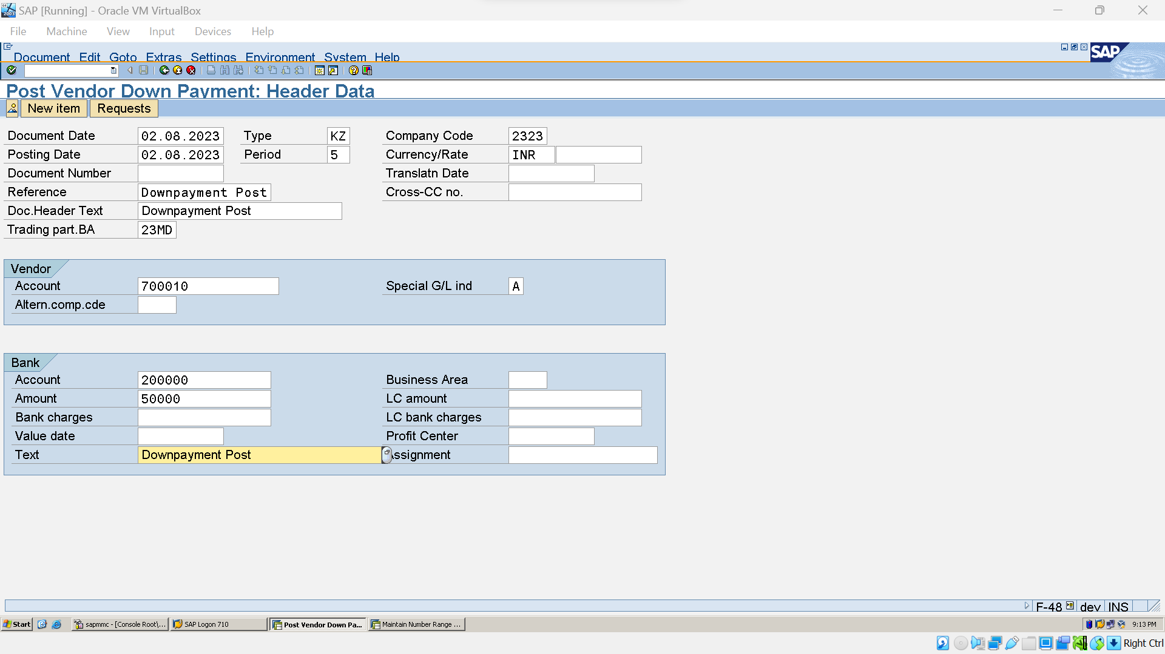

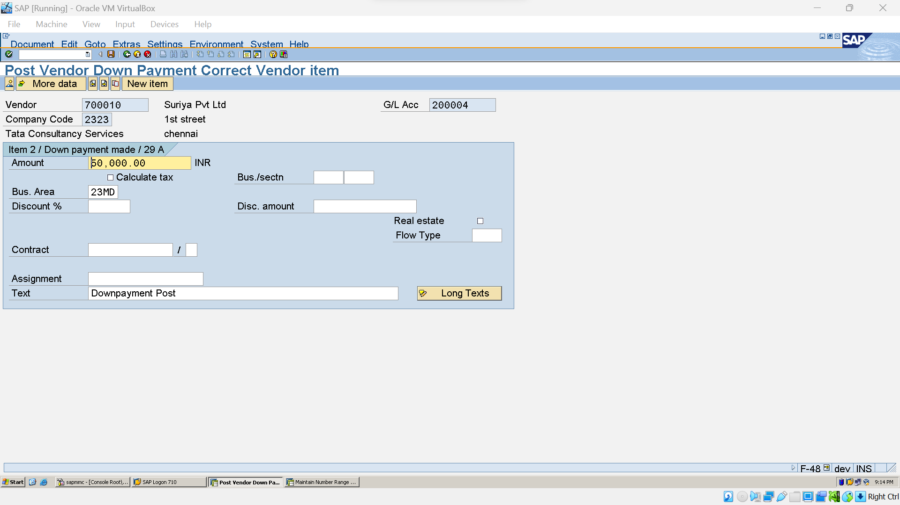



#### Vendor Downpayment Transfer (F-54):

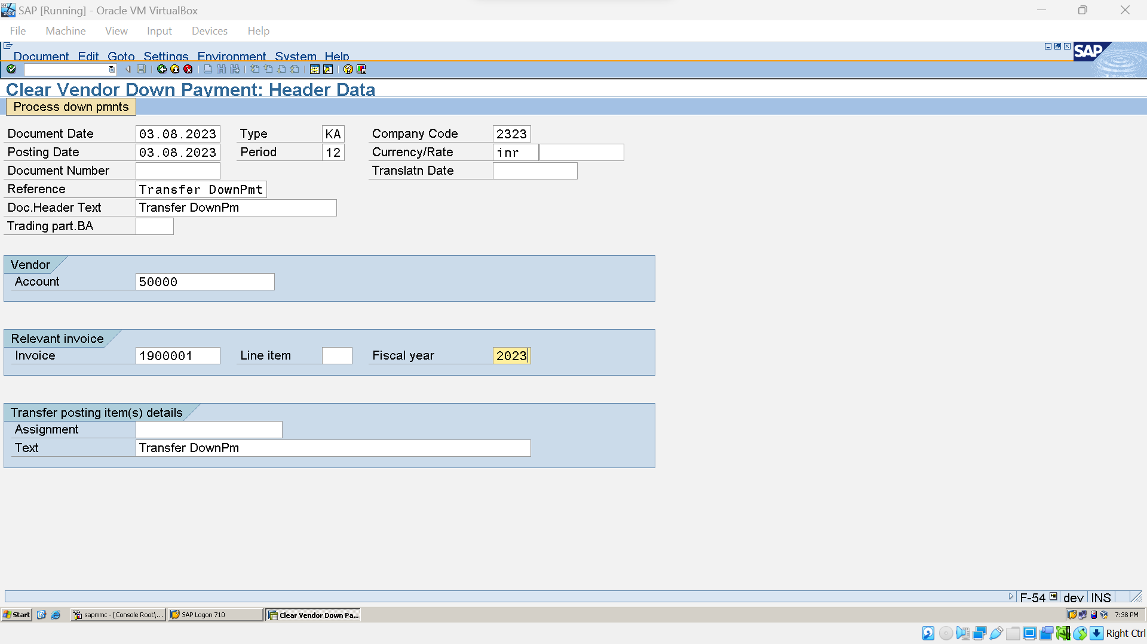

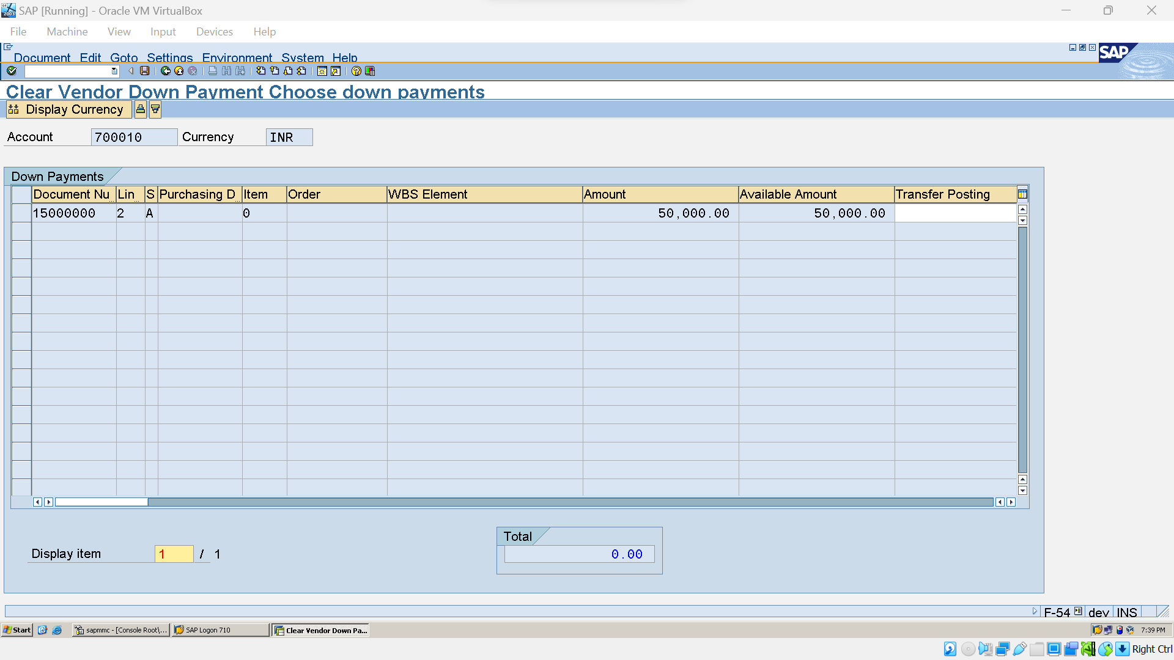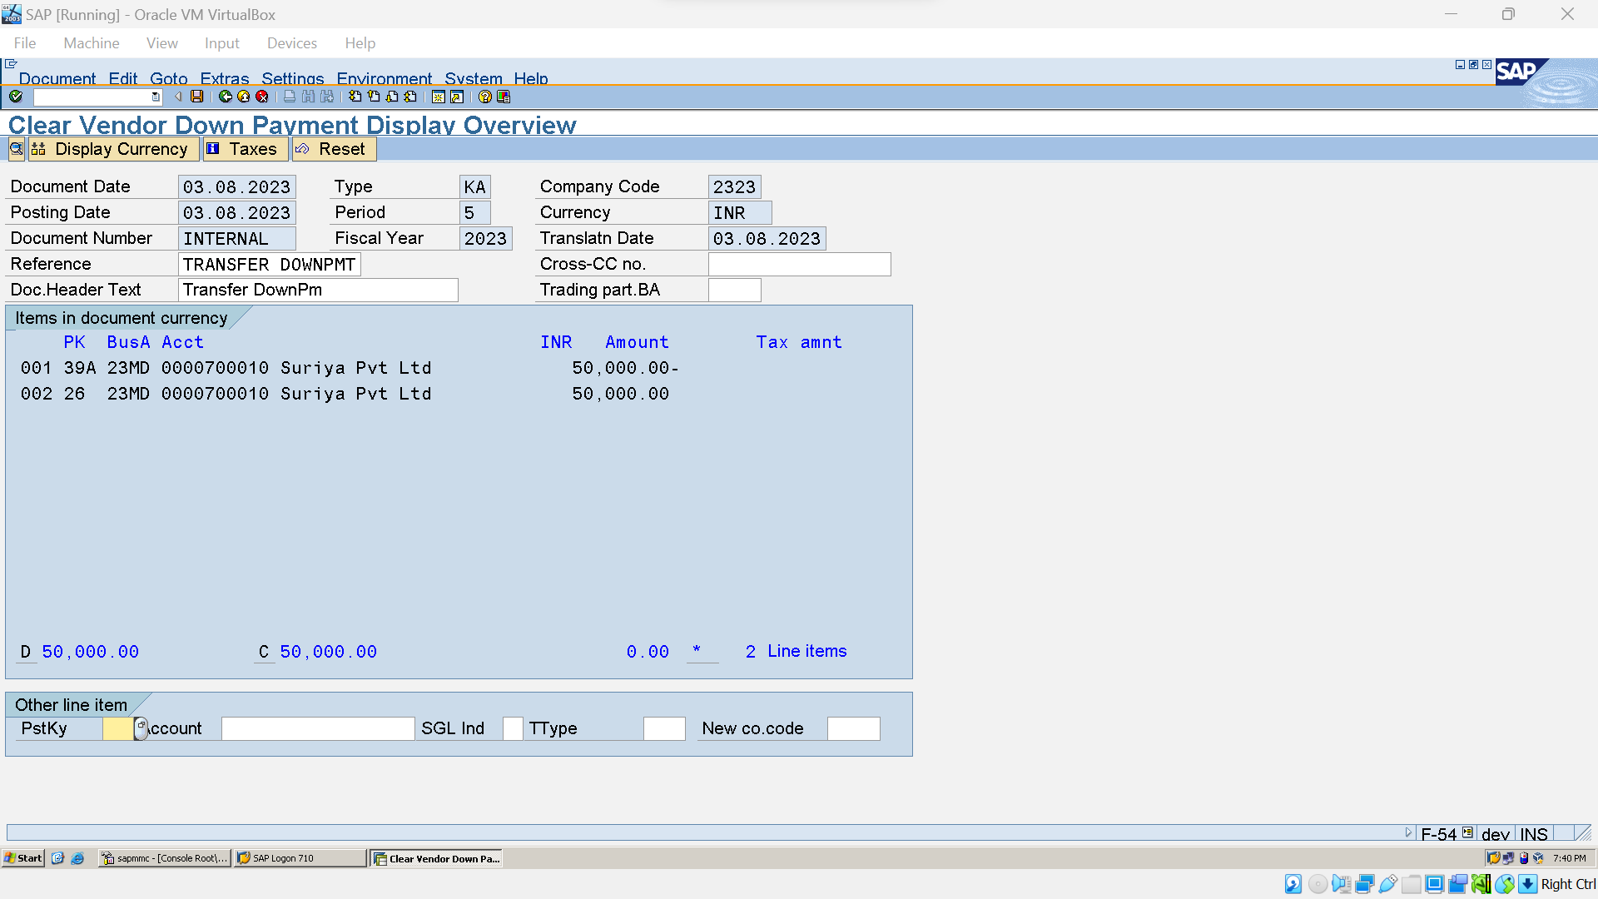

### Vendor Credit Memo:

#### 1.Vendor Inward(FB60):



#### 2.Vendor Credit Memo(FB60):

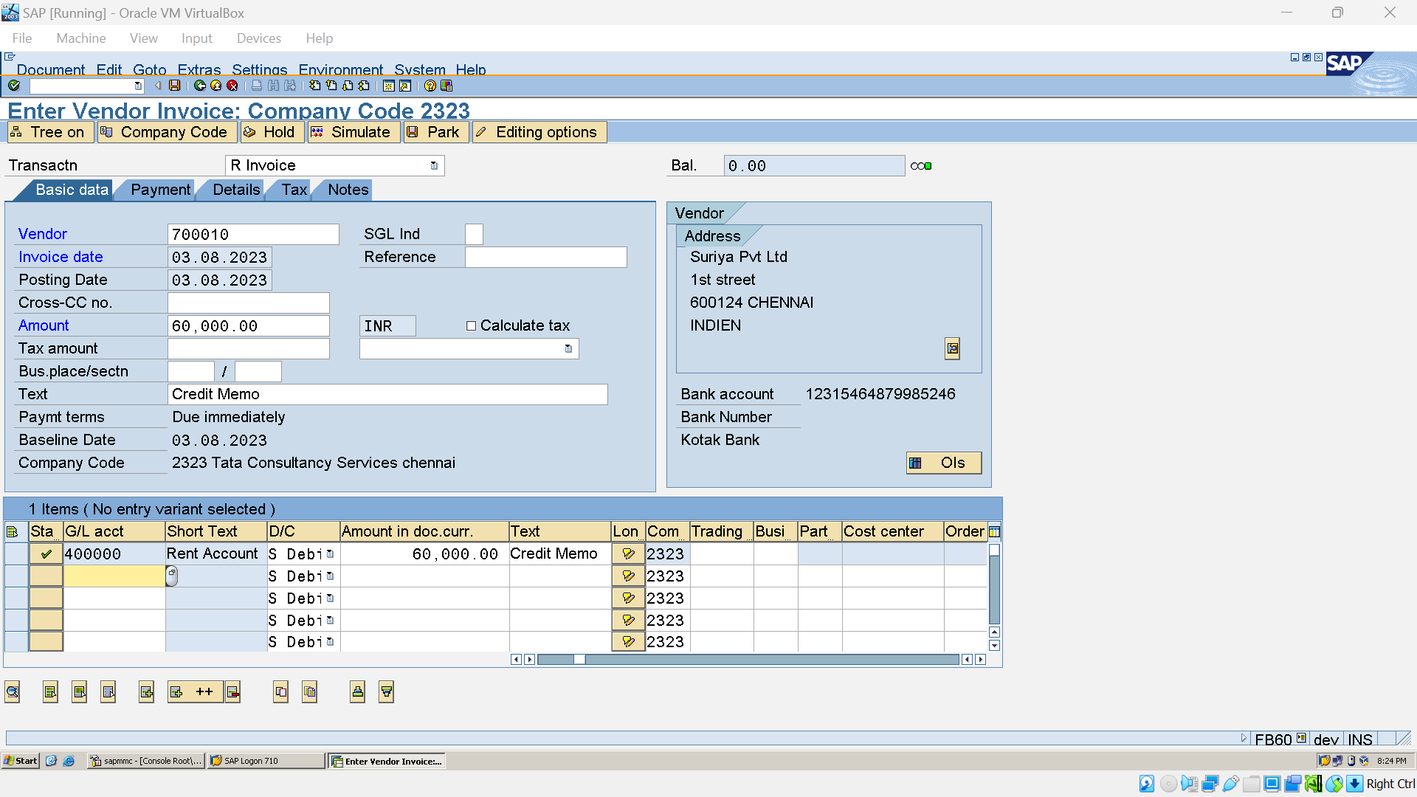

#### Create Vendor Park Doc (FV60):

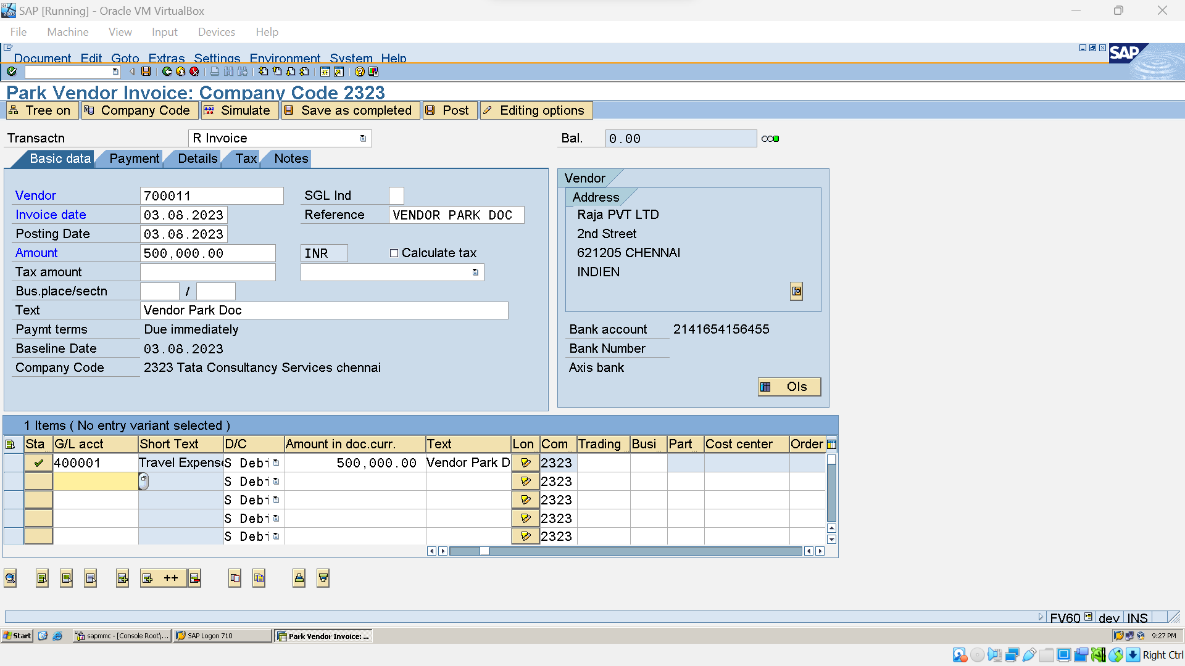

#### Display Vendor Park Doc ( FBL1N)

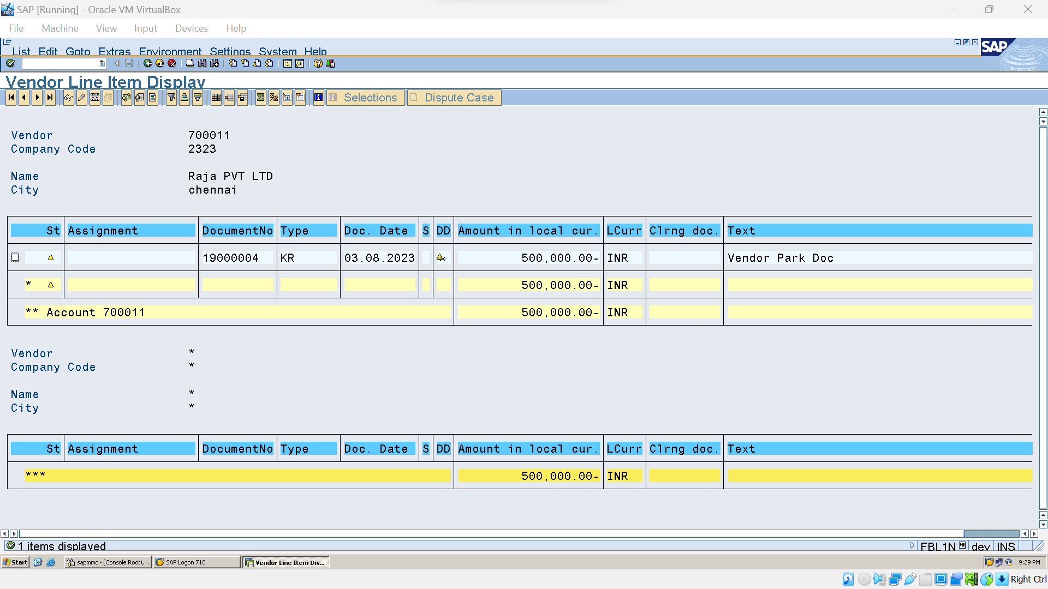

#### Post Vendor Park Doc (FBV0):

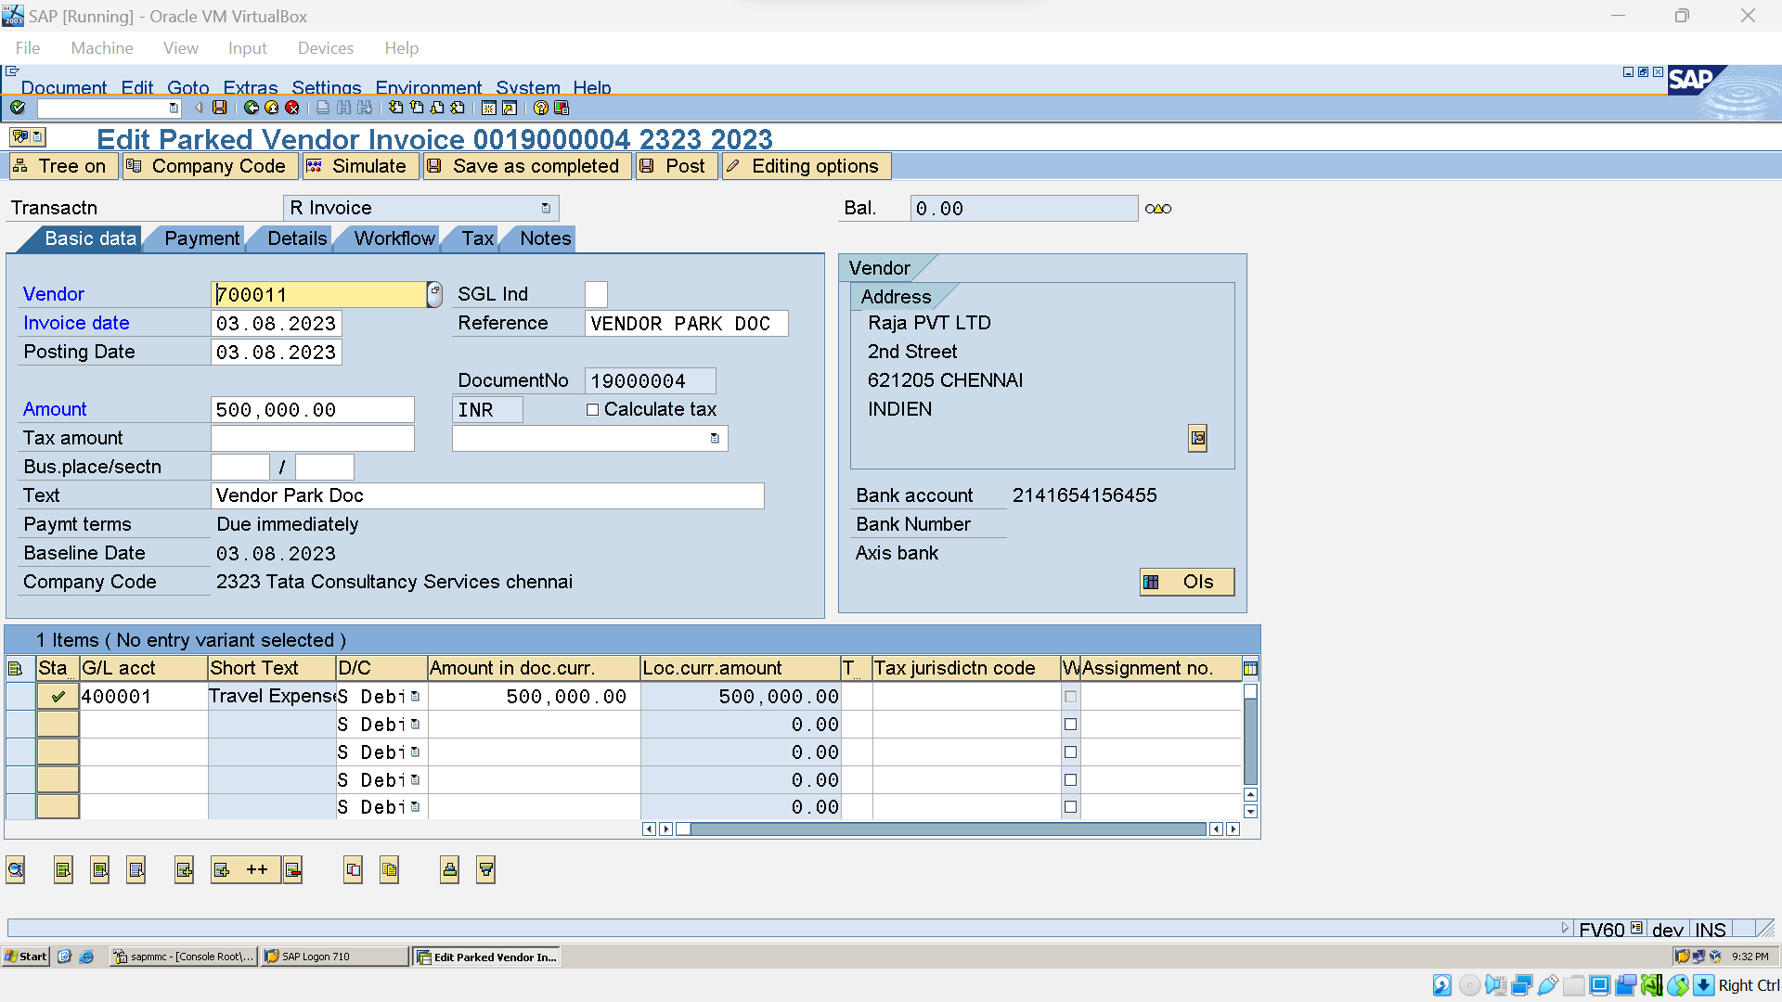

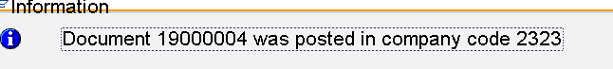

Vendor Invoice (FB60)

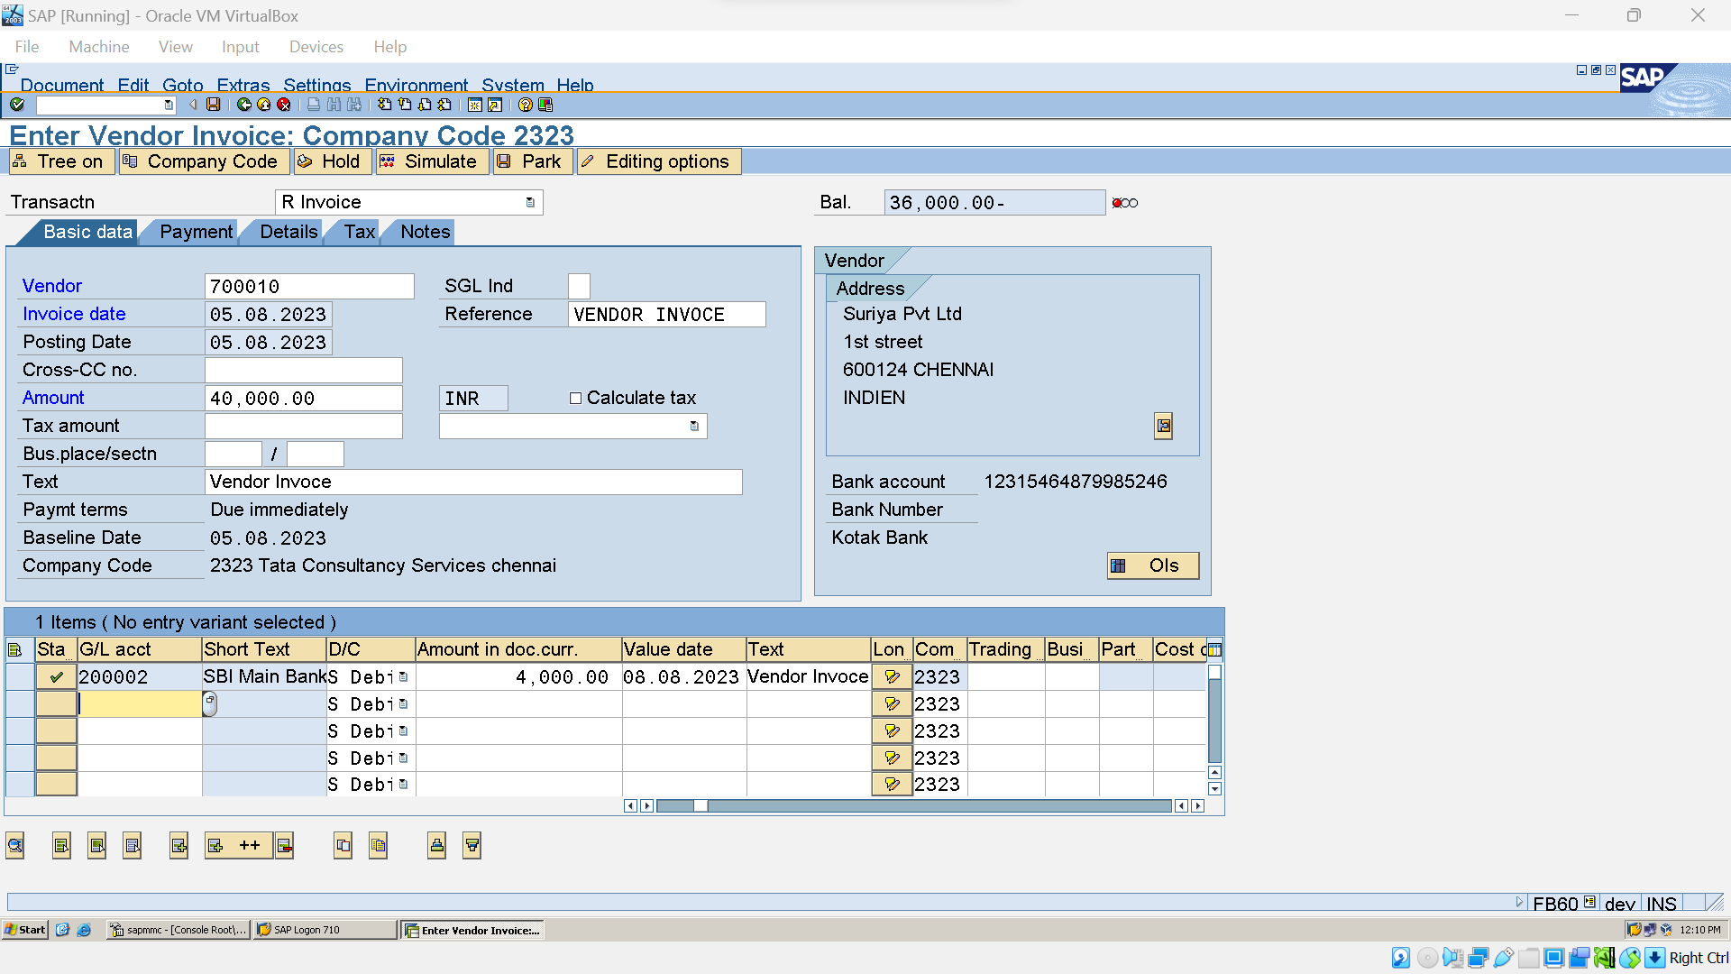



### Instalment Payment:

#### Create Instalment Payment (OBB8):

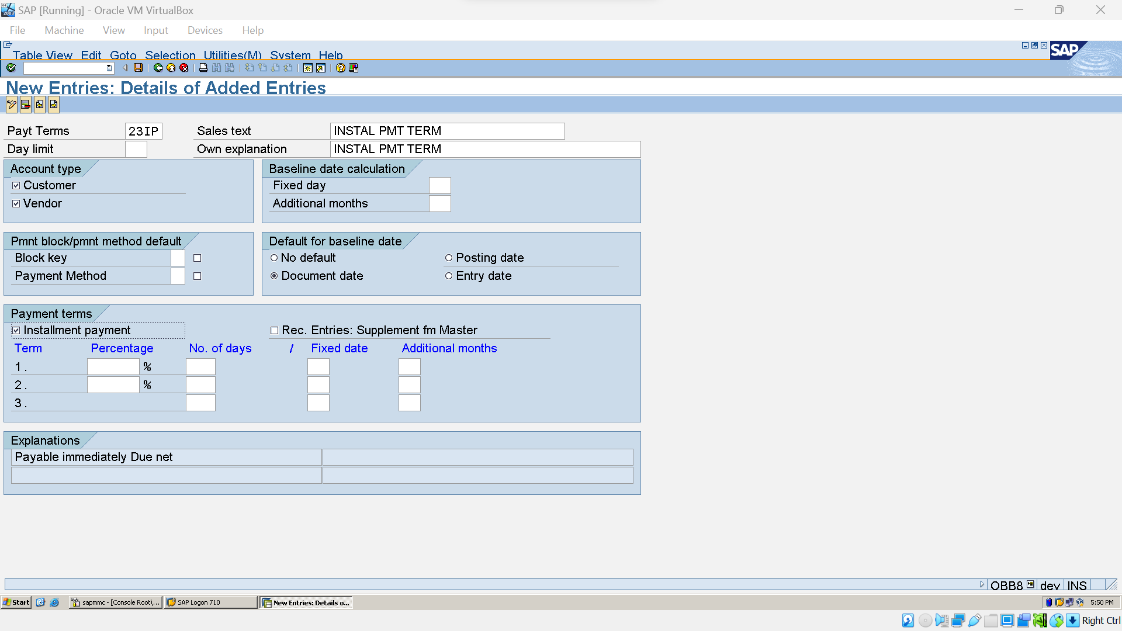



##### Create 50% payment term (OBB8):



#### Assign Payment Term to Installment Payment term (OBB9):

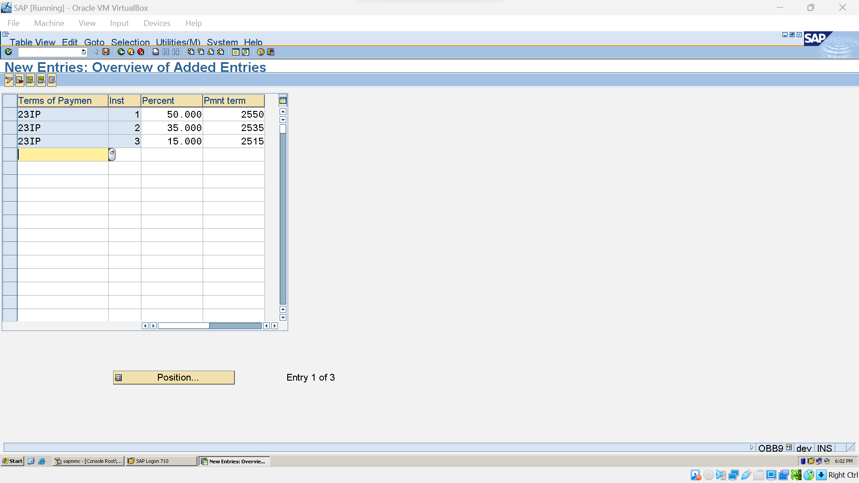

#### Post vendor Invoces (FB60)

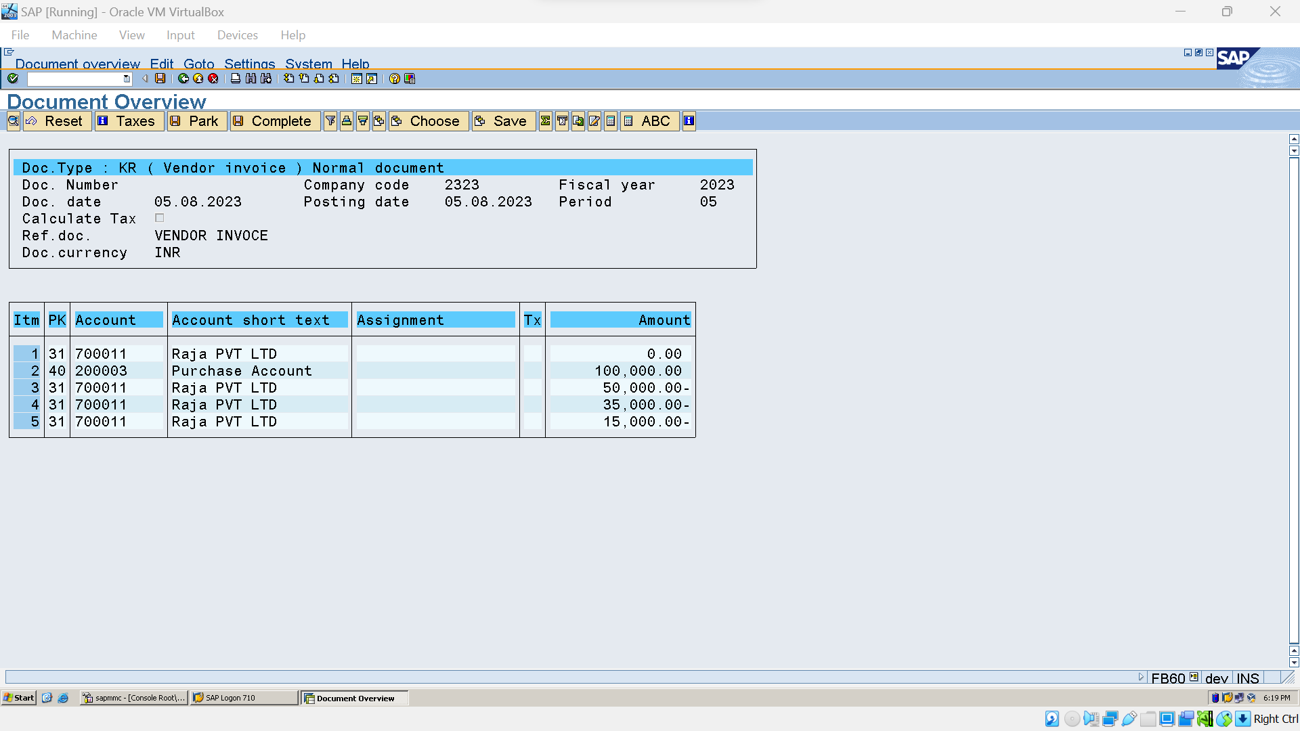



## Accounts Receivable:

### Define Customer A/C: (OBD2)

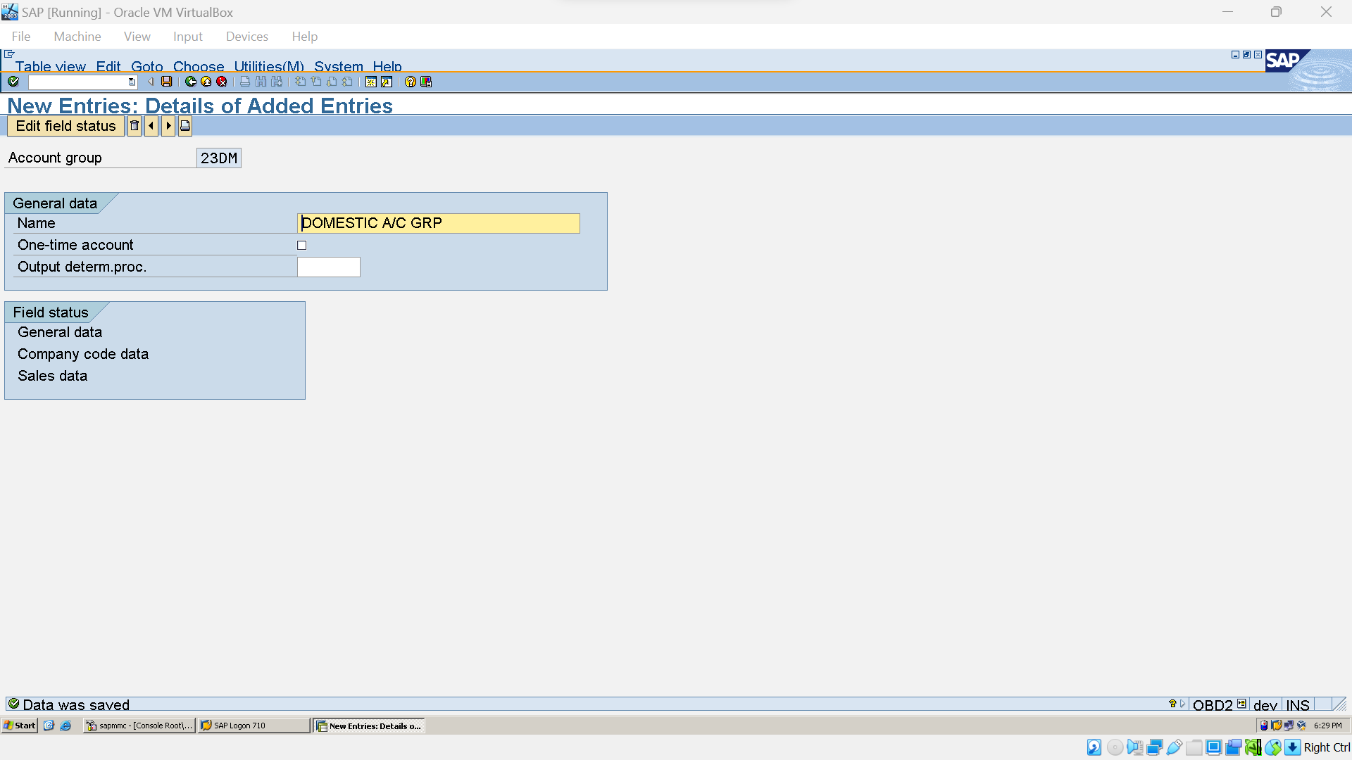

### Create No. Ranges for Customers (XDN1):

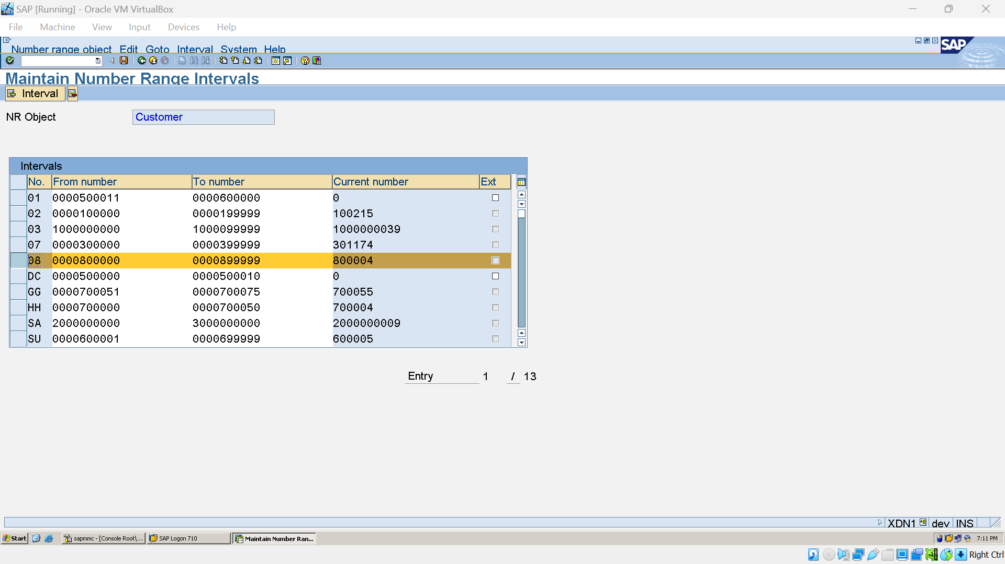

### Assign Customer A/C Grp to No. ranges (OBAR):

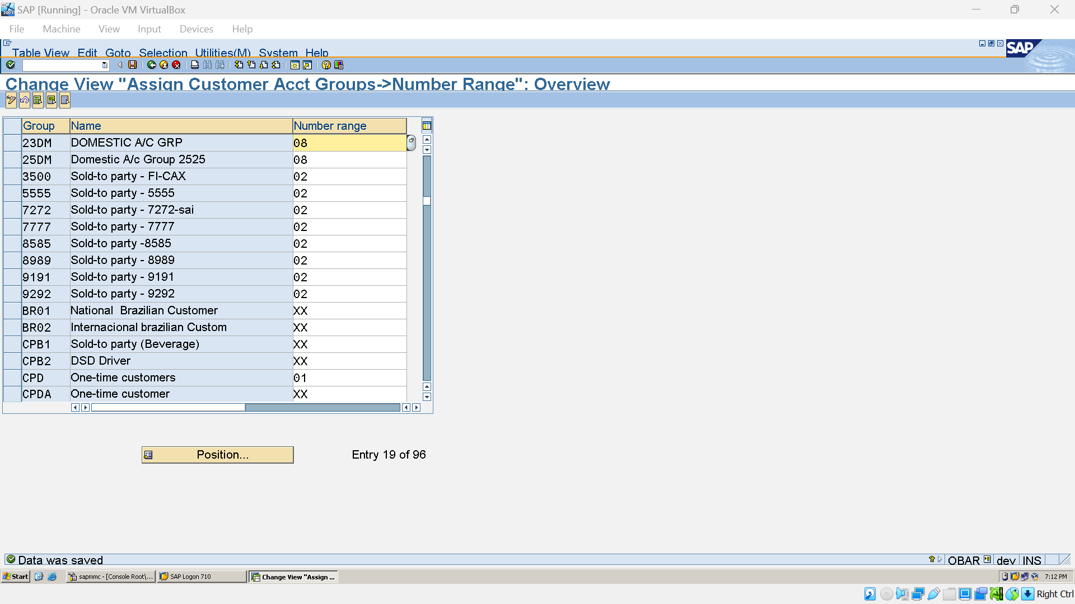

### Create Reconciliation G/L A/C from Customers (FS00):

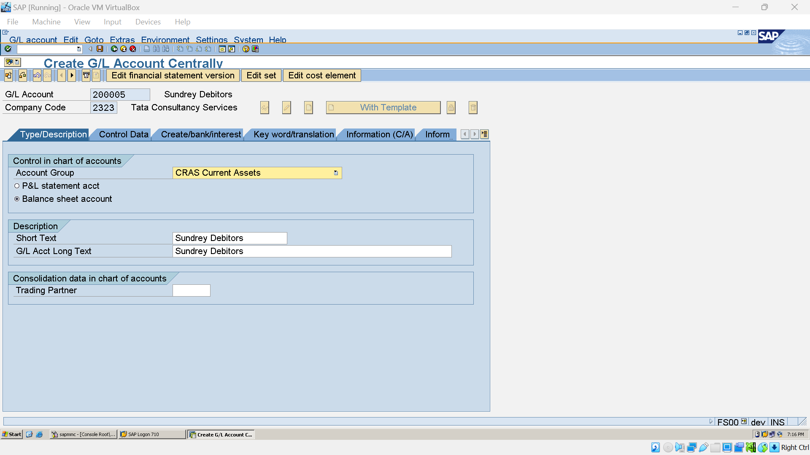

### Create No. Ranges for Customers Postings (OBA7)(FBN1):

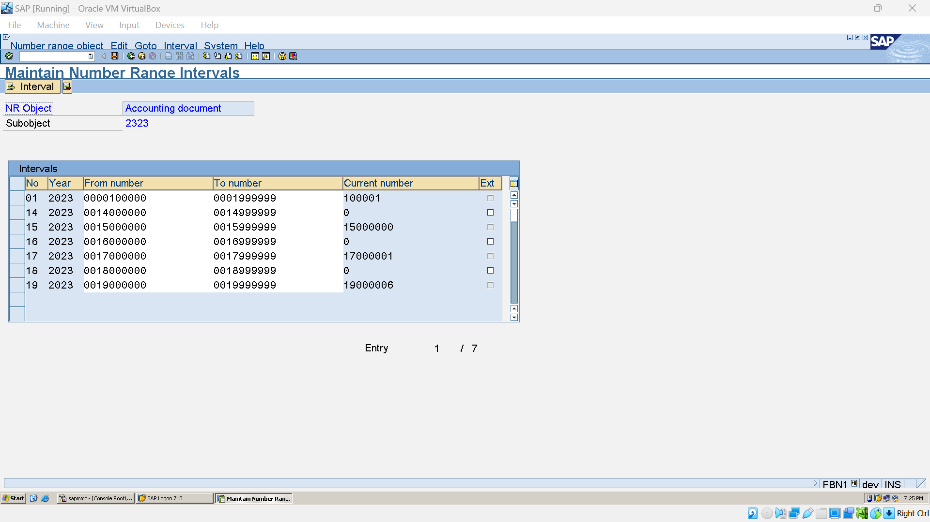

### Create Customer Master (FD01)

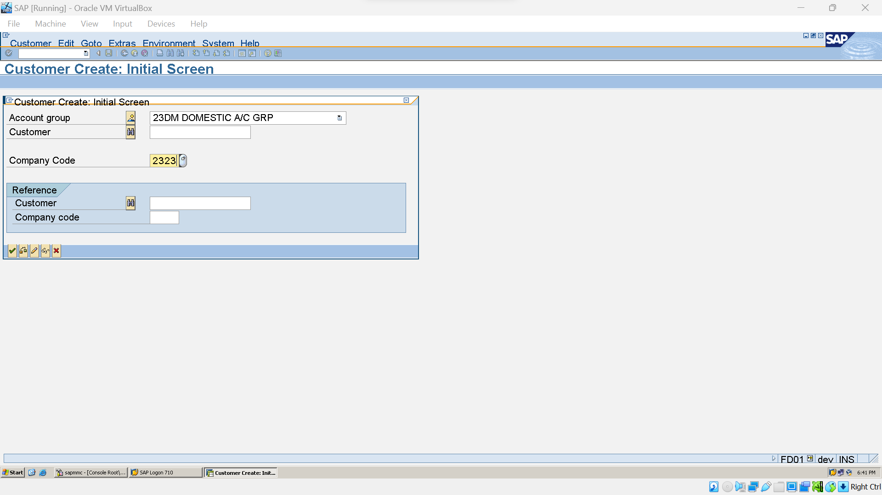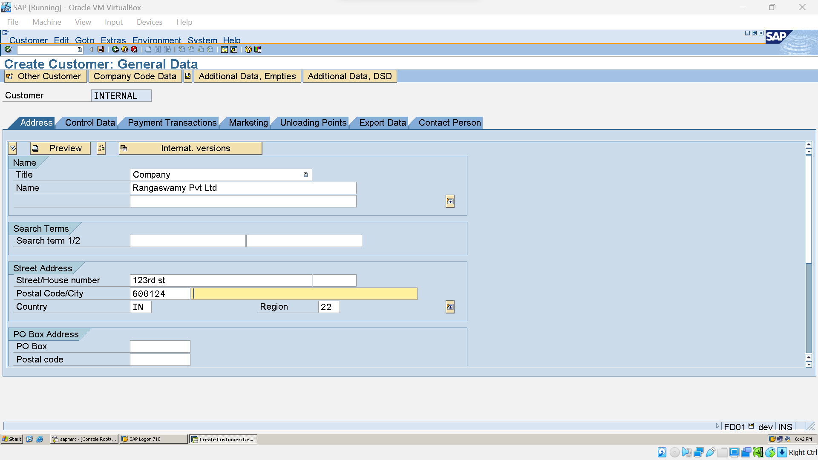

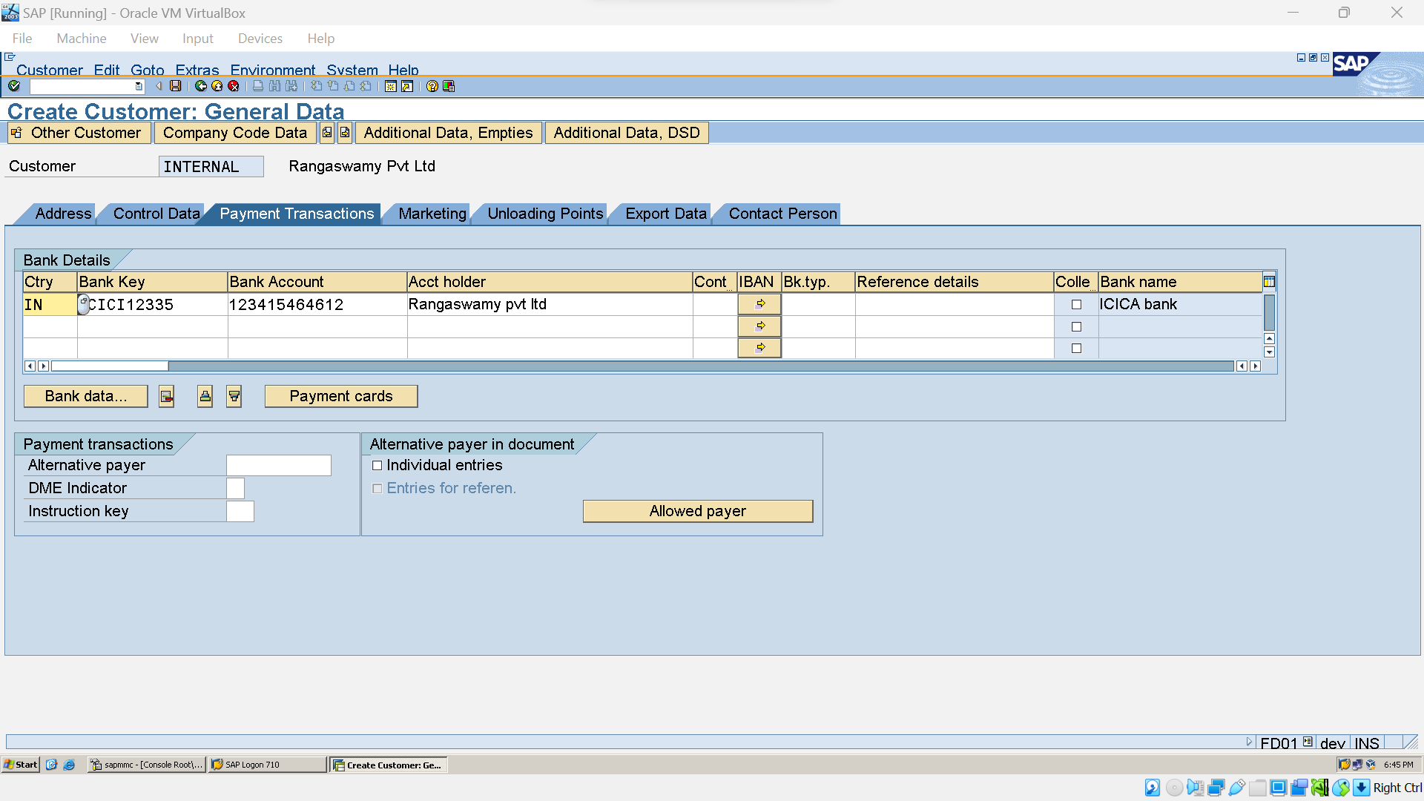

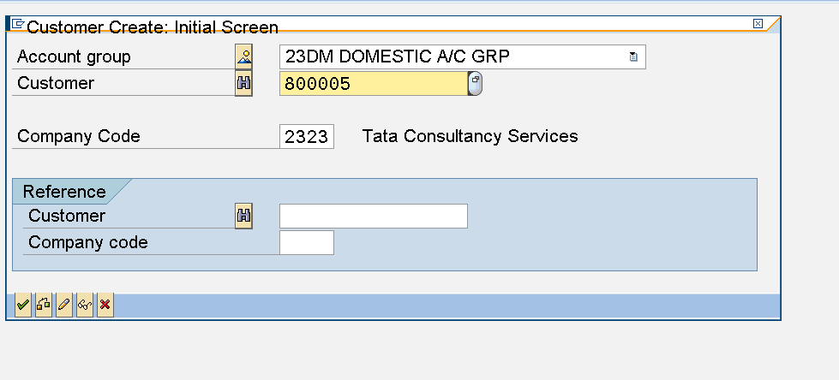

### Customer Invoice Posting (FB70)

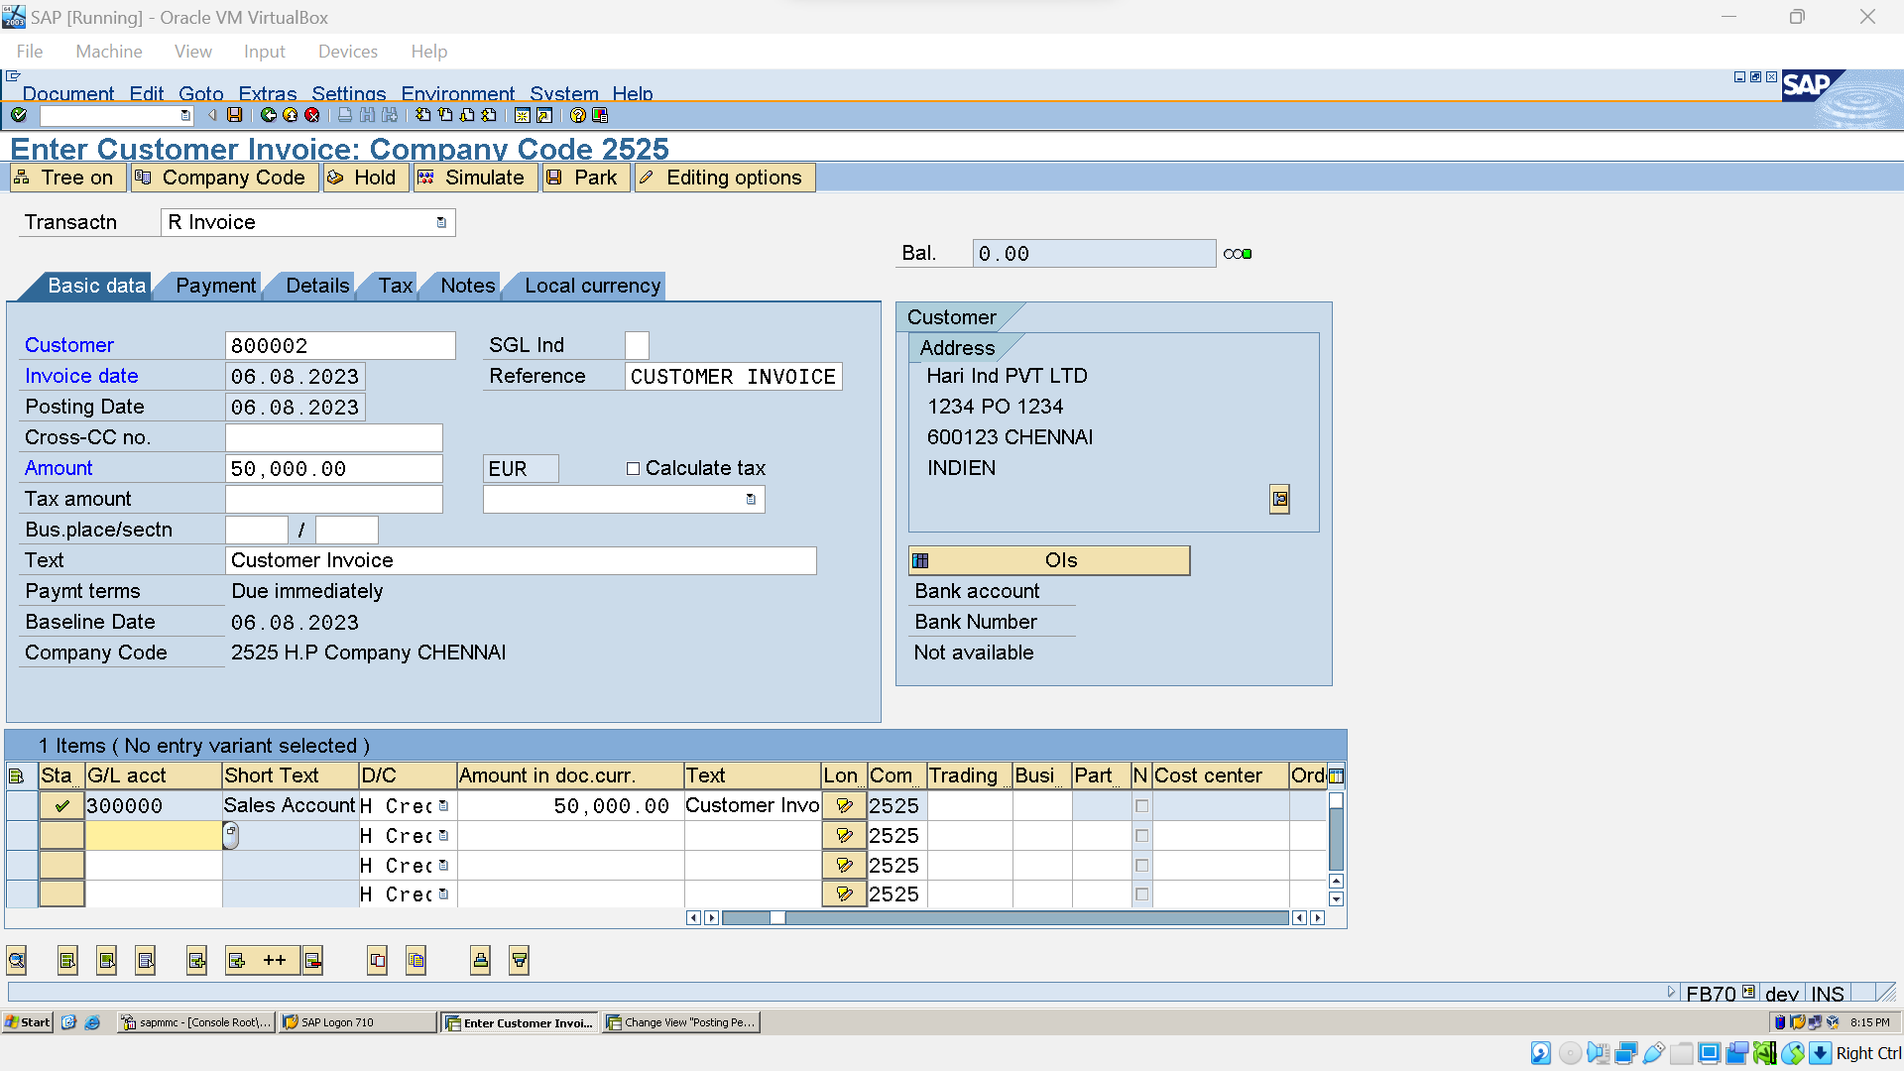

Create G/L A/Cs for Input & Output Postings 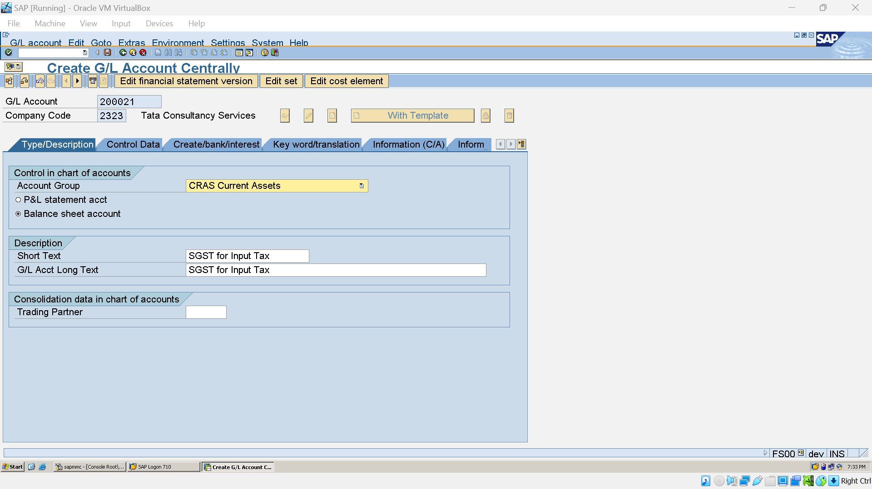

Create Condition Types (OBQ1) 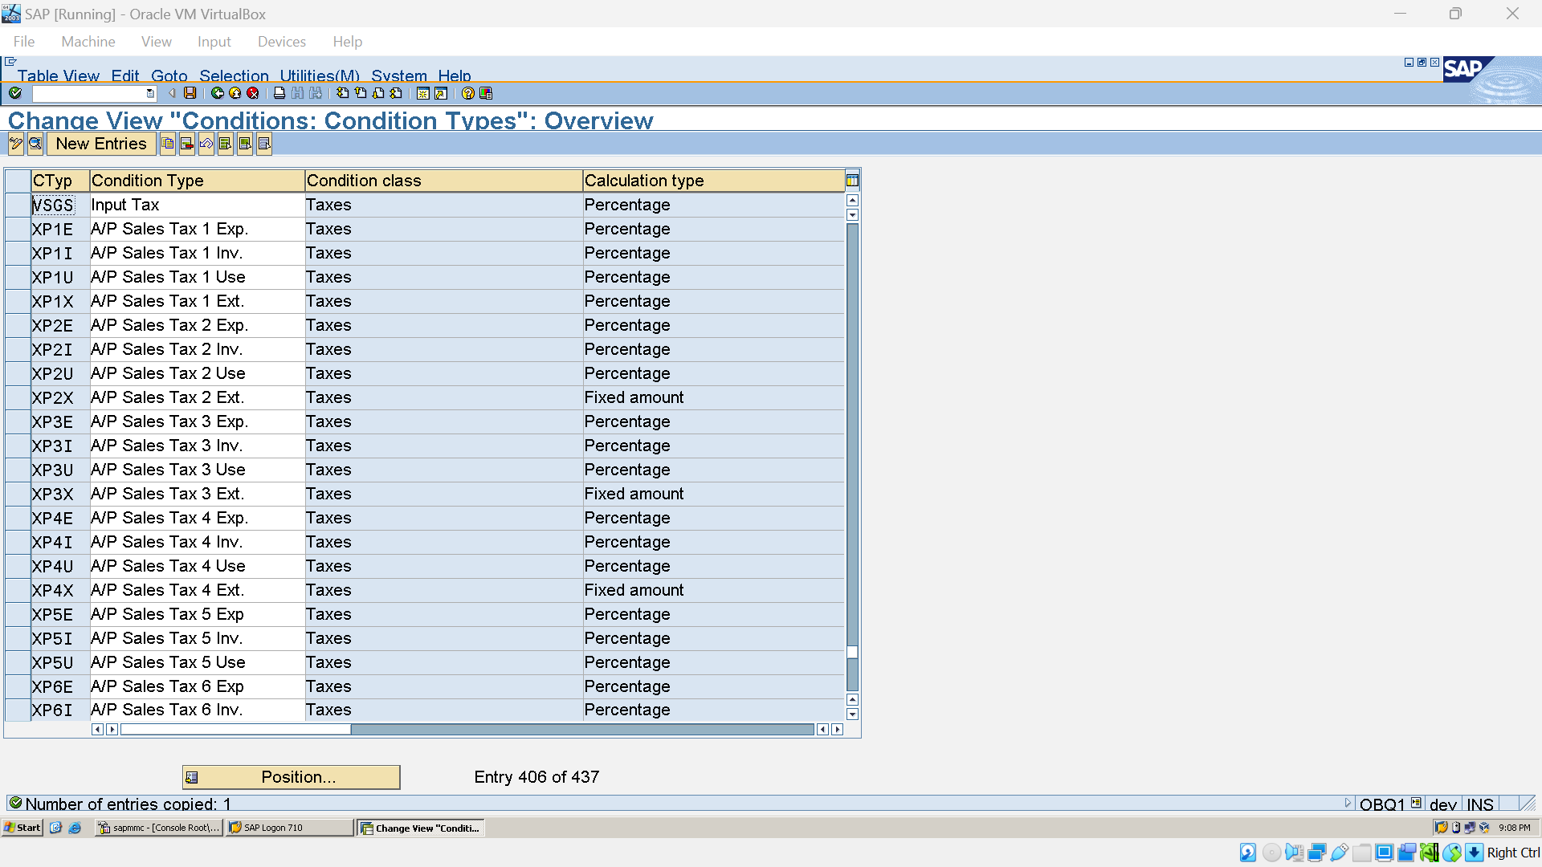

### Create Transcation Types ( OBCN):

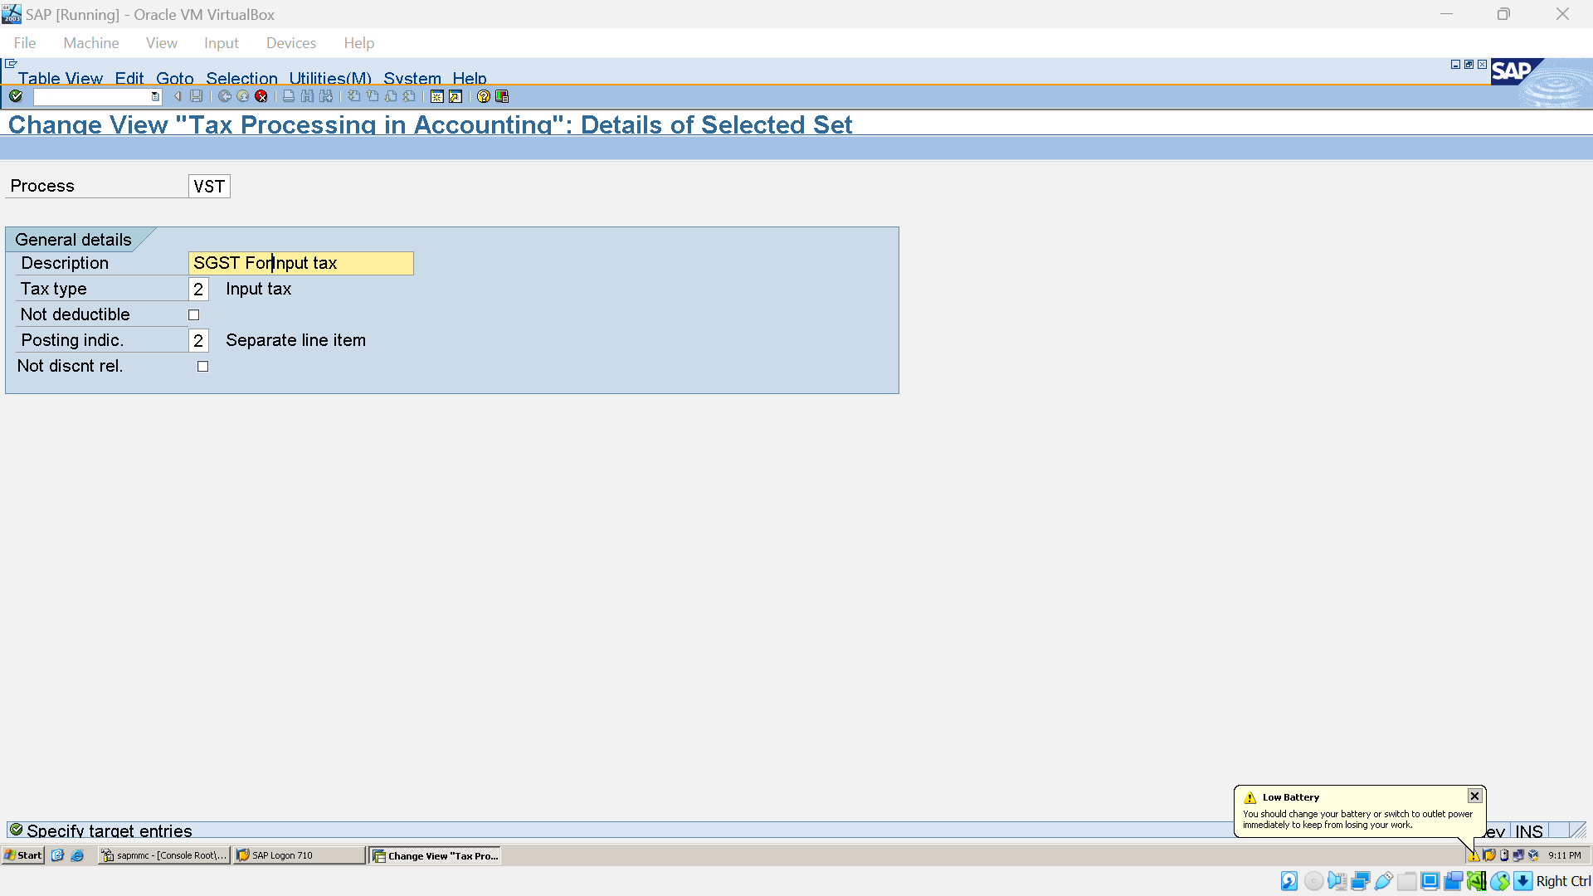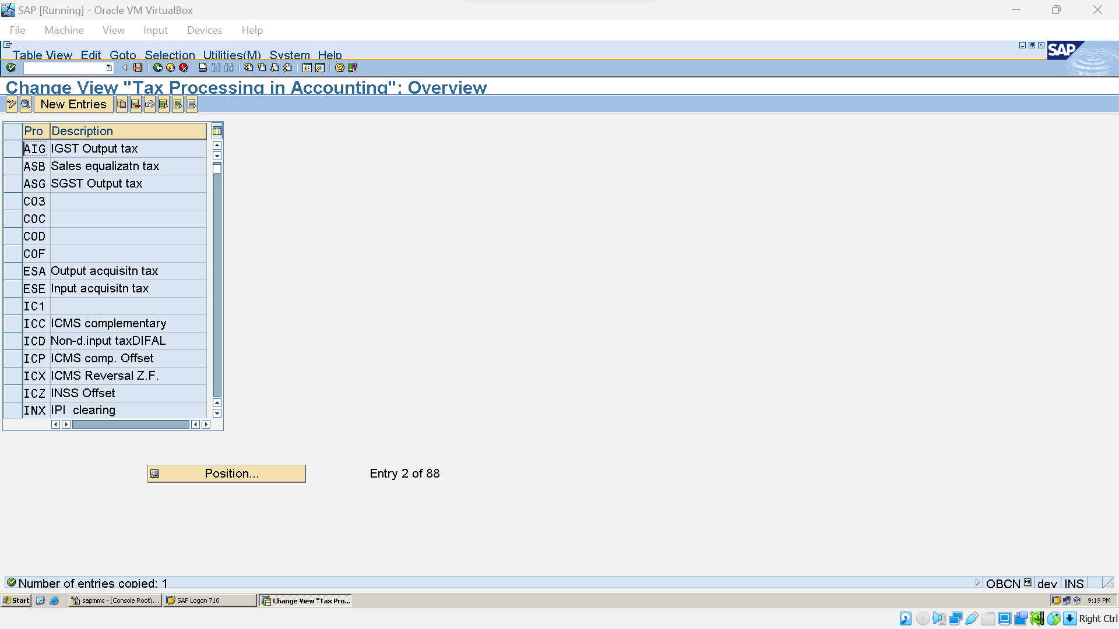

### Create Account Keys (OB40):

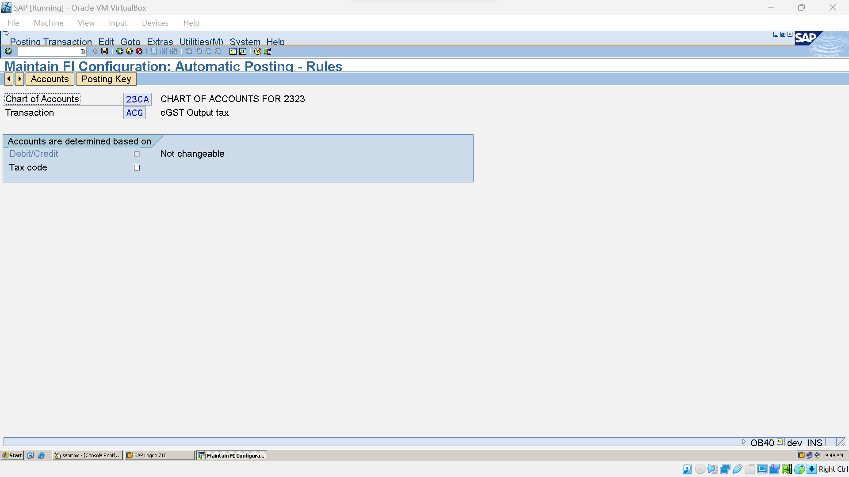

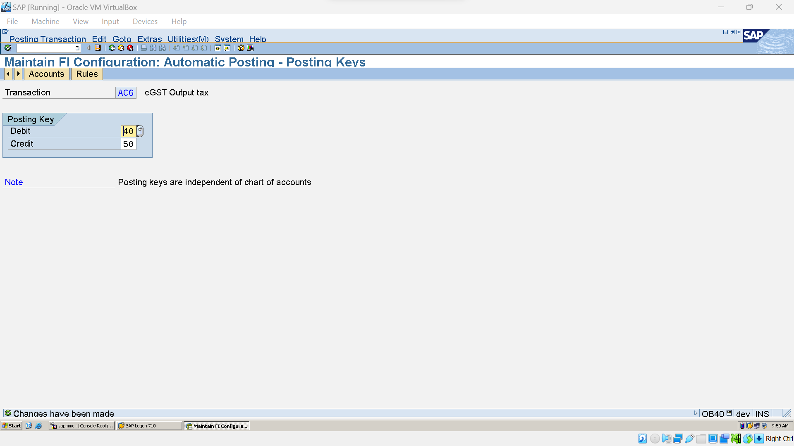

### Create Tax Procedure (OBQ3):

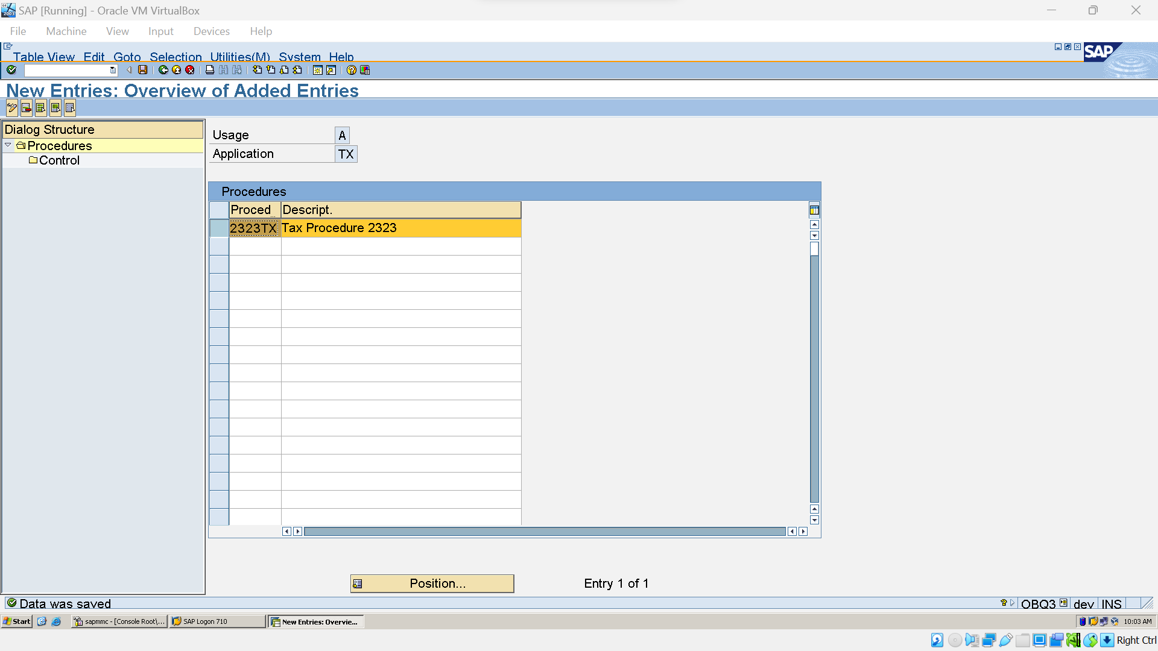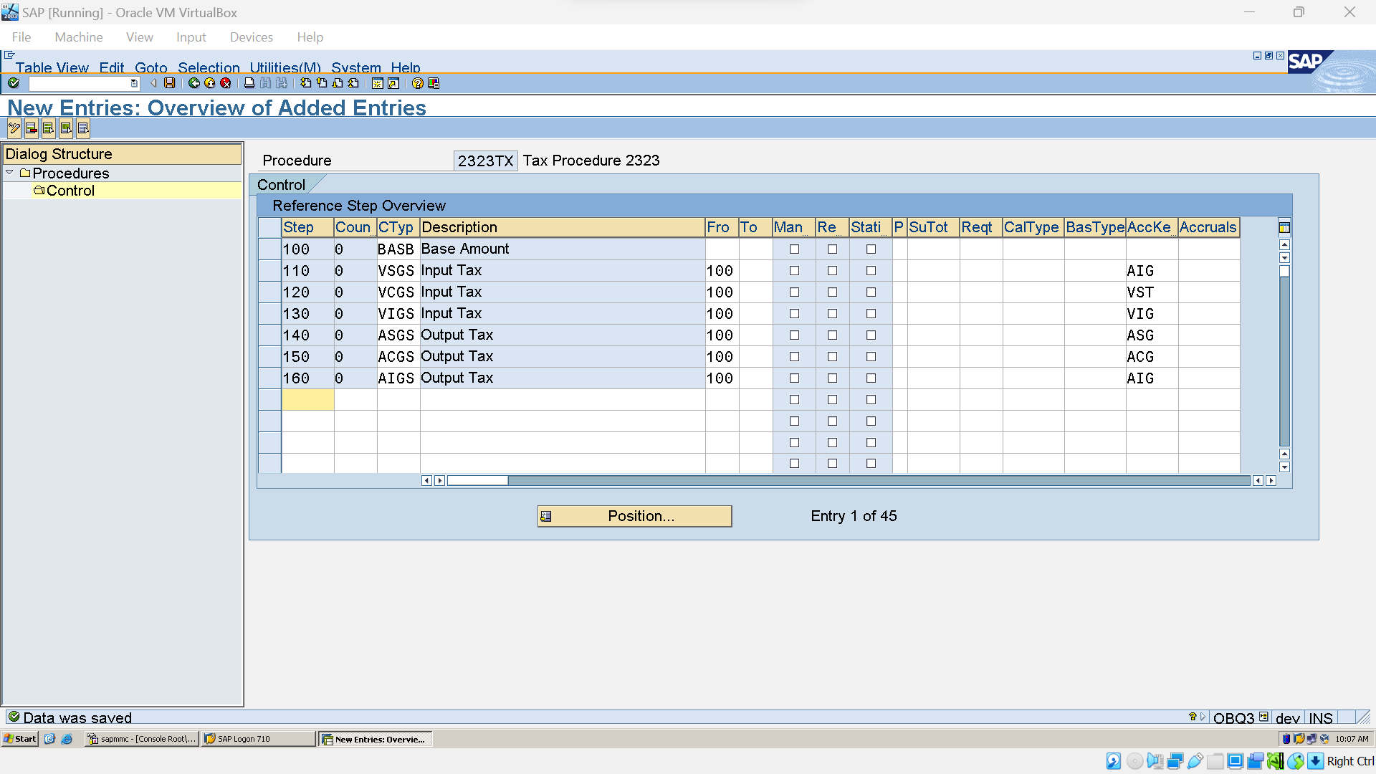

## Asset Management:

### Copy Reference chart of depreciation (EC08)

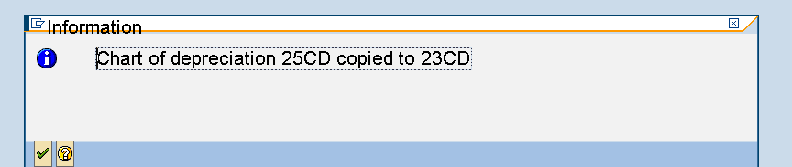

### Assign Chart of Depreciation to Company Code (OAOB):

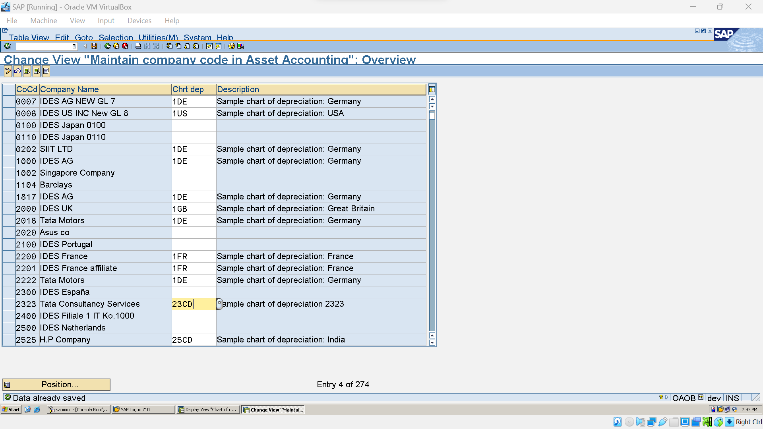

### Define A/C Determination

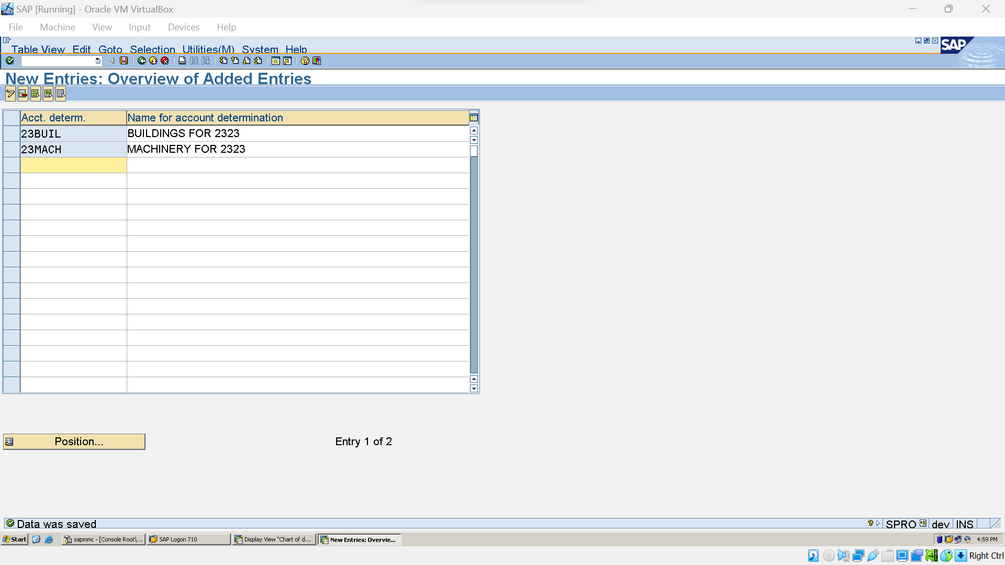

### Define screen layouts rules

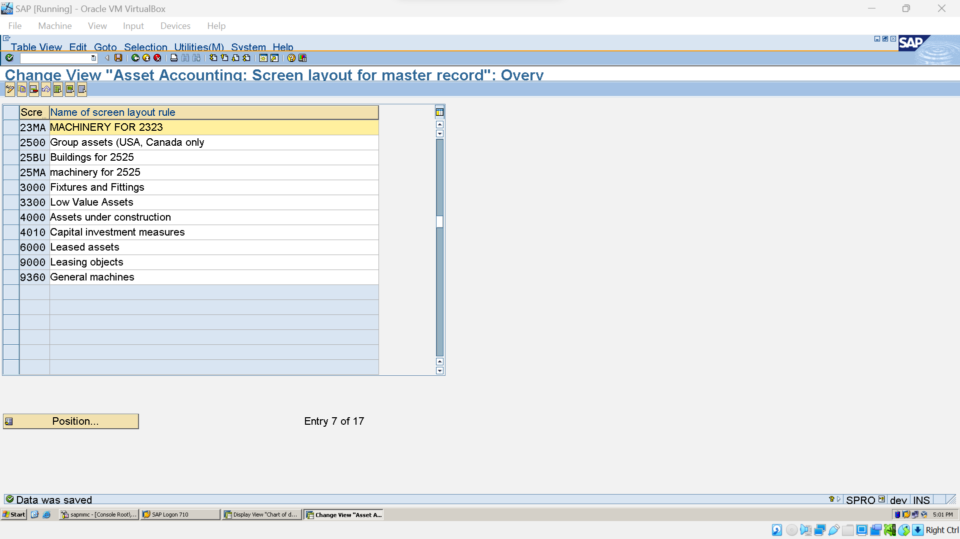

### Define No. Rages Interval (AS08):

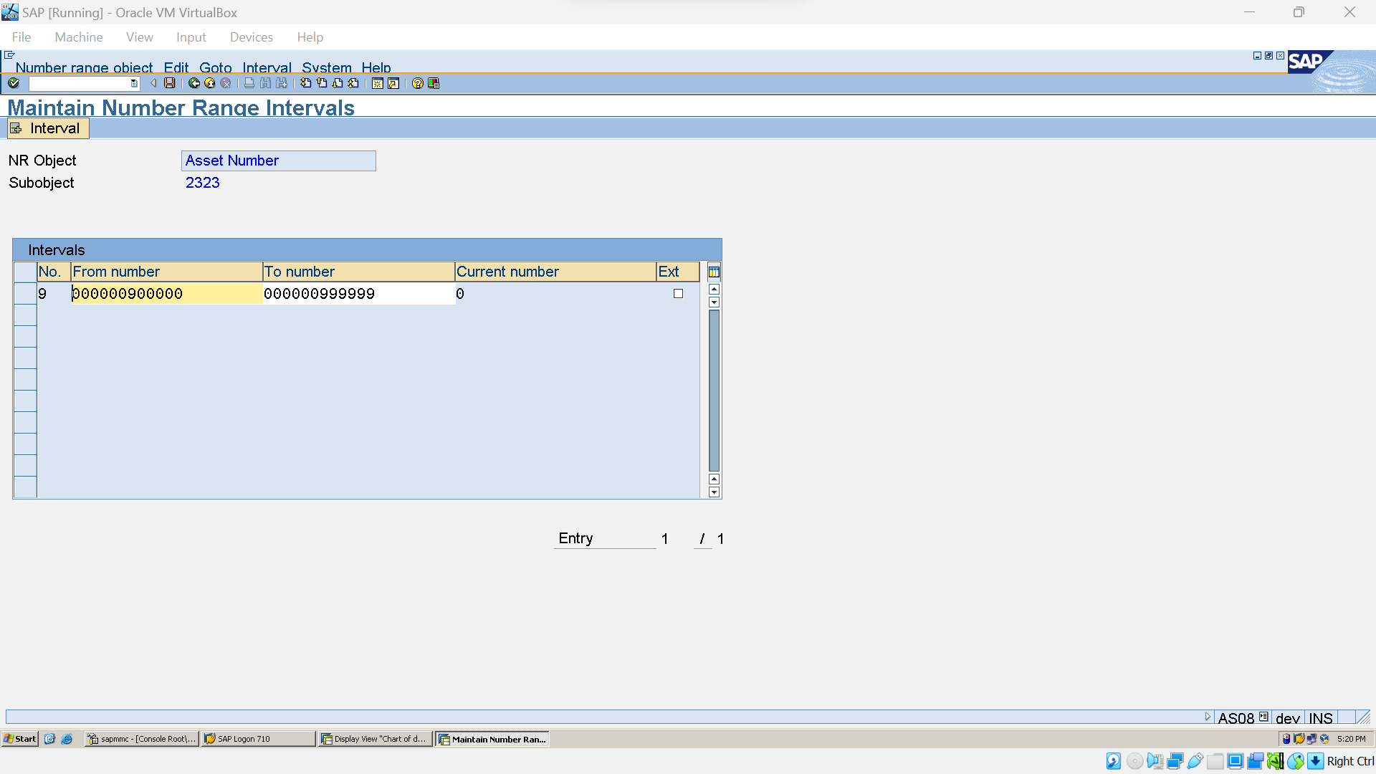

### Define Asset Classes:

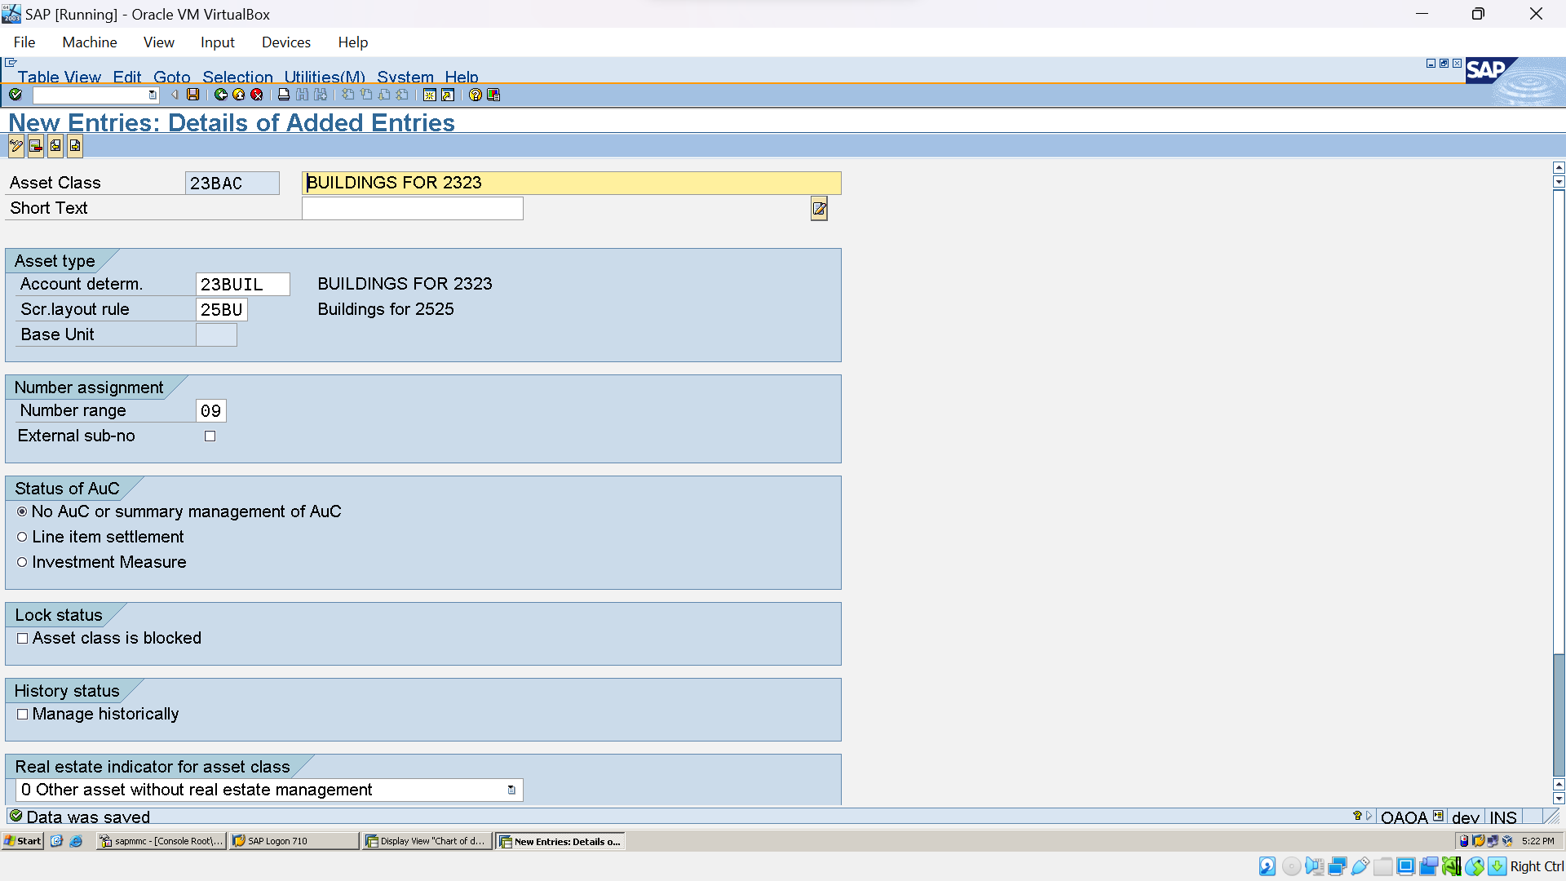

### Depreciation Key (AFAMA):

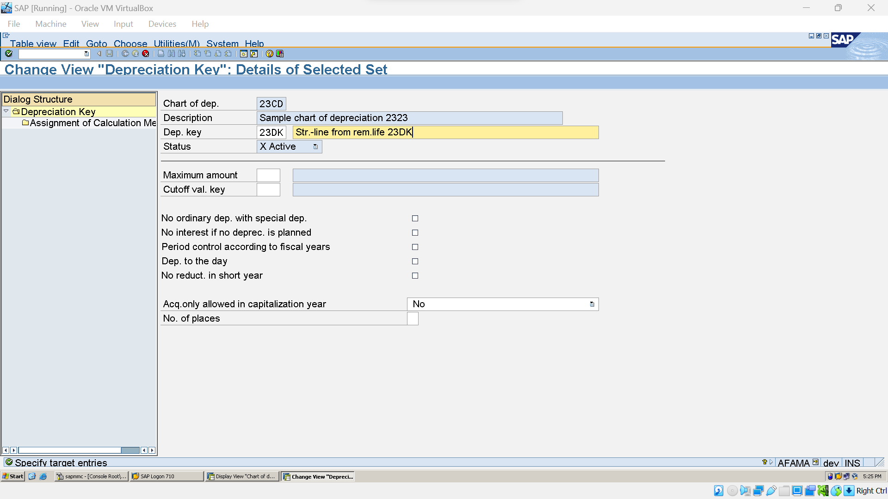

### Determine Dep Areas in asset Class:

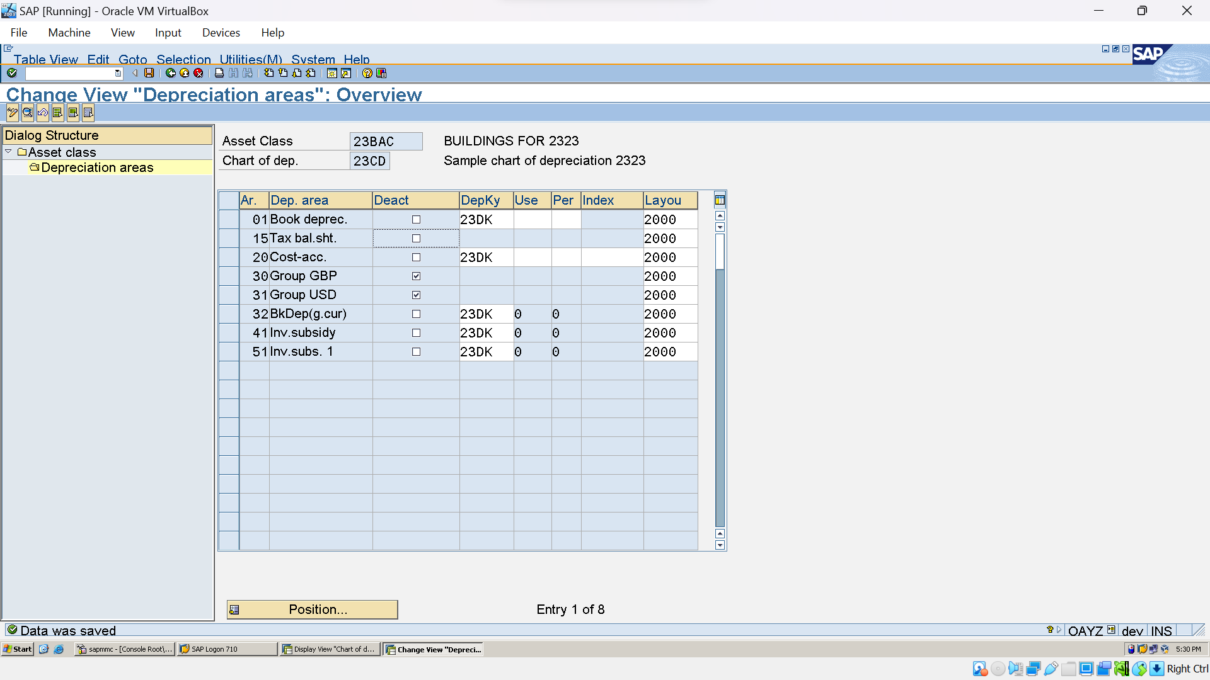

G/L Postings :



### Assign G/L for Asset Auto Postings (AO90):

